**Dr. Wenyue Pang’s Public Diary**

**February 12th, 2020**

Set off!

Shenyang-Wuhan, CZ, 19:30-21:45

This is the first time boarding a plane with a nameless ticket.  I feel a little bit honored, it’s a rare opportunity because not everyone is given the chance to be present in person at a historical event.

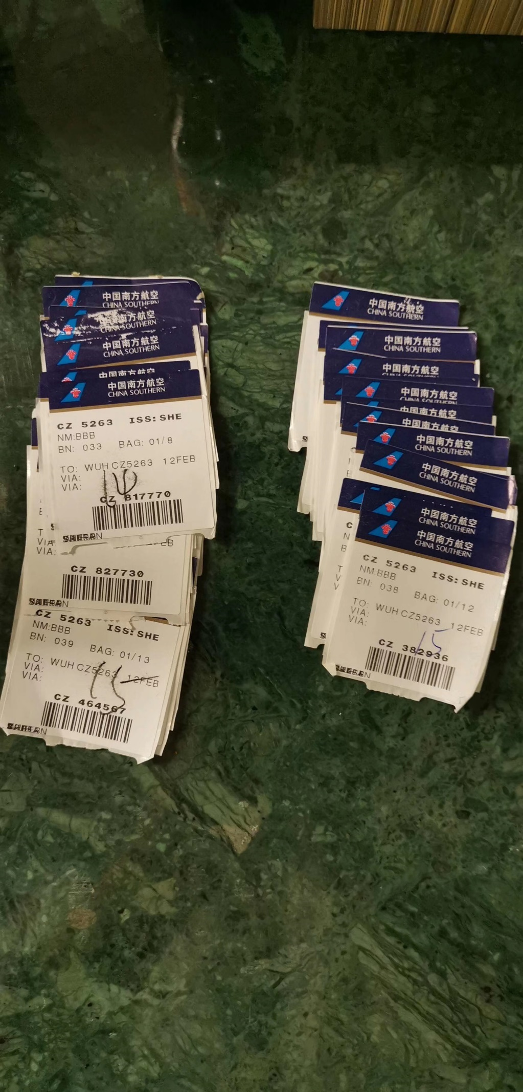

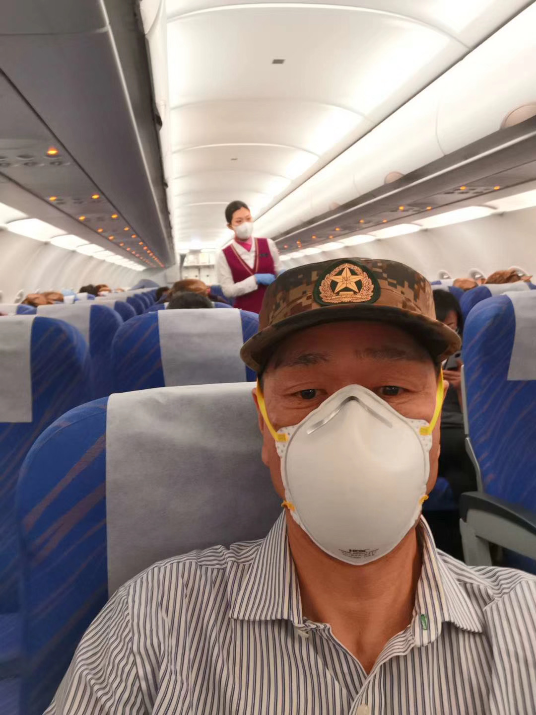After the security check, each member of the team received a warm meal for the road. Because of my duties as the captain, I didn't have the time to eat, but my heart was warmed by the kind gesture. The thoughtful actions can be seen carried out through the flight attendees’ blessings, the ground crew at Wuhan’s airport, and the drivers who transported us to the hotel in Wuhan.

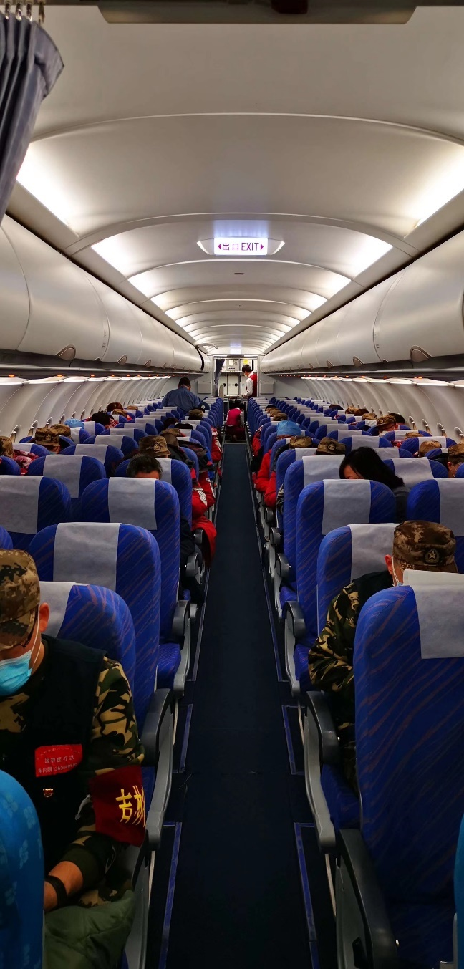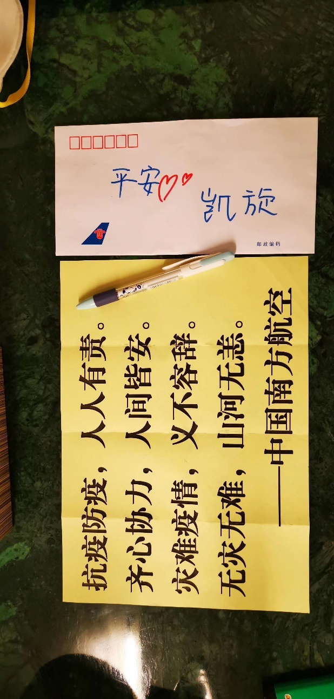

The once crowded city, now with an empty airport and vacant highways tells the same story. The city was devastated by the virus.

But in reality, the seemingly empty city is still filled with innocent, lonely, and helpless people. Those people must miss the old city and it’s the busy streets of the past. Luckily, help is flooding in every direction.

Wuhan don't cry! Wuhan, stay strong!

Let us together chase away the cold winter, and to embrace the warm spring with an open arm.

No matter what, the flowers will always bloom.

**February 13th, 2020, Thursday, Wuhan, Clear Sky**

Hopefully Spring will blow away the disease. Leaving things, the way they began.

Royal Grace Hotel in Wuhan - People’s hospital of Wuhan, East Section

Last night we were given arrangements to live in the Royal Grace Hotel, the previous team already determined the contamination zone and the cleaning zone. Before the doctors and the nurses can enter the hotel, they must be sanitized by disinfectant liquids outside the hotel. Also, all their work clothes and shoes must be put into the possible contamination zone. Afterwards they must wear the clean cloth that's prepared in advance in the cleaning zone by themselves before the beginning of the day.

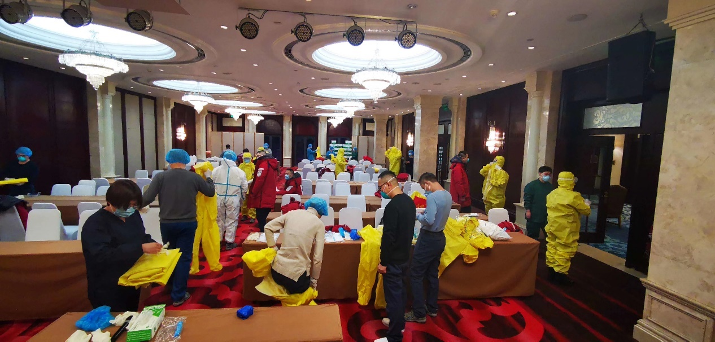

The food at the hotel is phenomenal, plenty for everyone, and there's always food at any given time. The manager only buys the best quality food. it’s been a habit of mine to eat once a day, I can live off with only bottles of coke. But I'm truly glad by the thought that everyone coming from a hard day of work can eat all the food they pleases, especially in this special city, at this special time. The hotel employees also created an online chat with us, helping us with convenient, it's truly an outstanding service.

This morning the team went through a serious safety training, no one was messing around, because we all knew the consequence: the savior might become the one needing saving.

At noon, I consulted with two other cardiologists, who are also academicians of Chinese Academy of Engineering, about the severe cases of COVID-19. They gave tips on the indications of ECMO associated with IABP or IMPELLA.

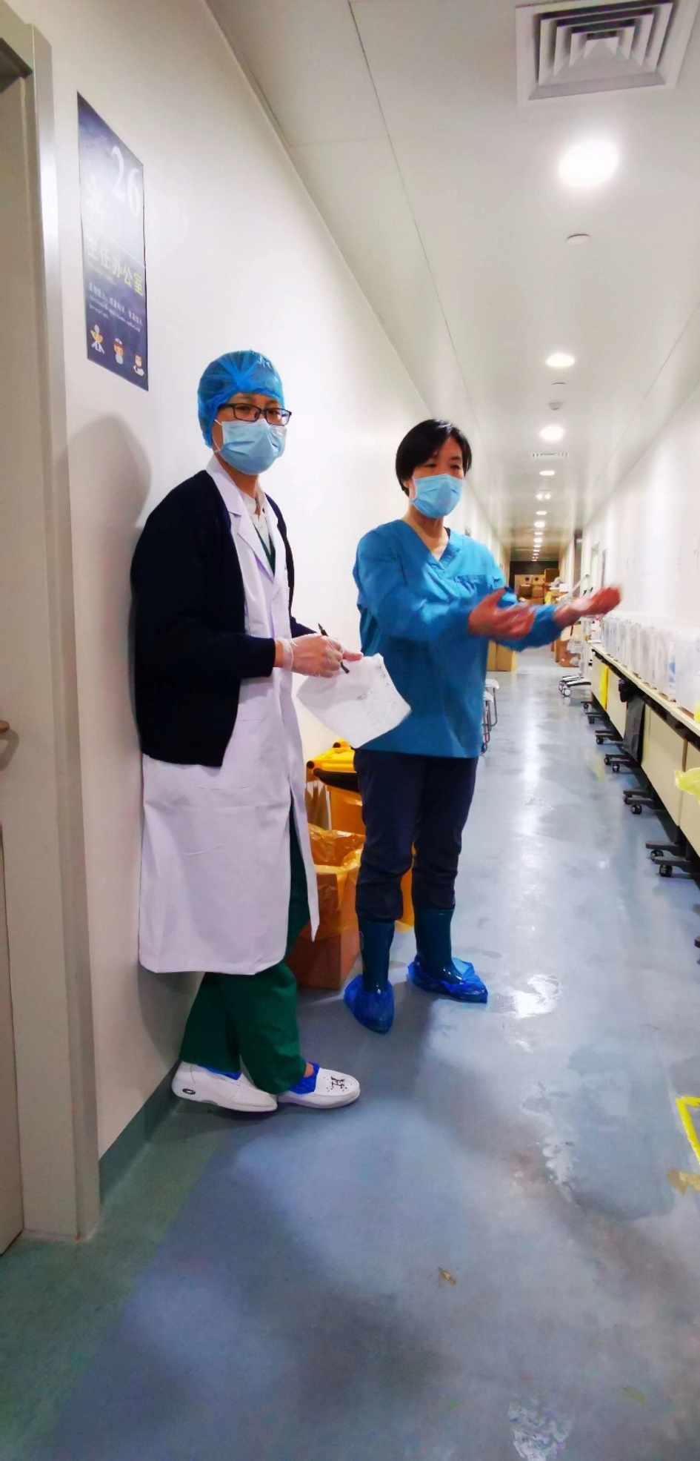

In the afternoon professor Zhao Li and I went to the People’s hospital of Wuhan to better understand the situation, and the layout of the hospital. Normal hospital rooms were used urgently as quarantine zones. Of course, we expected the condition in the normal rooms to be much more serious as it does not offer full protection to the doctors and the nurses compared to the dedicated quarantine zone. Because of professor Zhao Li’s past experience, she was able to offer a logical option on reconstructing the one hallway building, improving it to maximize the protection of doctors and nurses.

Due to the heavy workload, I missed the shuttle bus going back to the hotel. The weather in Wuhan is filled with the spring warmth. The hanging sun, the resting bird, and a dog who followed his hasty owner. There were shuttle buses parked beside the sidewalk, waiting for the next departure. There were no private cars on the street, all private cars were forbidden to go on the road. The driver who volunteered to work said any private car caught on the road, they will lose their licenses and pay a fee of 2000 yuan. On my way back, I saw a few grocery delivery men, and many security guards. Many people peeked out from their apartment window. Those people must be jealous to see us walking, they are trapped in their homes, unable to leave.

2020 must be a sad year for the citizens of Wuhan, only time can tell when things will get better.

Getting back to the hotel, one case of coke was delivered to me from a friend outside of Wuhan, it's very difficult to deliver something into Wuhan because the entire city was put into quarantine, He had to commission another friend from Wuhan local. When I was carrying the cases, two lighters fell out. He knew that I'm a smoker and so he decided to pack it with the cokes, this is something only true friends would do.

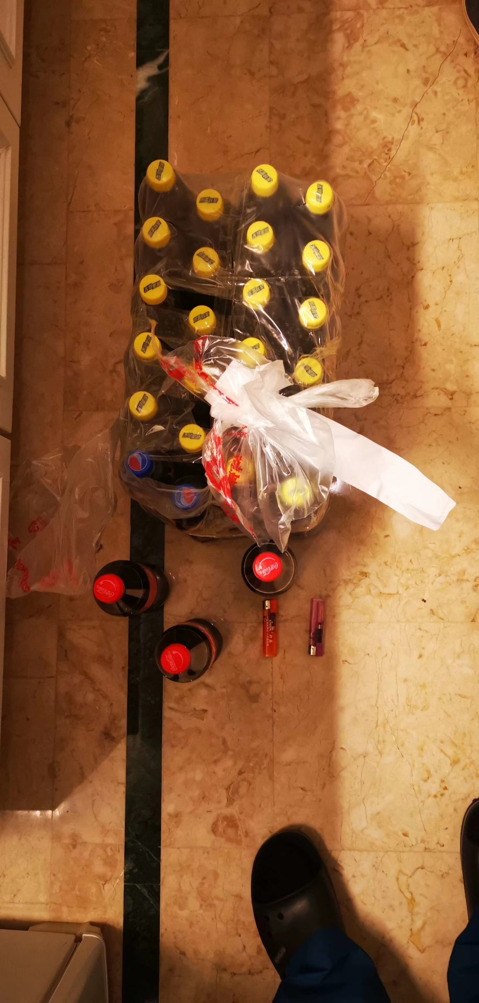

Hang in there. People of Wuhan.

Hopefully Spring will blow away the disease. Leaving things the way they began.

**February 14th, Friday, Wuhan, Wind and Rain**

Royal Grace Hotel in Wuhan

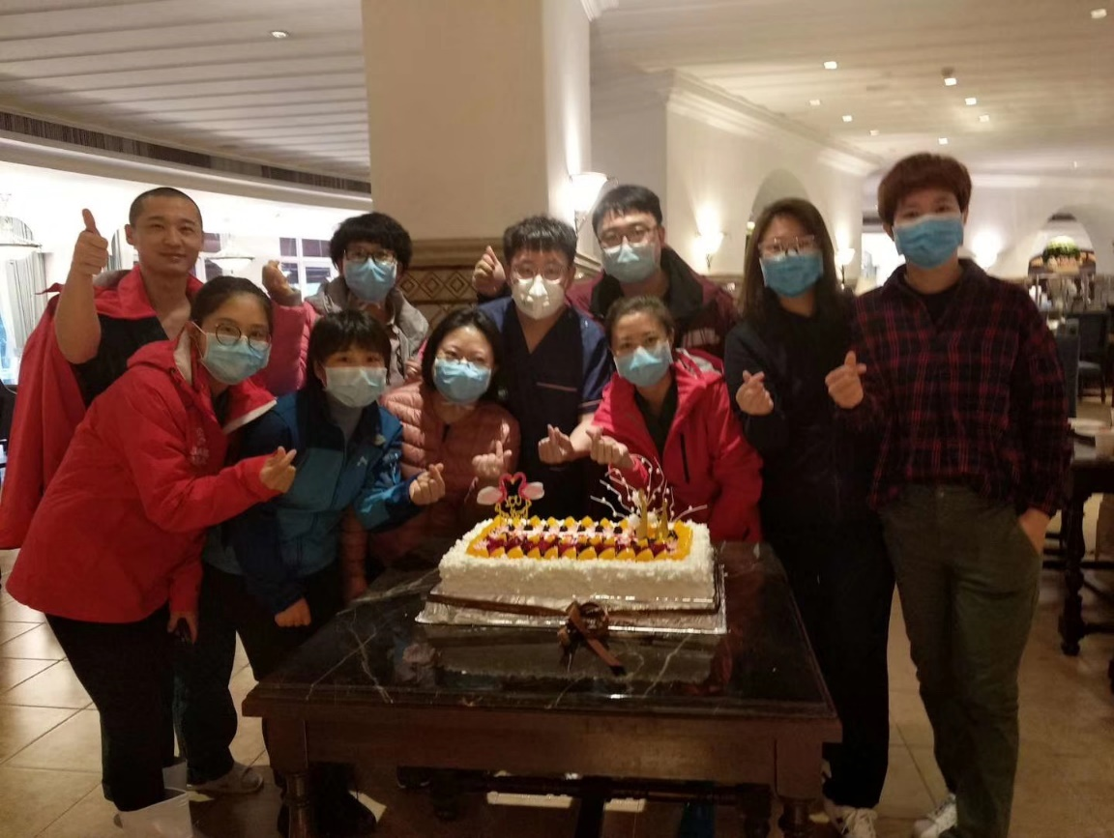The team continued their safety training, helping and supervising each other. They also tried to solve any confusion process together as a team. Yesterday was the gloomiest day for everyone, now the mood has gotten better exemplified by the people’s smile.

Smiles shows confidence, confidence shows talent, talent shows hard work.

From a long time, I know that our team does not lack courage, determination, or responsibility.

When everyone was organizing jobs, bad news was delivered. A nurse was suspected of being infected with the coronavirus.  The Doctor who was supervising the previous team murmurs: “How is this possible? I was talking with her yesterday.” Although the doctor stayed calm, I can see his frustration. Feeling the same frustration, it's not easy seeing other companions whom you work so closely with getting sick. The news was hard on the team, but our team was not deterred by it one bit.

After the meeting, the hotel prepared a cake for Valentine’s day. The young adults in the group all risked their well beings to come here, the cake reminded them of their Valentine days if not at work in Wuhan. Feeling bittersweet, many of them still decided to take pictures of the cake as a memento. I never understood the meaning of Valentine's day before. But after seeing my work mates’ posts online I realized that today is more than a day between lovers, it's a day between friends, families, doctors and their patients. In this year’s Valentines, we need more love than ever before. It's the only way to drive us forward.

Love cannot be stopped by mountains or rivers; love can solve everything.

It may be storming outside, but a rainbow always follows.

Goodnight, my team.

Goodnight, my Wuhan.

**February 15th, 2020, Saturday, Wuhan, Sleet**

Don’t worry, Wuhan! Shengjing is here!

Royal Grace Hotel in Wuhan - People’s hospital of Wuhan, East Section

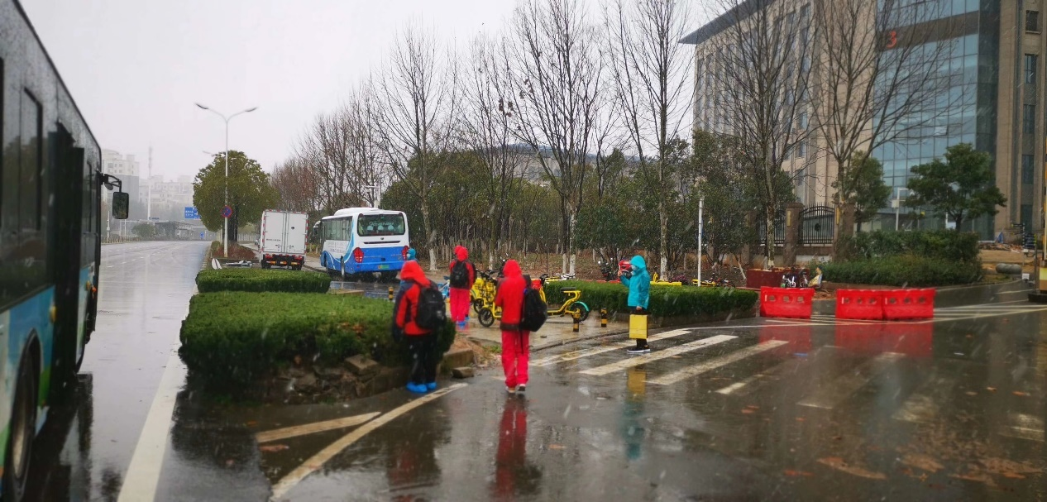In the early hours of the morning, the first group of our team was about to enter the battlefield. In order to alleviate the tension of everyone, after the training yesterday, I told them that if they encountered any difficulties, please tell captain Zhao Li or me.  Welcoming them to call me either Dr. Pang, Brother Pang, and Uncle Pang.  Maybe because my face looked older than my age, with delight, everyone unanimously decided to call me Uncle Pang. In the evening, I sent the WeChat group message: "Tell me if you have any difficulties." In response, they answered with Professor Pang, Director Pang, Supervisor Pang, Brother Pang… but still, most of them called me Uncle Pang. I jokingly messaged back: "Call me Uncle Pang, you can come with me back to Wuhan to enjoy the cherry blossoms during next year’s April". Everyone messaged back saying: "Thank you Uncle Pang!"  So now I unexpectedly recognized a large group of nephews and nieces. Someone joked, "No trickery is allowed." Also many listed must eat and must visit places in Wuhan. Just like the Chinese saying “you can’t back out now” and I answered: "I promise, as your Uncle Pang, I will do what I said!". In fact, deeply in my mind, it is my honor to have a chance together with so many excellent young adults. Today, Director Fan Ling from the nursing team sent a thankful message in WeChat to me about my work for them. While in my heart, I am really thankful to them for their outstanding service in our hospital--Shengjing Hospital.

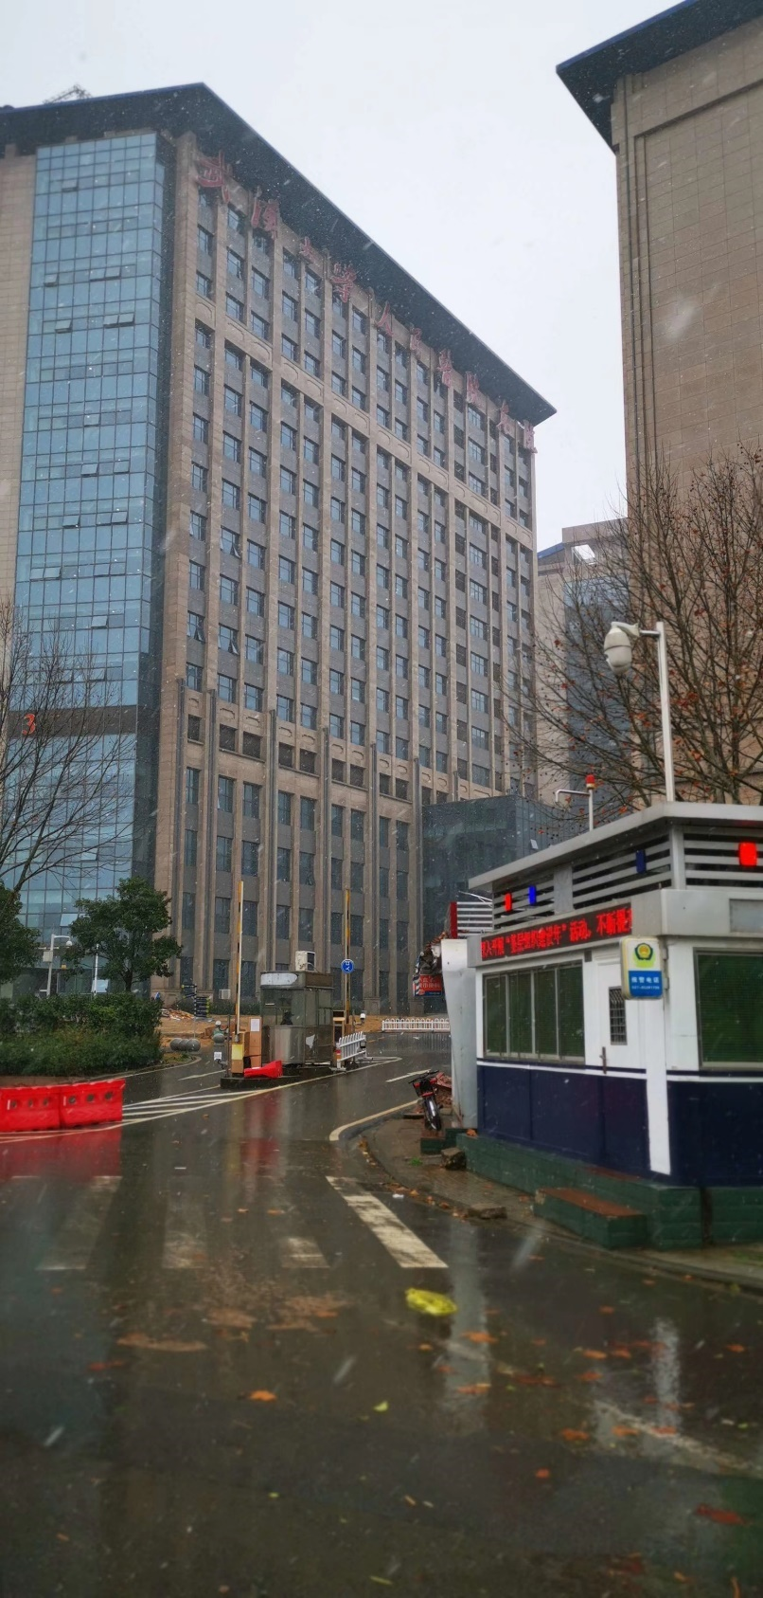In fact, taking them back to Wuhan next year is really not a joke, let alone an impulse. Before coming to Wuhan, whenever I saw a group of beautiful and handsome young women and young men who were usually sunny and looking for fashion in their life, when the country was facing a disaster, they cut off their long hair, removed their jewelry, and put on a dull camouflage, rush to the front.  When you see the blood stains on the faces by the protecting masked and goggles in Wuhan, they deserve to win, and it’s their honor and right to wear beautiful clothes and with smiles on their face to look back at the battlefield again.

Along with the blizzard that began last night, the first nurses entered the battlefield at midnight, and the doctors entered at 8 in the morning. Before our team started, unfortunately, we heard two patients who we never met died due to the virus. The visual and psychological impact on the nurses who entered the strange ward for the first time, facing the strange patient, and countering the strange disease, was beyond imagination. But I also believe that a moment of tension and anxiety can also inspire their stronger sense of responsibility and mission.

Because the Eastern part of the Wuhan People's Hospital in Wuhan University was transformed into an infectious ward for the treatment of severely ill COVID-19 patients, it was divided into multiple quarantine sections. The so-called China famous hospital teams, like East Shandong Qilu team, West Huaxi team, Chongqing team, Shanghai team and many other hospital teams were stationed here. There were two hospital wards taken over by our Northeast Tigers team—Liaoning team. One of them, the fourth section wards, was taken over by our group, Shengjing Hospital. Another section was taken over by combined medical teams from our province. Our team is filled with the top specialist medical staffs in China. As for top medical skills, they are worthy of being the elite team. I’m confident that my team will treat the most sophisticated patients. And I fully prepared for a long-lasting fight with the virus.

Looking at the His in-hospital patient’s system today, there are more than 600 patients in the whole hospital and nearly 40 patients in our wards, two of whom are in critical condition. The team quickly conducted a three-level round of high-risk and elderly patients to set out removing the risk factors that may cause complications, or even to death.

The details of the medical specialty are inconvenient to communicate with non-professional friends and will not be mentioned again. I Just want to tell the patients and my friends: Don’t worry, Wuhan! We, the people of Shengjing, are here!

Feeling a bit tired, ending with a sentence from the song "Chime of The Dawn Bells" I heard today.

The dark will end, and the sun will rise again.

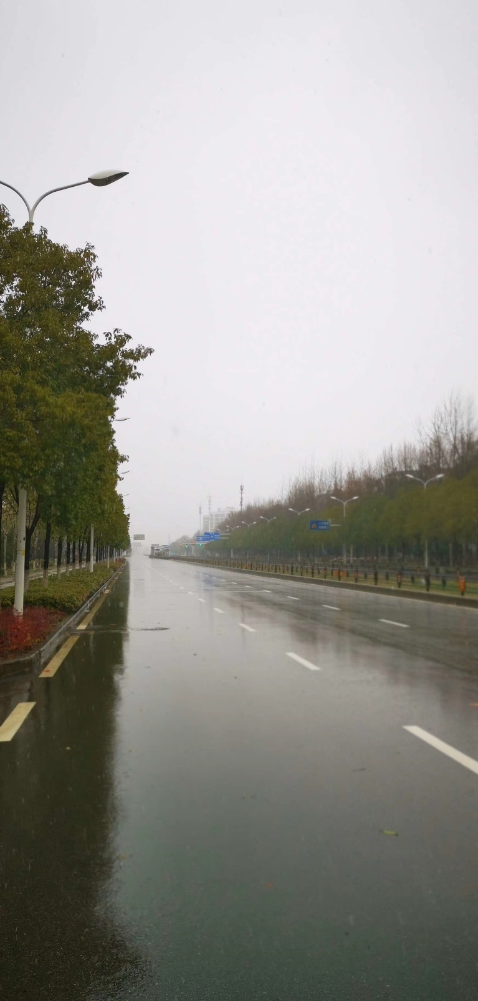

**February 16th, 2020, Saturday, Wuhan, After Snow**

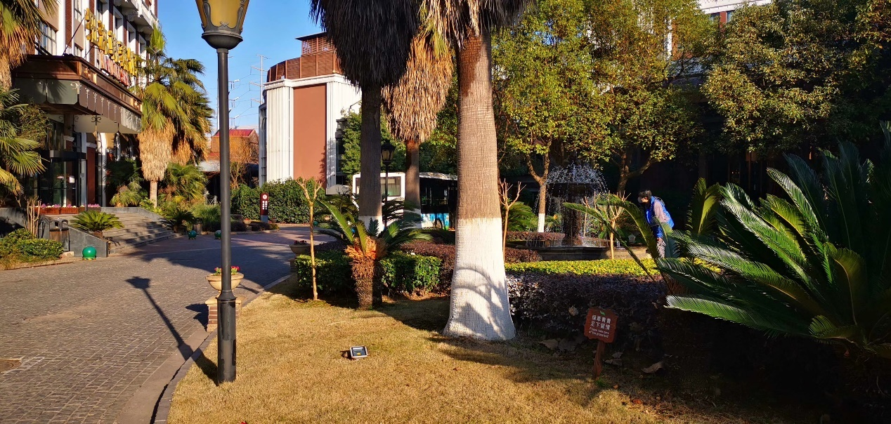The past few days were like snowflakes, always different. The only thing staying the same is the alarm clock that rings at 6:20. When I open my eyes every day, I feel my forehead to see if there is a fever. Little things like a sneeze can be seen as dangerous. It also does not help that the inner material of the masks sometimes causes my nose allergic reaction.

Ten years ago, when my son just attended elementary school, I always thought our generation invested countless efforts into theirs. We invested our time, our love for them. I always wonder how they will contribute to their society in the future, now looking back at it, every generation never stopped contributing to the future. Of course, it's always been the young women and men who drove society forward. Right now, isn’t it the young men and women from the 80s and the 90s driving society forward? They are filled with the energy of the youth; those young scientists are my coworkers and as scientists around the country. When a disaster like this one happens, they sacrifice everything to come here.

I’m very glad and proud to have the opportunity to work alongside them. Their young appearance hides their talent and their strong responsibility. The first time we went to the quarantine zone I asked them: “Are you tired?” their response was: “not at all, we are all eager youngsters.” Those simple words show their bravery and dutifulness.

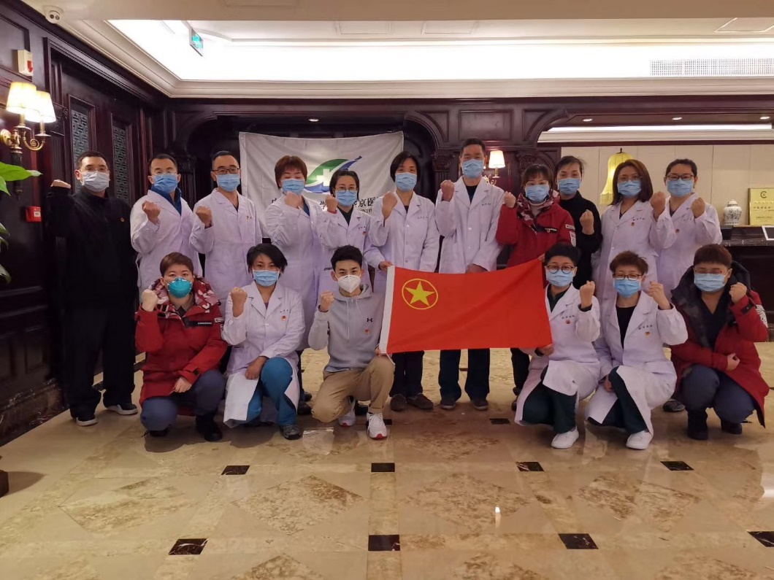Those are our young doctors.

Every doctor has already battled with the virus, and none of us showed any fear. After the snow, Wuhan is lit brightly by the sun. I walked 5 km to return to the hotel. On my way back, the streets are still empty, only buses appear to carry other doctors. The bulletin boards on the road all have one message: “Thank you Doctors!” I, being one of the countless doctors, can’t help but to feel proud. One member of a family of three was now able to be transported to a less serious hospital, but he insisted on staying with his family. Indeed, the happiest moments are with families, even together in a hospital ward. He refuses to leave because he knows it might be the last time the family will be together. Yesterday, two critical patients seemed to start to recover, their oxygen concentration can be adjusted down, and one’s heart function also recovered.

Our teams focus on three types of patients, those are patients in critical condition, the 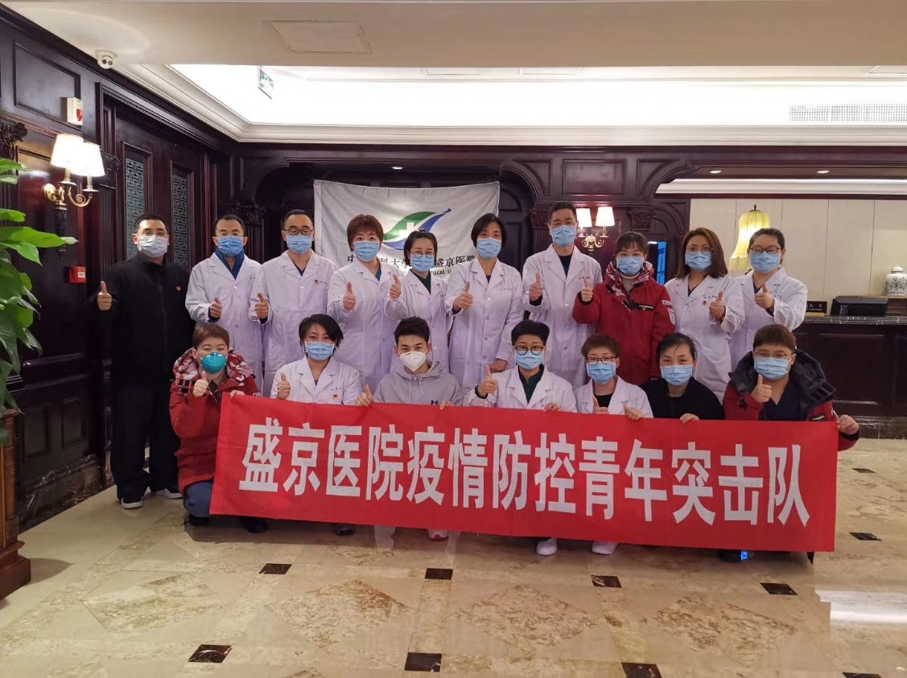elderly, and the newly infected.

Now, the work is slowly becoming more familiar, every day, I go from home to work, work to home. Only this time my home became a hotel, and the traffic was gone.

But now I'm facing a question, the question of why I decided to go to Wuhan. I can't find it. Maybe many years after, when my son is boasting in front of me, I can always respond:

During the Spring of 2020, your dad was in Wuhan.

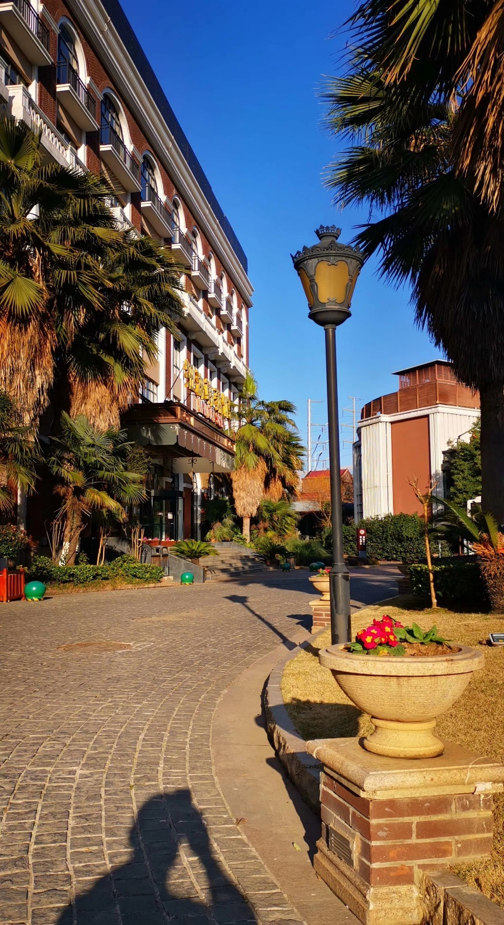

**February 17th, 2020, Monday, Wuhan, Clear**

As the day continued, an elderly man inspected every corner of the hotel. From the entrance, the lobby, the hallways, the resting areas, and even the gym. I noticed him because he was wearing a full suit. From the leather shoes to a fancy tie, and of course he was wearing masks. So out of my curiosity, I asked him who he was. The old man replied: “I'm the manager. I wanted to make sure everything is okay and to make sure to keep you doctors safe.” The manager was not the only one though, the chiefs of the hotel also said the same. Truly, Wuhan needs this, needs the help of everyone, everyone’s contribute, everyone's passion, and everyone’s love. We need most importantly are the people who are operating their job with love. Their love helps them to work dutifully. Just like the dutiful doctors flooding in.

When the sixth reinforced team went to Wuhan, adding the seventh, there were in all about one hundred staff. The hundreds of people leaving caused Shengjing some trouble.  When we received the list of the thirty people from the six and seventh team, my jaw dropped. Those 30 doctors and nurses are the top of the top, 12 physicians/surgeon with associate professor or professor level, besides are 3 attending and lecturer. Such a luxury team, Shengjing Hospital of course wanted to keep her doctors’ home, like parents wanting to keep their children safe.

But it was necessary, the need of many outweighs the need of few.

People’s hospital of Wuhan is still working at a high speed and working thoroughly. Although there are many new patients, the critical patients are getting better.  The team is confident in their jobs, so we secretly decided to make a “zero death” goal. The goal might be hard to achieve, but a goal is needed to motivate oneself.

After leaving the hospital, I continued the 5 km walk home. On the way back I saw a warm sun and a clear blue sky. Like today’s better epidemic data, my current feeling is so promising and stimulating. But there were also urgent matters. The difficulties that Wuhan went through can be seen, read and touched, but the emotional damage on the people of Wuhan cannot be experienced by any other.

Wuhan, It pains me to see you lose hope, becoming sad, hiding in your bed crying. But you must wait, it will not take long. Please have hope.



**February 18th, 2020, Tuesday, Wuhan, Clear**

My team and I were finally able to rest earlier now because of the incredible rate of recoveries. Although there were plenty of blankets, the cold night still woke me up. Since I’m awake, the same question that haunted me in the beginning of this journey.

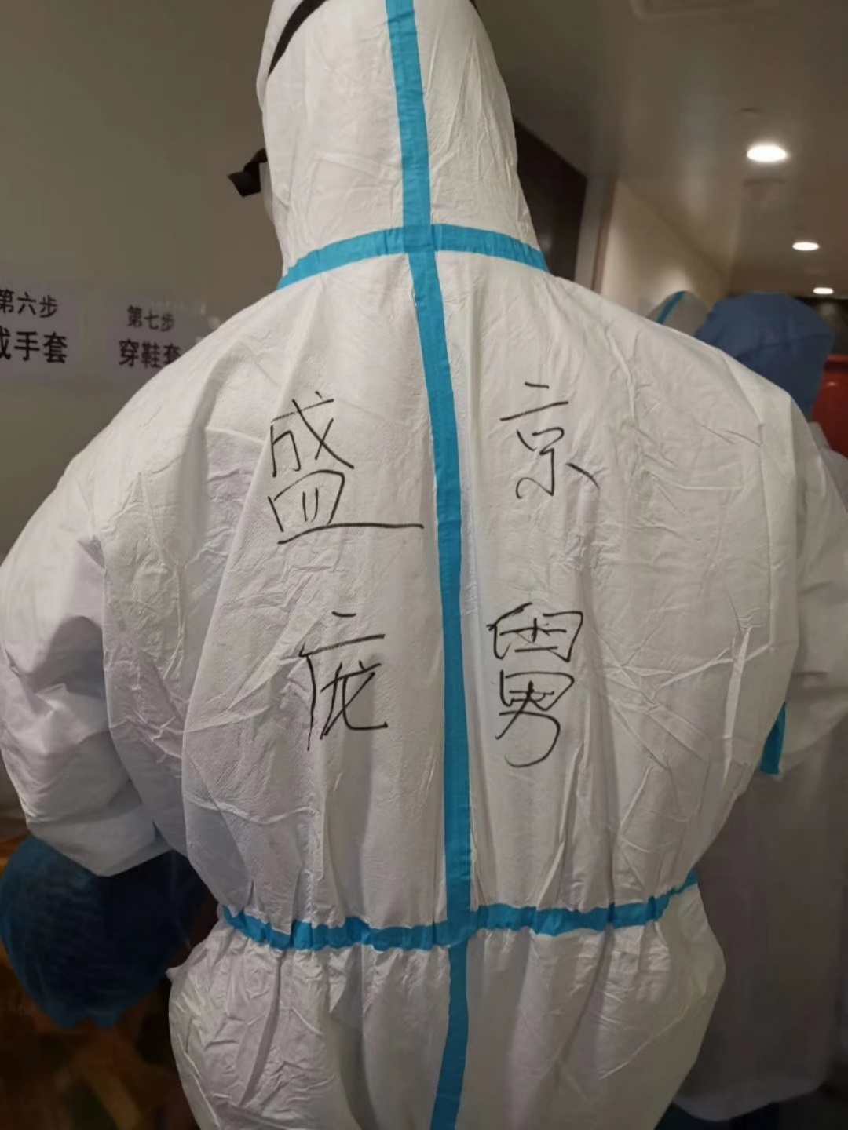Why was I in Wuhan?

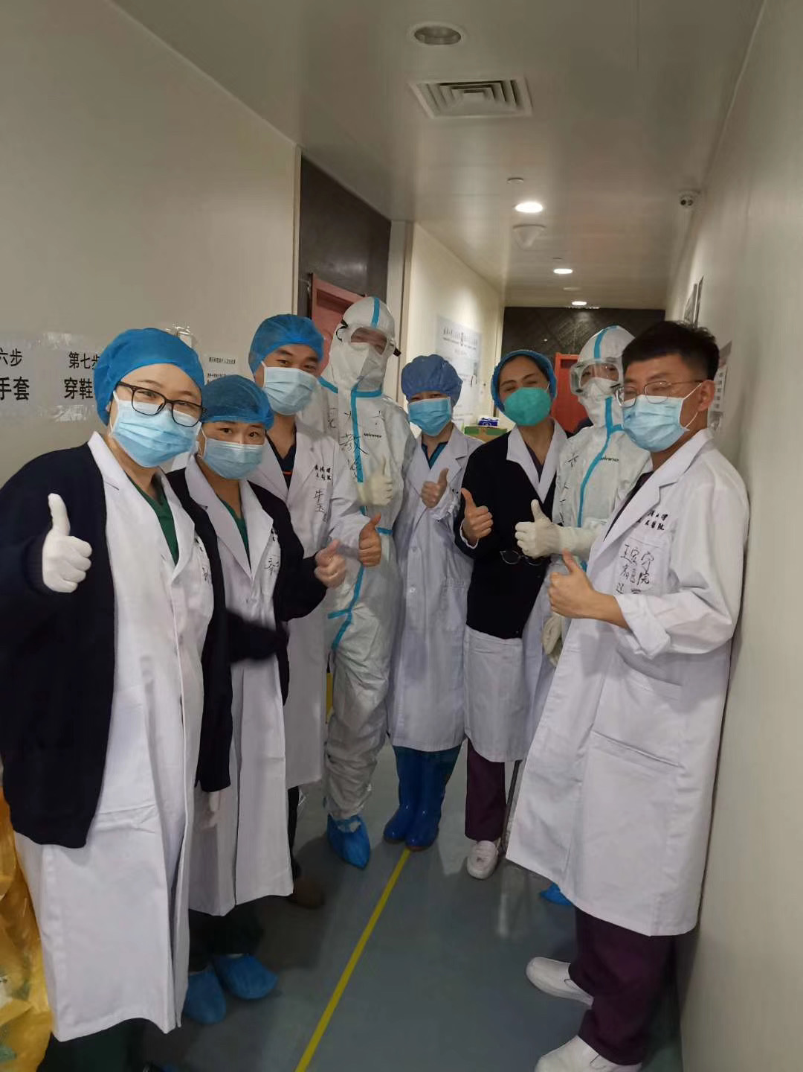A thing lingering on my mind. This must be taken back to the Spring of 2003, Beijing was suddenly under the attack of SARS, just like Wuhan in 2020 with Coronavirus. March 5th was the day my son was brought to this world, unfortunately the first case of SARS infection in Beijing was on March 6th. When my son was a month old in April, SARS could be seen in every corner of Beijing. And just like Wuhan, doctors and nurses were infected left and right, causing fear to all. At the middle of April, the hospital I was working for sent eight nurses to the fount line. Nearing the end of April, the entire hospital prepared to join in. Everyone knows this battle will be a hard one, and no one knows who will make it out unscathed. While everyone was readying to join the battle, I was faced with a dilemma. Whether to combat the virus with a chance of being infected, or to stay home and protect my son. It tied my heart like a dead knot, I was unable to choose. A fellow colleague whose two years younger than me decided to volunteer to go. While I watched him rush into the fire without hesitation, I was ashamed, I felt like a 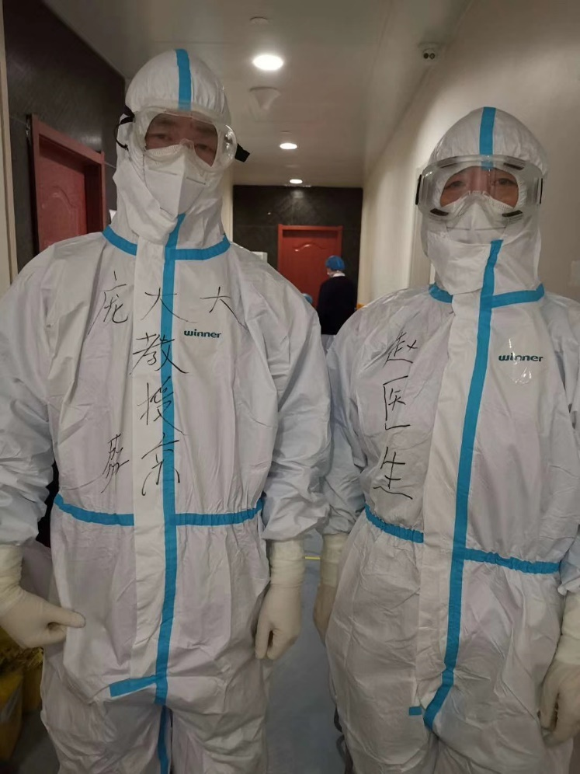coward, and my fear of being infected departed. So during May 1st, I hurriedly sent my son to my relatives living in the rural part of the country and prepared to sign forward to fight the SARS. Because my boss was considerate of my family, I was never sent to the 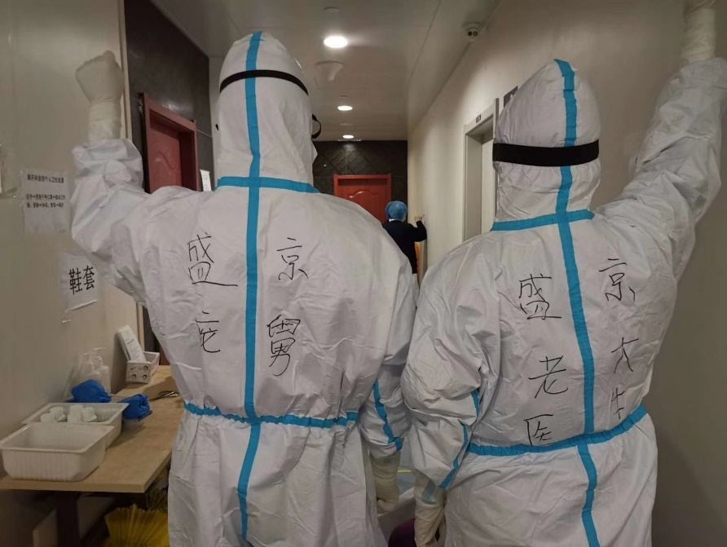front line. And this haunted me for a very long time, it eventually turned into regret. Only until now, the Wuhan epidemic, was I finally given the chance to fulfill my duty, to wash away to shame. This time I know I was professionally and personally needed.

The old me now, loves to imagine the past.

Things are getting smoother in the hospital ward.  There was even an occasion where two patients had the energy to bicker, which I was needed to stop the two. Meanwhile a nurse completed her duty and was now able to leave Wuhan to return home. We wished her a safe journey and congratulated on her hard work. New patients went from the thousands to only 2 critical and 38 serious I believe we can save everyone.

Everything is turning around, Spring is now finally closing in.

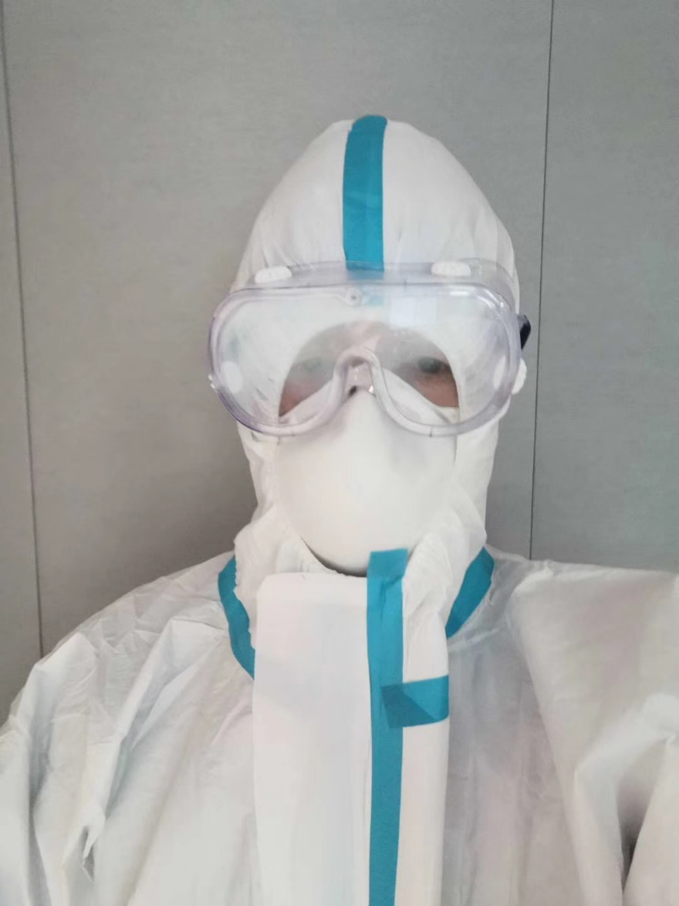

**February 19th, 2020, Wednesday, Wuhan, Clear**

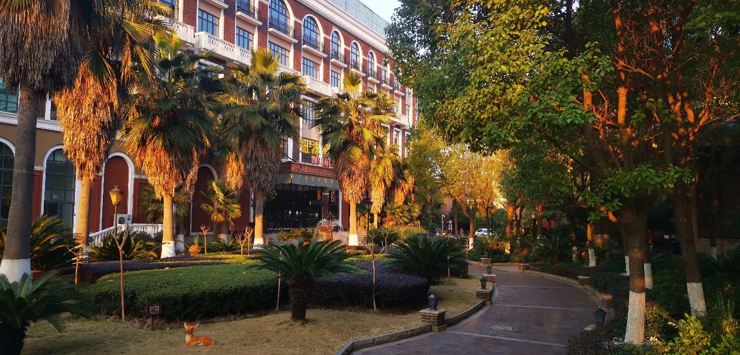The weather in Wuhan is getting warm, and today is a sunny day. After returning to the hotel, I decided to relax on the hotel balcony. Of course, there was no champagne, instead I lit a cigarette. I was able to relax, because of the hard work and the dedication of the team. The number of patients stayed consistent, and the three severe patients started to recover.

Yesterday, the team decided to improve the condition of the ward. So when I entered the hospital ward in the morning I was surprised by it’s brand new look. This speedy improvement was all due to Professor Baixin Li and his team. Our team worked hard and we noticed every detail. When we just arrived at Wuhan, we immediately contacted the previous team. We asked them for the detail of every patient and we also worked to analyze the cause of previous deaths. Then we organized a plan of action. This plan of actions consists of preventing patients from becoming sicker, to find the cause of each individual case, to apply the right medication to each case, and more. The ultimate goal is : Zero Death.

In the afternoon, I received news of an elite group of doctors coming to Wuhan. This group consists of 20 different specialists in unique medical fields from another hospital. After reading the message, I know that our team is also filled with specialists too but instead we arrived a week earlier. The reason for such diversity was due to the fact having different medical specialists reduce the chance of death among patients with combined complex circumstances as a whole. Our team consists of Respiration specialists, Cardiologists, Nephropathy and more.

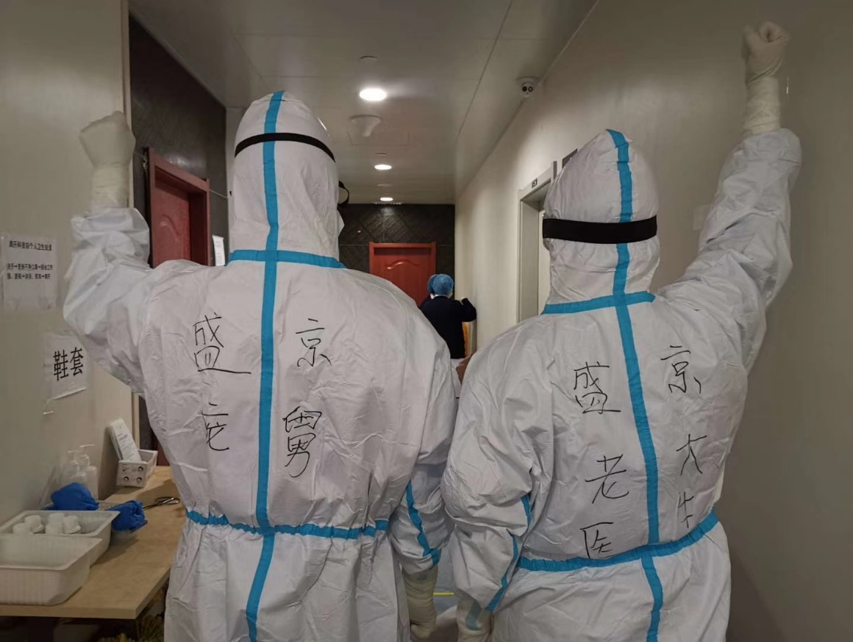The Combination of Specialists Is pinnacle to the safety of patients.

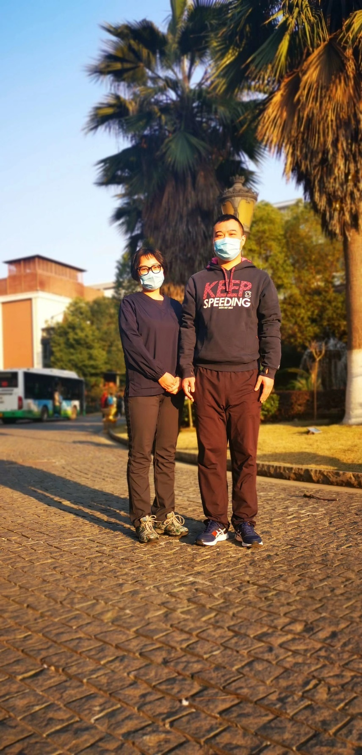

**February 20th, 2020, Thursday, Wuhan, Clear**

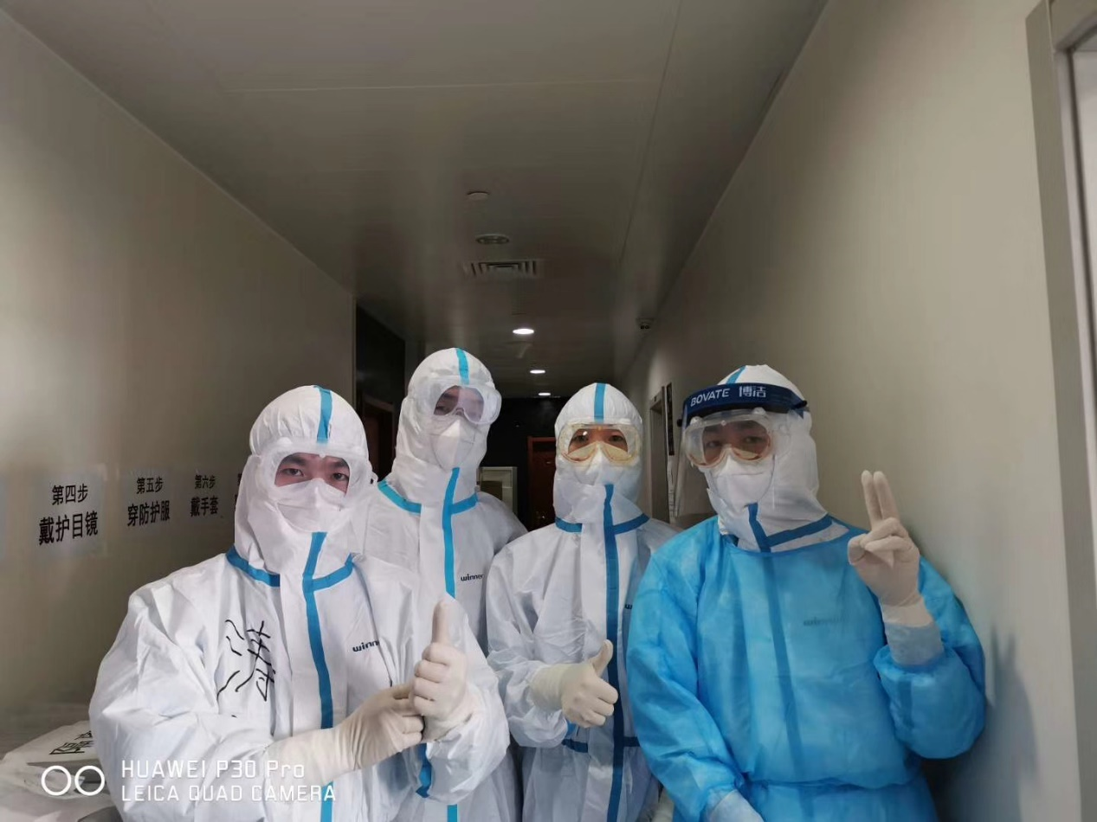Today, I finally understand why it's possible to be cold with two sheets of blankets. It was not because of the cold air, or the lack of air conditioning at the hotel, it was because the window was left open. For days now as soon as I go into my room from work, I dive head first into the bed, and never realized I left the windows open.

The first thing I do every morning is to look at three specific locations in the case map. The first place is Liaoning, the place where I work alongside friends and colleagues. And the Liaoning province is used to support Wuhan and Xiangyang. Recently, Liaoning shipped 1400 cases of milk here, enough to give every doctor one bottle a day for four months. On top of that, we also received gifts and food from the entire county.

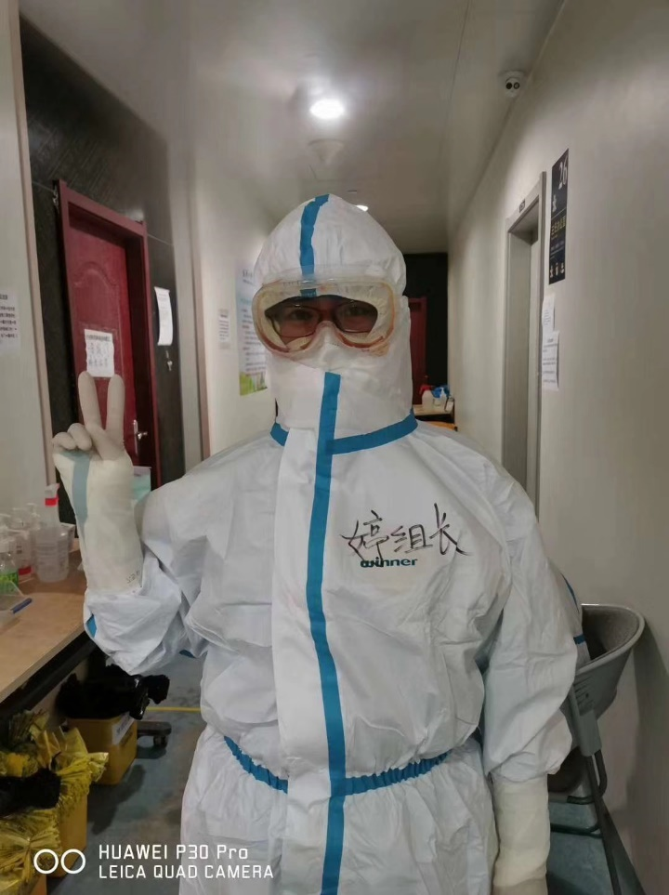

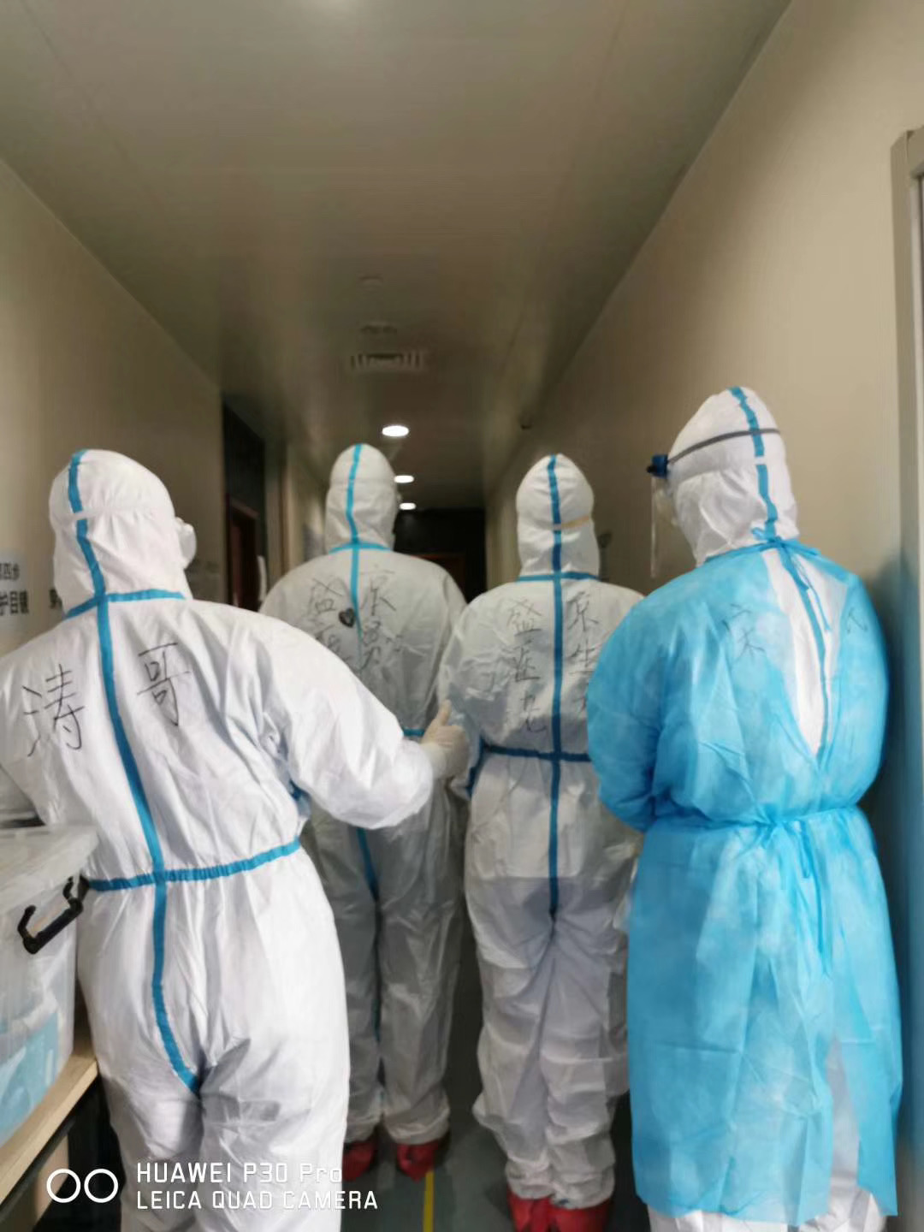The second place is Inner Mongol, a rural place up north of the country, my birth place.  When I was upset as a child, I lay down on the green field and look up to the sky to feel better. Living there are my family, classmates and my 90 years old mother. She probably thinks that the Coronavirus are like bugs, and doctors use hand to squash those bugs. The Church is my mother’s life, she taught me to be kind. I originally planned on visiting her, but now it seems it'll have to wait until April. The virus there is 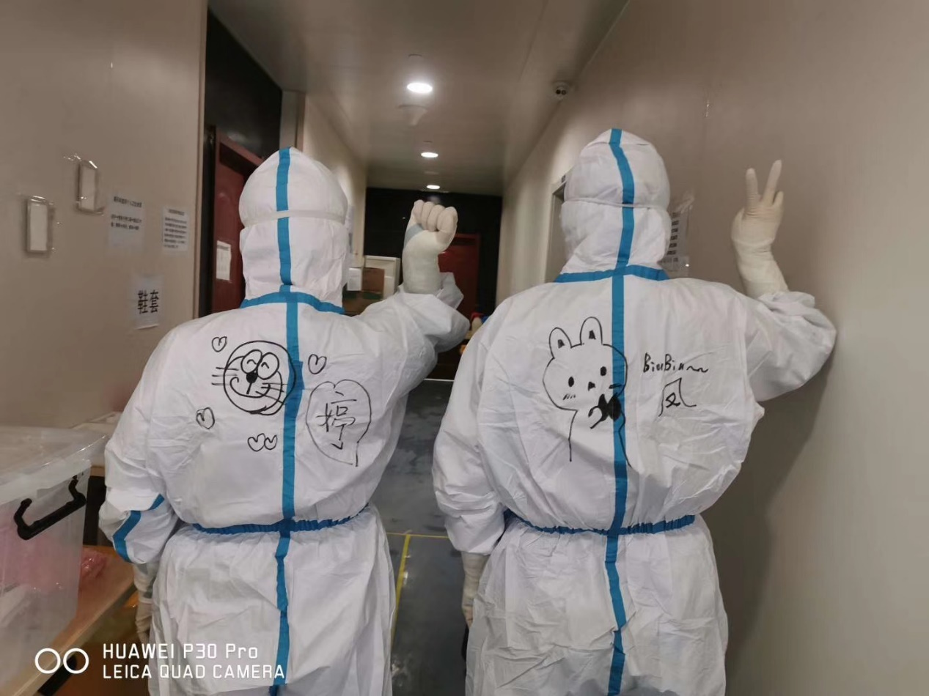contained, but I still have friends there in their frontline, fighting the virus.

And the last one is Wuhan, where I met many doctors here. In the past, I have been here for lectures, conferences. Every time it's a short visit, not many memories. But now, the city is imprinted into my mind, even though the condition here is tough, it will get better soon. Every day, we received less and less patients and more and more recoveries.

Now the hospital patients, they are recovering slowly, but they are getting better. The happiest moment is when two patients recovered and left the hospital, they also took pictures with us as a memorial. One of them said: “Even with the picture, your faces are covered with masks, so I still don’t know what you all look like.” We are all doctors, here to help the people. Some of the patients require emotional support, and many of them are in a state of discomfort. So besides observing the patients, we also talk to them, to offer them words of comfort.

But not all patients are easily comforted, A patient shared her sad story. She was at a party with seven other classmates and friends. Although she didn’t show any of the symptoms, she infected few of her friends. Sadly, one passed away. Although she didn’t cry, I can see her sorrow and regret. It's evident, no words can comfort her.

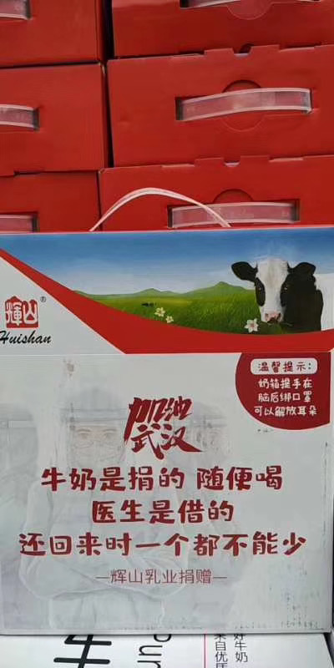The people of Wuhan are hiding their tears deep down, there is no time for crying.

It's time for action, from you, form me, from them.

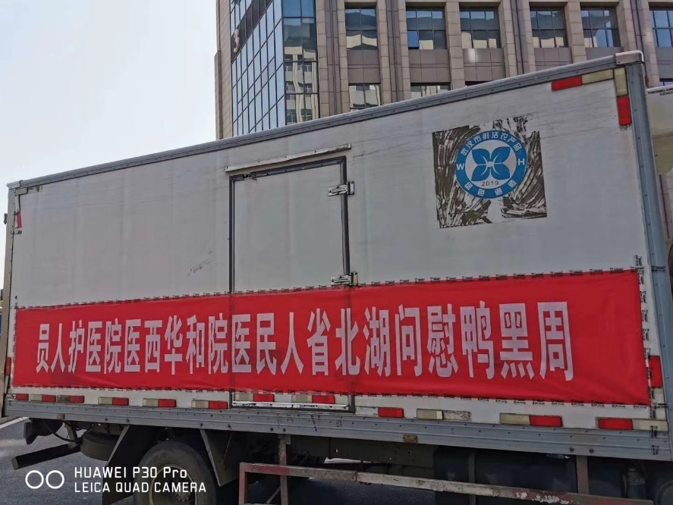

**February 21st, 2020, Friday, Wuhan, Cloudy**

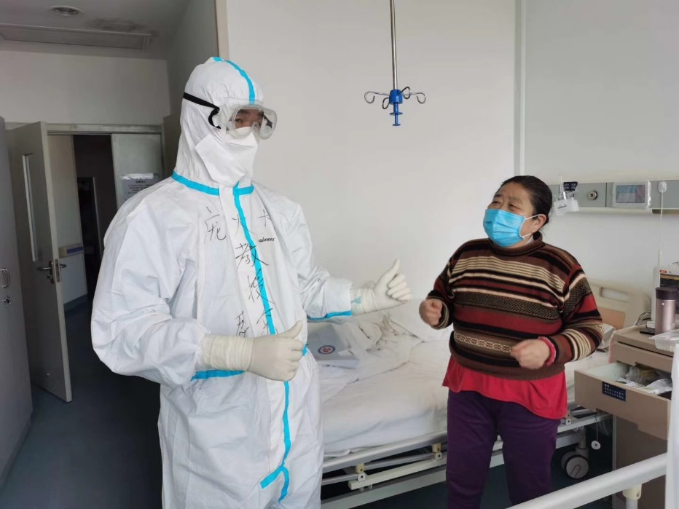The days here In Wuhan are alternating from easy to hard. I try to not look up sad news and stories, those sad stories of hopeless citizens in Wuhan can be tear inducing.

When the epidemic began in Spring, because of people’s fear of the virus, they mistreated the people of Wuhan. A letter written by an American teacher to parents says: “Anyone can get sick; therefore, you and your kids shouldn’t shun any Chinese people or people that are close, not even the sick. Because shunning them will make them feel ashamed and embarrassed, which causes them to hide their sickness…. I'm against the virus, not the Chinese people. When the situation becomes dire, it then requires logic, patience, humanity and unity.” The goal is to protect, but it shouldn’t be done selfishly, it should be with intelligence and love.

There's always more love than hate.

Conversation from two employees of the hotel yesterday

“So hungry, this one looks tasty.”

“You can’t eat that one.”

“Why?”

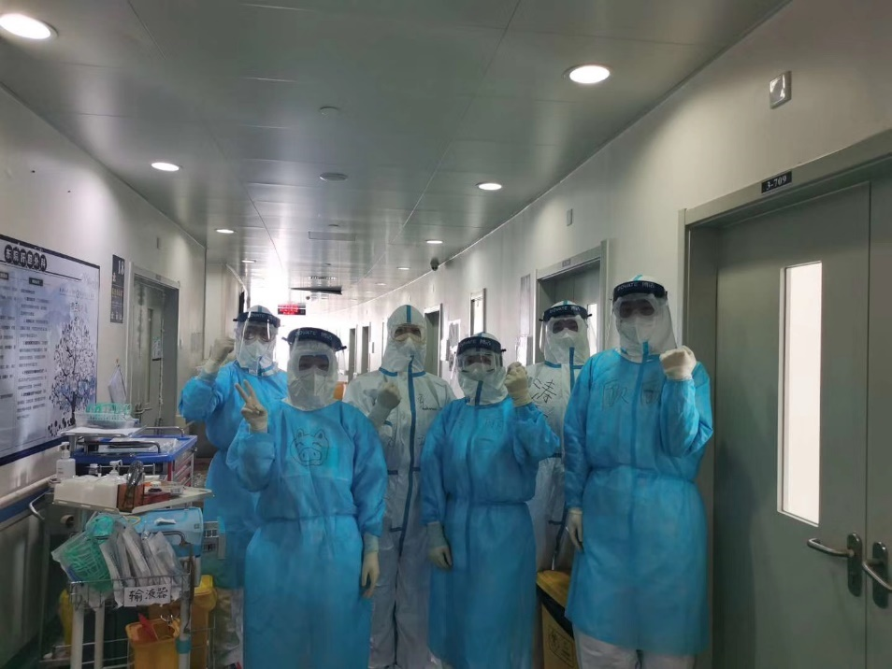“We don’t have enough of this dish for all the doctors, they might not be able to eat it after work.”

We were all borned kind. And this kindness in us remains with us in difficult times.

Today, three more patients were able to leave, only one new patient. The medical staff increased in numbers despite the decrease in patients.

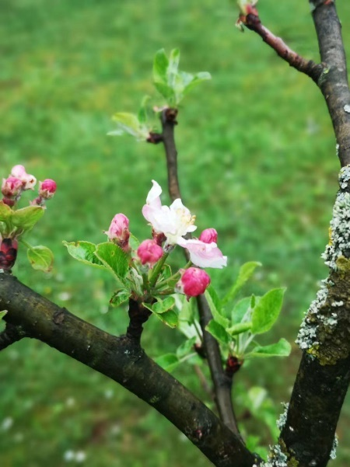The night sky slowly vanishes into day.

**February 22nd, 2020, Saturday, Wuhan, Mist turn Clear**

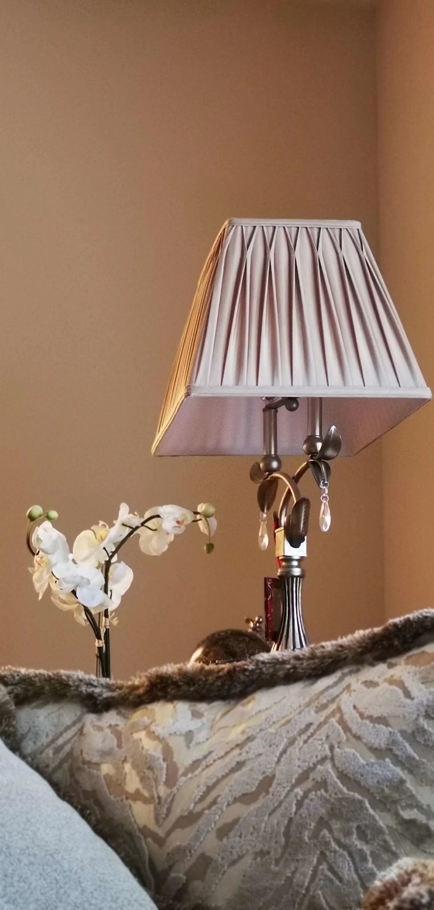In my bed at the hotel, in my dream, a voice calls out to me “If you can relive your life, what would you do?”

If I can relive my life, what would I do? I would listen to the rain through my window, to look at  the gentle trees being blown by the wind, to look at the countless clouds hanging around the blue sky, or to feel the thick snow with my feet. I believe everyone truly yarn for a peaceful life like this one. A tranquil life, from every day, every season, to 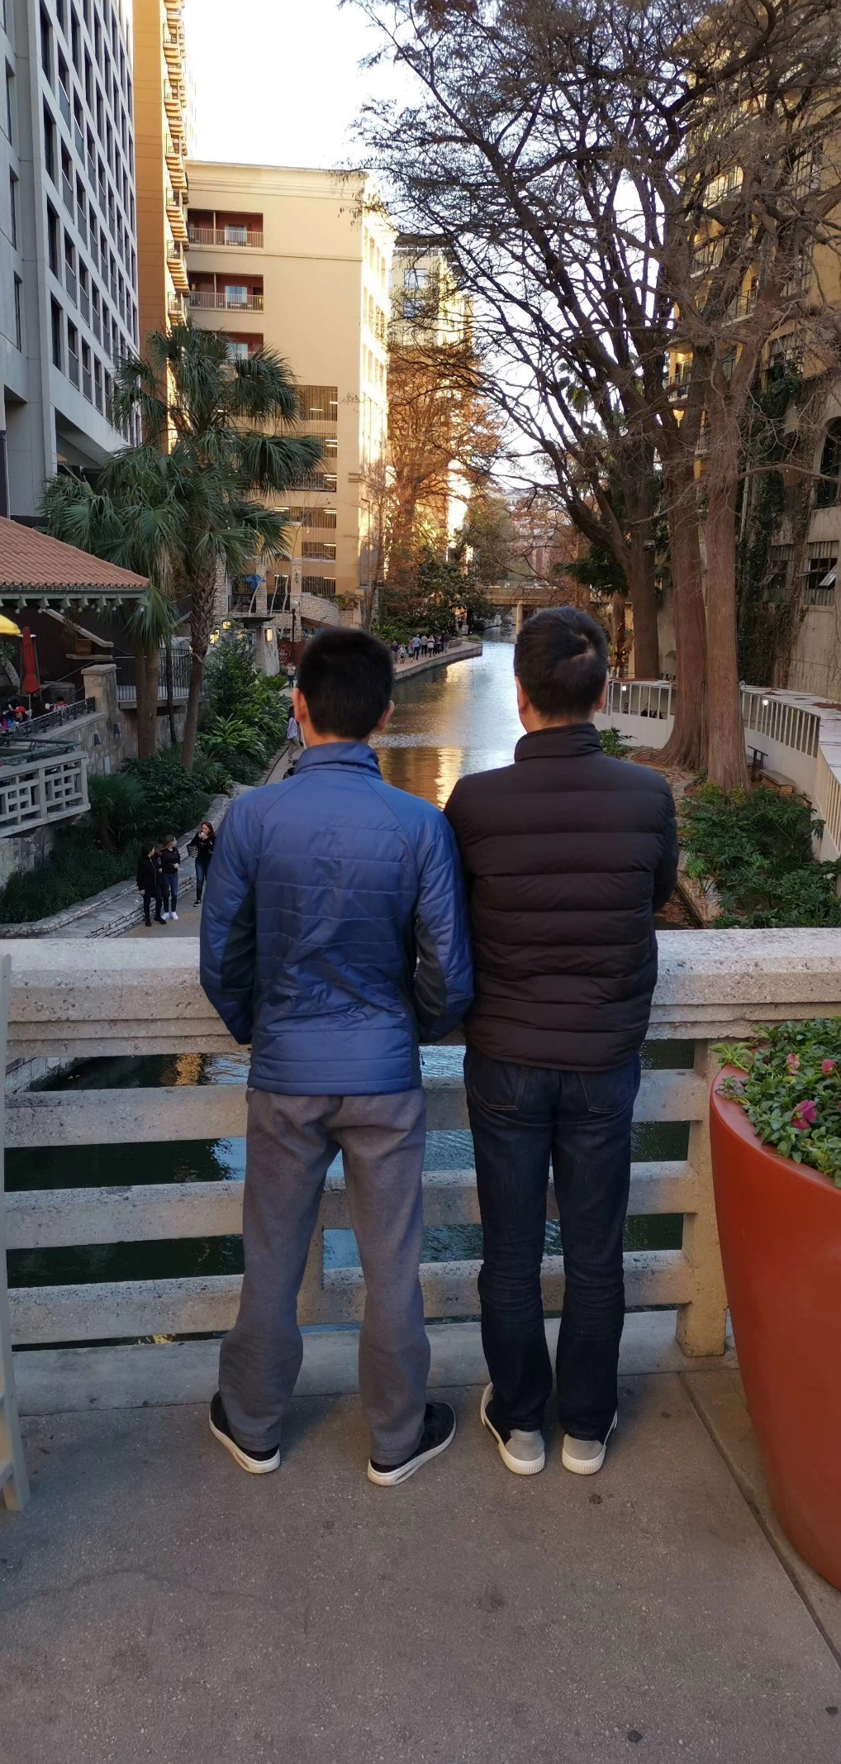every year.

Maybe you want a peaceful life, but life in reality like the Spring of 2020, is full of ups and downs. Everyone only has one life, and you must make the most out of it. If you blink, it will be gone.

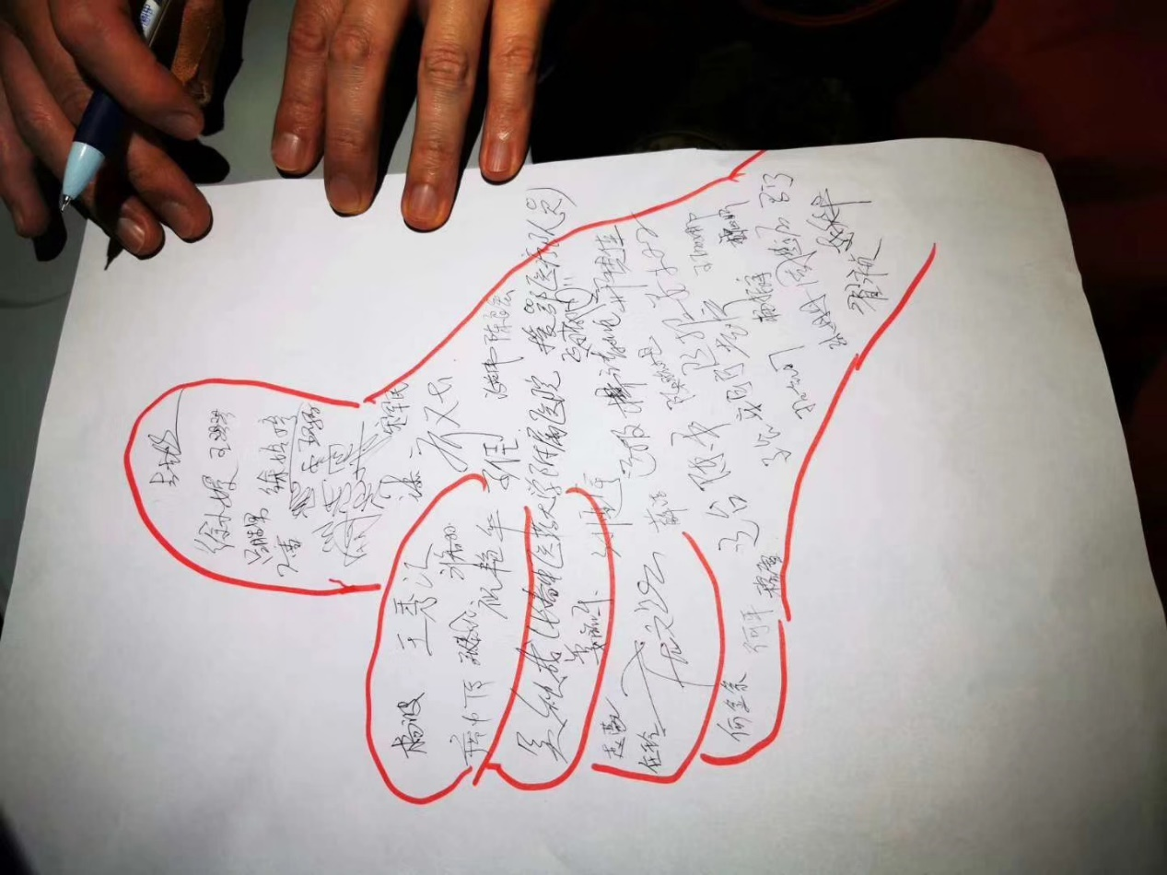There was this story online, the story was that a father died. The Doctor called the son, telling him of his father’s death and informing him to arrive at the hospital to sign the documents.  Contrary to what the doctor believed, the son did not cry, he remained silent for only a few seconds. The son said: “I'm also a doctor, yesterday, my mother passed away, also the same virus.” The son’s voice sounded dry, tired, and sad. The doctor cried, him and the son are both doctors, they fight for the same cause. The son continued to speak “My wife and daughter are quarantined at home. I stayed at the hospital for two weeks now. Today is finally my off day.'' The son doesn't know why he said those things, maybe he was in shock, a hurt heart, wanting somebody to support him. The doctor did not have the courage to meet the son. He later received a thank you letter from the son.

How can you live a tranquil life if the world is full of surprises? The world requires you to fight, It requires you to take responsibility. In 2020, the world requires you more than ever! Because your name is the white coat worrier.

Taking a stroll outside of the hotel, I see shadows appearing and disappearing into the darkness of the streets.

Today we received many new colleagues, the patient who stayed at the hospital with his family were now all able to leave. Today must have been their happiest day, leaving the hospital with everyone. On top of that, we continued our zero death streak.

Time will not stop for anyone, so we must take advantage of the time we have and to make the most out of it.

**February 23rd, 2020, Sunday, Wuhan, Clear**

A shocking news was heard this morning, a local doctor passed away, she was 29 and had a two years old son.

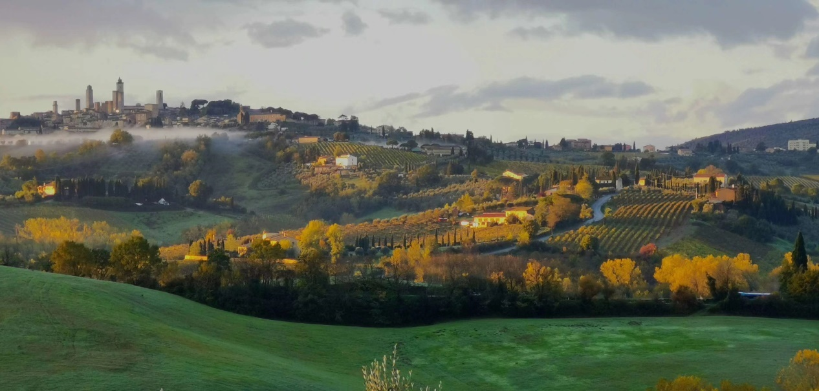I heard the news while I was browsing the web for something interesting, I never expected to find something this shocking. We were all 29 years once, we are all in the same profession, but I lived, and she died.

In memory of her.

2020 February 23, you, like a flower, ever so beautiful, left the world while you are still blooming. You tomorrow, will be buried under the dismal Spring ground of Wuhan. Your life should've been a long lived and a happy one, but instead, you left. The sadness of your son and husband will follow you too. Your tomorrow should've been with your family, living the happy life you deserve. But instead, your life was taken by the fever of hell, forcing you to leave this world. When the Spring rolls around next year, your soul will become the flowers, your essence will become the dancing butterflies. We will remember you, you will become immortal.

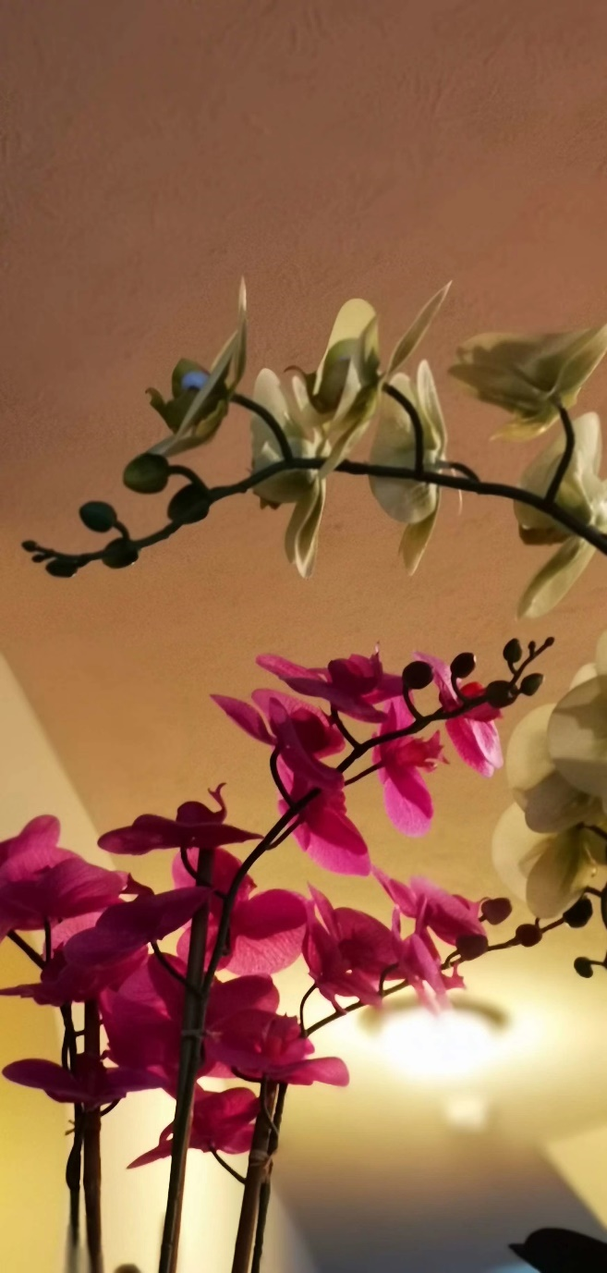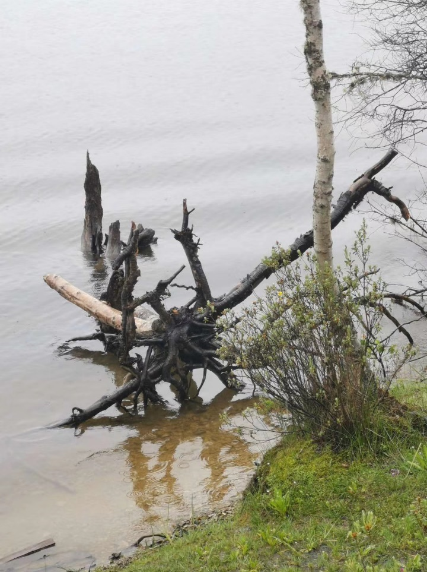The patients in the hospital are safe and sound, the streak continues.

**February 24th, 2020, Monday, Wuhan, Clear**

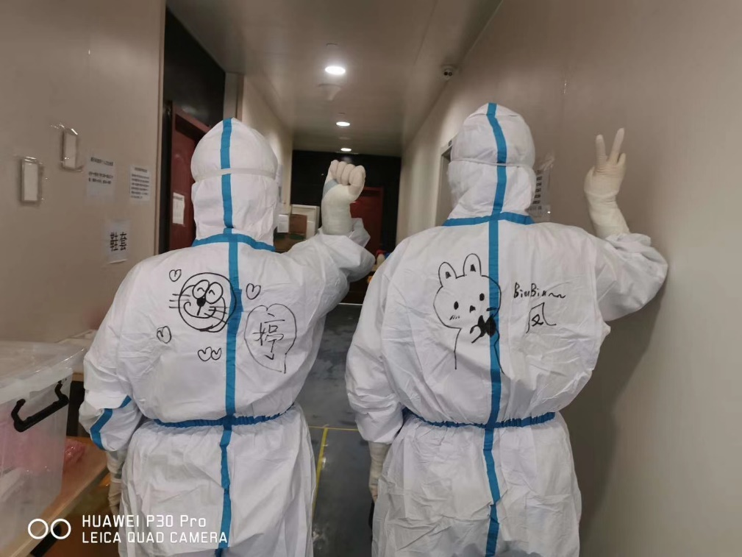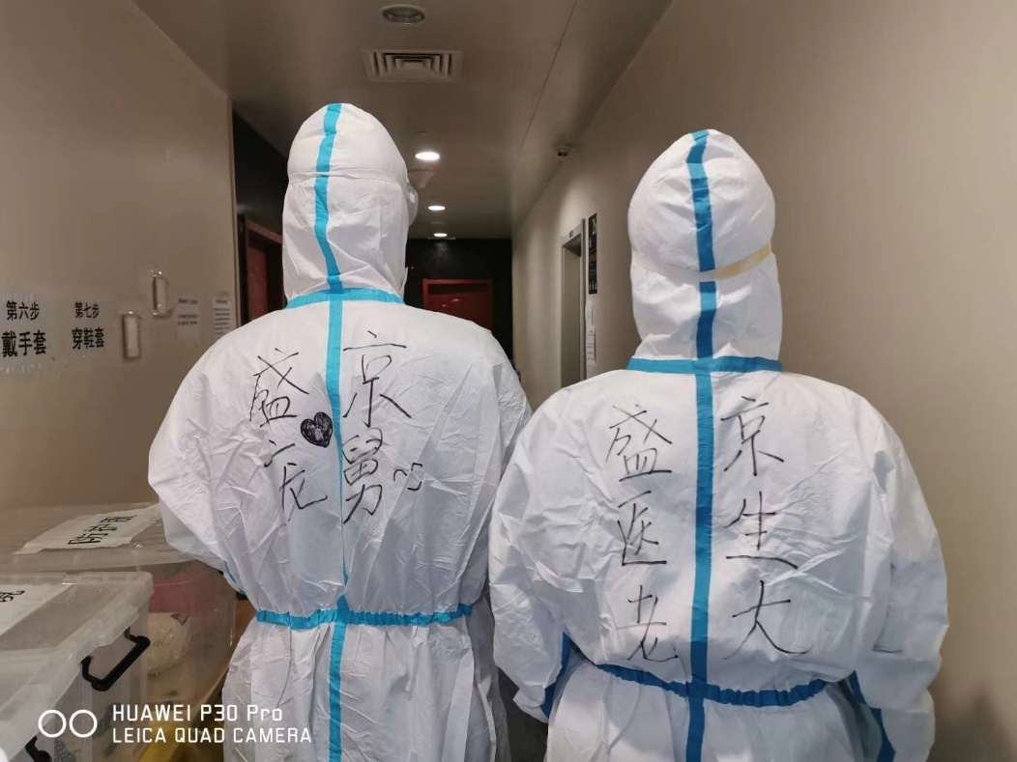The situation in Wuhan is improving steadily, with more people leaving hospital everyday. Due to everyone’s hard work, there is more time to relax. But we remained on high alert with our critical patients. We hope the no death streak continues.

Many people are interested in my hospital’s history, so allow me to share the history of the hospital I work In.

Shengjing Hospital as you may know, the full name is Shengjing Hospital of China Medical University. Let first talk about the China Medical University. Yeah, this is the only hospital firstly to have the nation title. It was built on November 11th, 1931 as a former military hospital founded by Communist Party of China. Then based on the military medical professions, she developed pharmaceutical and nursing professions in the next year, and rename as China Healthcare School of China Worker and Farmer’s Red Army. In 1934, the school started the Long March leaded by the army. Two years later, she arrived at Northern Shanxi. In 1940, she changed her name to the current one: China Medical University. During the civil war, the university transferred to the Northeastern China. After the liberation, she combined the former Shenyang Medical School and Municipal Liaoning Medical University, and encountered several recombinations and renames.

Isn’t it glorious?

Let’s now talk about Shengjing hospital, in the spring of 1883, a man Dugald Christie (1855-1936) from Scotland founded Shengjing Hospital near a river in Shenyang. With the curiosity of Chinese people, Dr Christie accomplished the first cataract surgery in Northeast China. Then after enrolling medical students, it came to a medical school. The most important date for the hospital was the winter of 1910. Plague spreads across the north east region, then a brave doctor named Jackson sacrificed his life. After the epidemic, Shengjing hospital’s area was the area with the fewest deaths. So it is a tradition that our hospital will fight viruses. Mukden Medical College was established in 1912. I hereby quote several professional celebrities cultivated by the college, such as Professor Liu Tonglun, who is the founder of tuberculosis therapeutics of China, and Dr. Gao Wenhan, the pioneer of Ophthalmology, and Dr. Bai Xiqing, the first chairman of Chinese Medical Commission, and Wu Yingkai who is an academician of Chinese Academy of Medical Science in thoracic surgery, and Professor Chen Shuzhen, the first female surgeon in China. Mukden Medical College was combined in China Medical University in 1949.

Isn’t it ancient?

No matter if we were fighting plague a hundred years ago, or fighting COVID-19 today, Shengjing was always in the front to take home the victory.

Just like all the White Coat Warriors.

**December 25th, 2020, Tuesday, Wuhan, Clear**

*Because I love your love, because I dream your dream, so I felt your sorrow, felt your happiness.*

*Because I traveled your road, because I experienced your hardship, so I’ll experanc your joy, and I'll follow your dream.*

Recently, I can’t help humming the song of Su Rui, *Holding Hands*, not only because depressed of the unfortunate of Wuhan, but also inspired by the energetic of my teammates.

According to my current understanding, holding hands maybe means joining hands with spirits.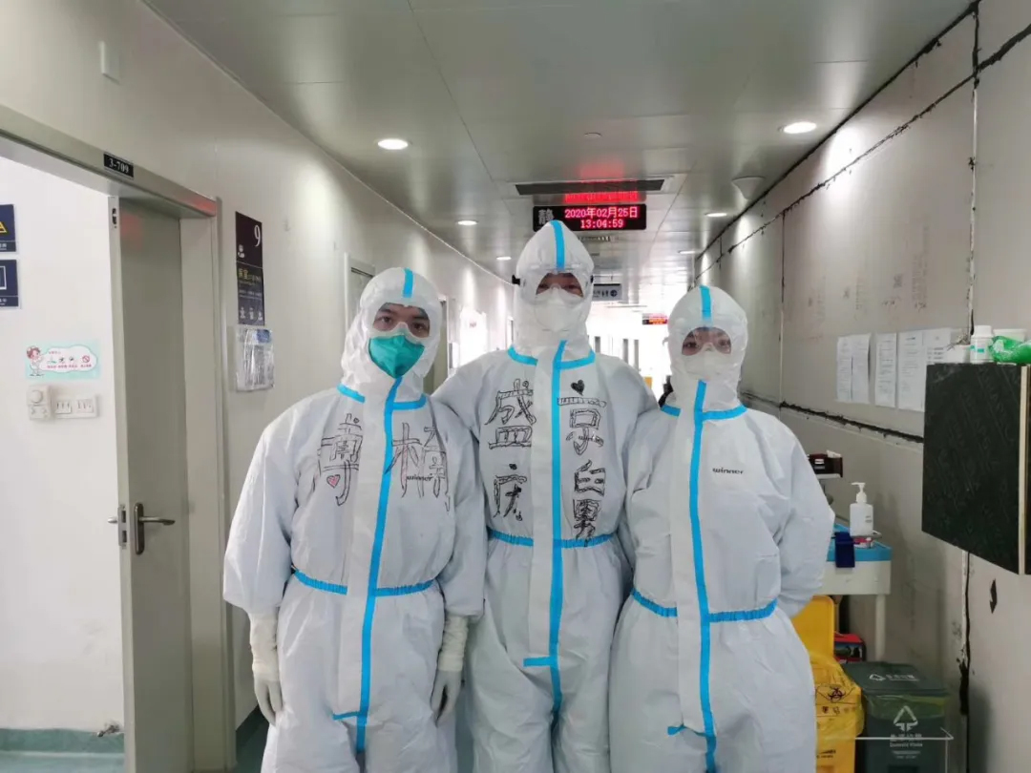

After the situation in Wuhan became public, everyone around the country started to work feverishly. The selfless doctors all arrived to save the patients. The different communities worked day till night to contain the outbreak. The police and everyday citizens all volunteered to help the sick. Companies decided to share their goods. While the media spreads positive messages for all to see. The entity of China, from the West to the East, from the North to the South, all work to drive the virus away.

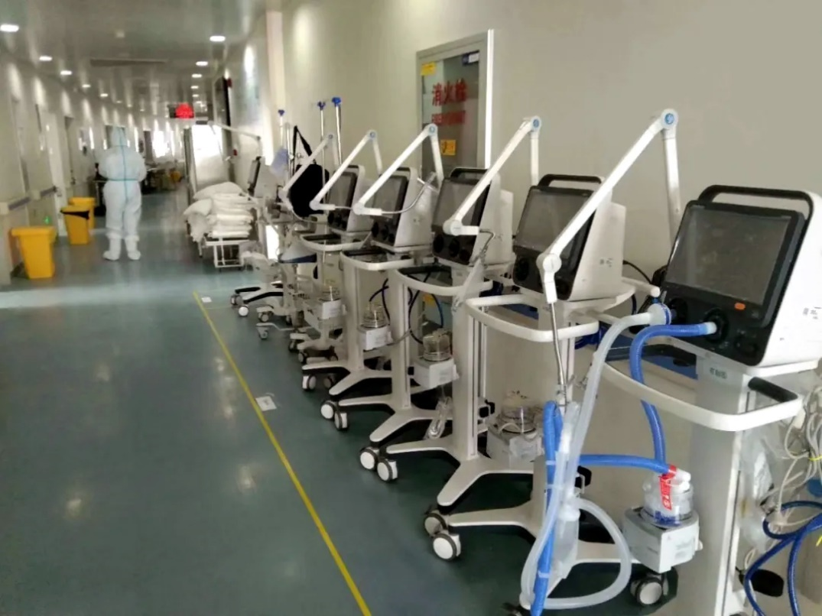

We work to relieve Wuhan’s pain, for the hopes and dreams of Wuhan’s future, for the happiness of Wuhan’s tomorrow.

We only have 26 patients remaining in our ward. The idle ventilators are lining up along the hallway. The eleventh day of zero death continues. The warm weather in Wuhan caused many doctors to sweat, but this did not slow them to help the patients with Rejuvenating Aerobics. After returning to the hospital, many jokingly wanted to go to a spa. And many others want to eat the signature food of Northeast of China, this surprise was delivered to us. Ms. Qiyue, a lady from department of infectious disease control, had ordered tons of vegetables of Northeast, which will have shipments tomorrow. So many people wanting to help us, and each with their own jobs and duty.

Together, we can move (remove) mountains.

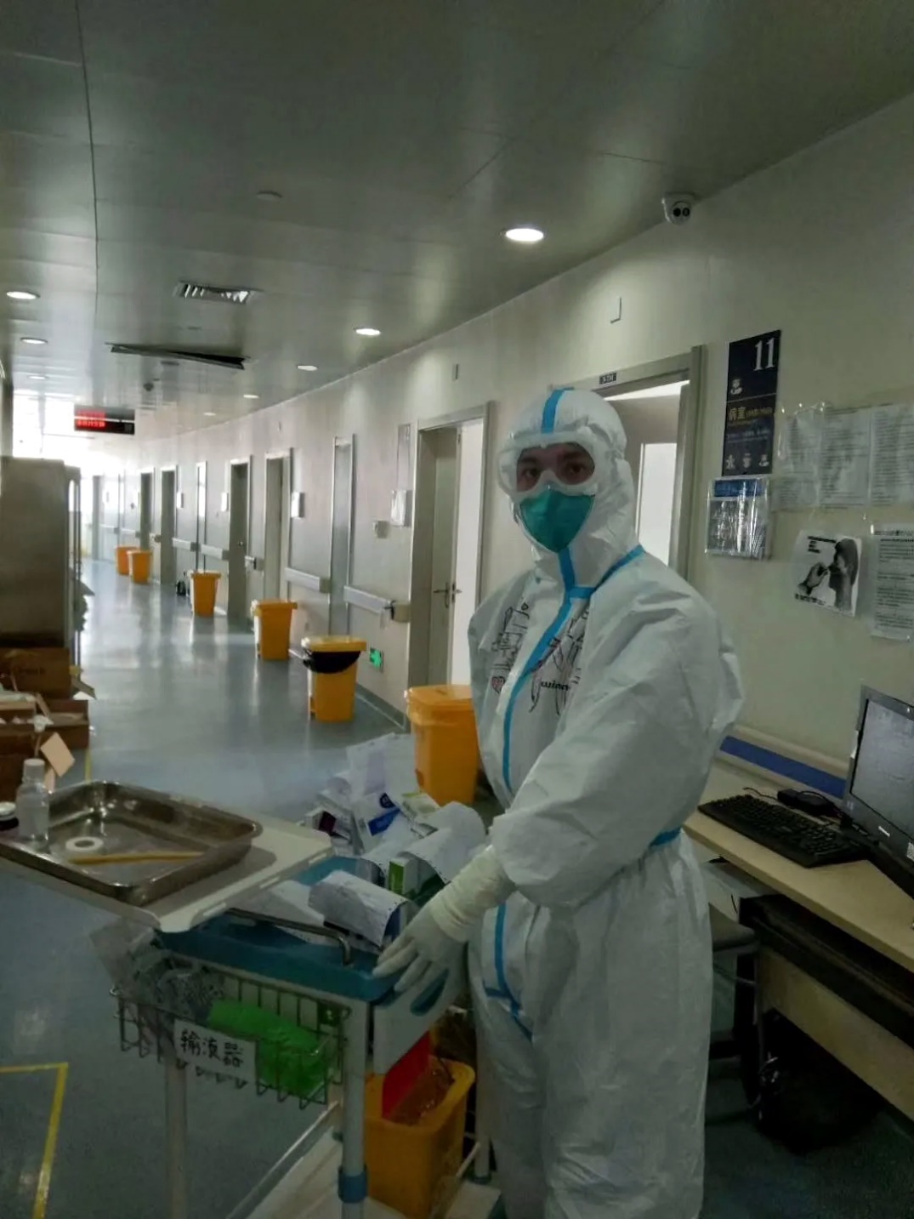

**December 26th, 2020, Wednesday, Wuhan, Cloudy**

Besides the hustle doctors of Wuhan, the city appears to be peaceful.

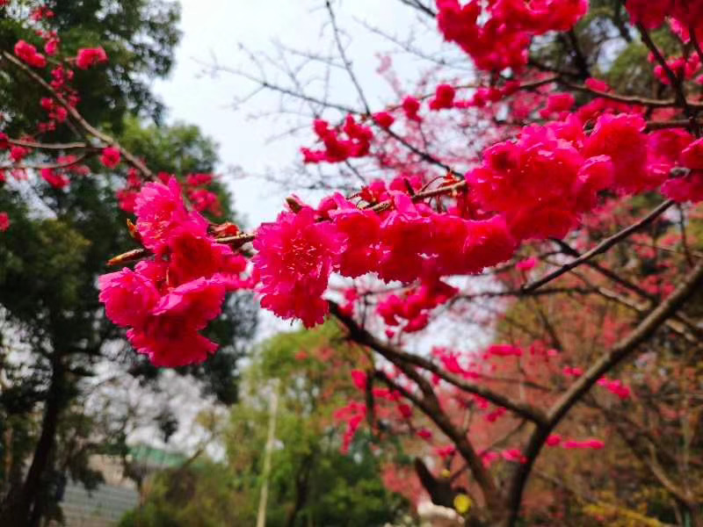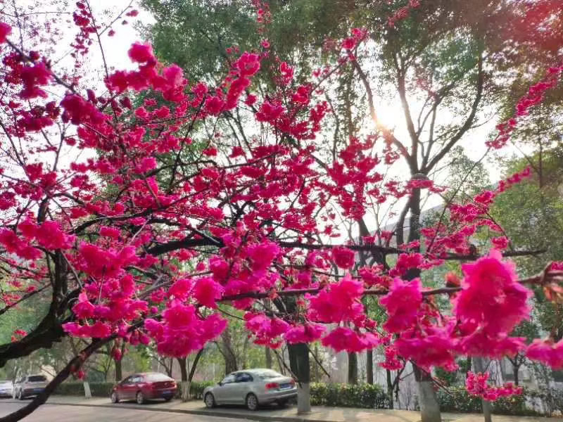The Spring of 2020 tells the story of reunion and departure. In life, although life is filled with lies and betrayal. People always remember love and kindness.

The story below tells a patient who's waiting for the result of his COVID-19 test.

Before the Spring holidays (Chinese New Year, Spring Festival), he originally planned to take his family to visit relatives. Before departing, the father of a colleague became sick. When he saw the message, he took the next train back to Wuhan leaving his wife and kid to go visit relatives themselves. Of course, his wife was very angry with him for leaving the holiday break early. During that night, the city of Wuhan was sealed. The man wanted to leave the city, but he realized he must follow the rules, so he abandoned the plan. Unfortunately, three days later he became very sick, with fever, cough.  When he visited the doctors, it took him hours of waiting for a checkup. Another three-day passed, he started to have trouble breathing and was sent to the hospital. His wife doesn’t know he is in hospital, he didn’t want to worry her. When she called him, he made lies to comfort her.

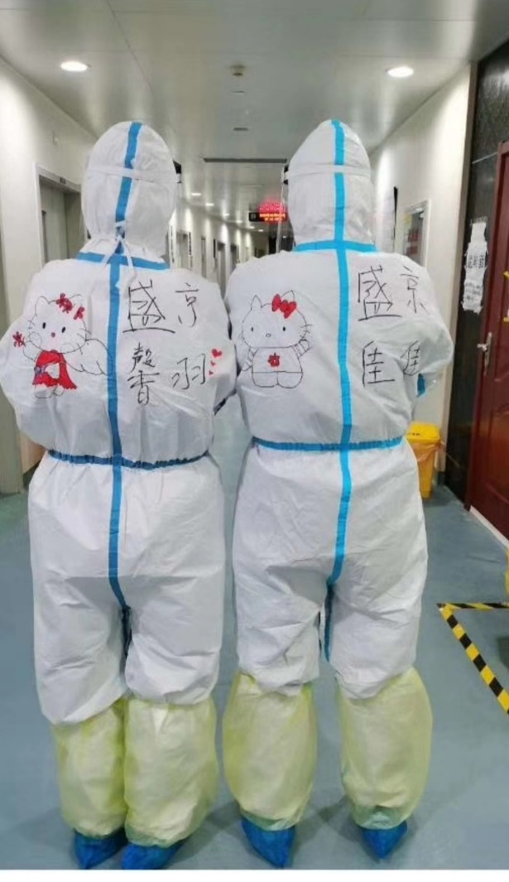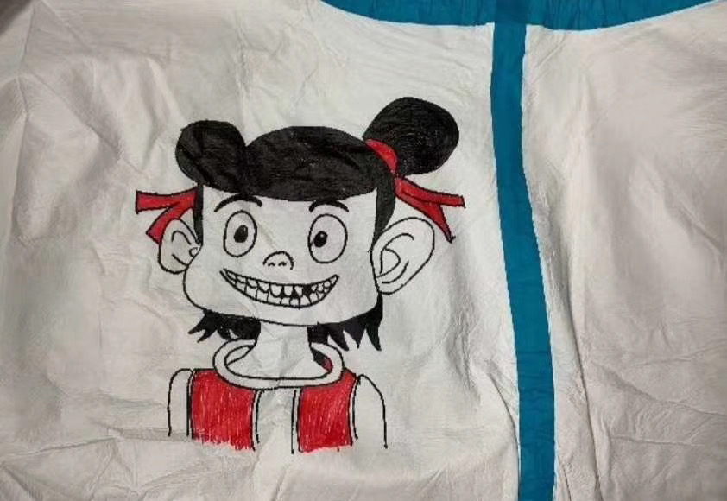

Love can be many things at once, kindness, lies, misunderstanding, helpless.

The role of a doctor requires the skill of lying. When you encounter a patient whose life is nearing its end, you will always say: “You will get better soon.” If those lies give them hope and comfort, then the lies must continue. Truth and lies are sometimes intertwined, if the intention is good, then lie you shall.

Recently, kind lies can be seen everywhere. When a young daughter asks his dad where her mother (who is a doctor) was. The dad replied: “she’s working a very very long shift.” while the daughter was pleased by the simple answer, the father’s eyes were filled with tears.

Lies can be a way of loving. Behind every lie, there are loneliness and sadness.

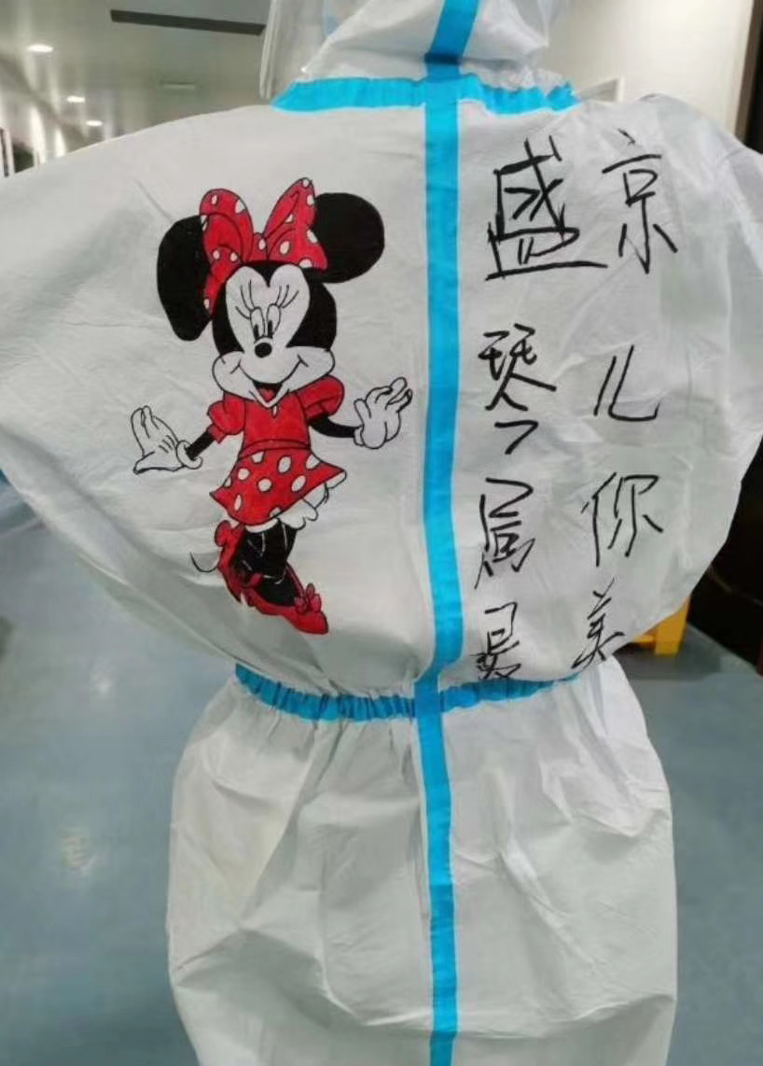

**February 27th, 2020, Thursday, Wuhan, Rain**

Yesterday night I received an emergency call from Bonan, a nurse. Startled, is something wrong with a patient? After talking, it was something else emotional.

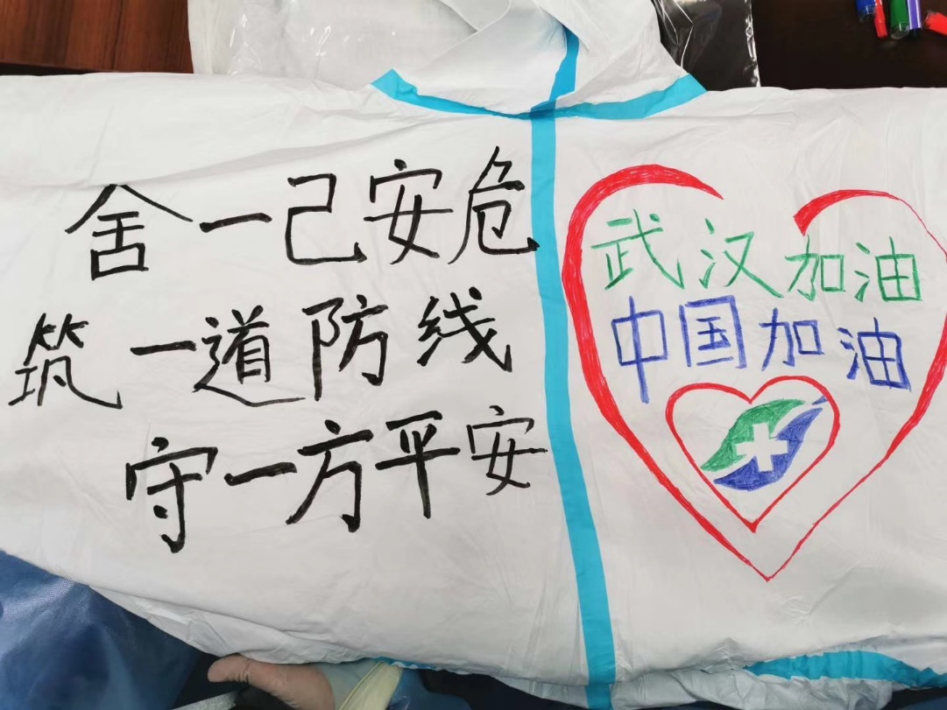A seventy years old patient, who is relying on nasal feeding to support life, were feeling severely dyspnea when we took over the ward. I was discovered besides from being infected from coronavirus, she also had heart problems. After treatment, she luckily recovered, and is now waiting to leave the hospital. Before leaving, worrying about her health she continued to chat with doctors.

Bonan:  It's my day off today, aunt, how are you feeling?

Bonan: Tomorrow I can deliver you some breakfast.

Patient: Okay, today the doctors told me my test was negative, and CT is also good. I'm glad, please be happy, because you did a great job.

Bonan: This is great, if the test is negative again, you can finally leave.

Bonan: When you leave the hospital, I want to escort you out, and let's take a picture for a memento.

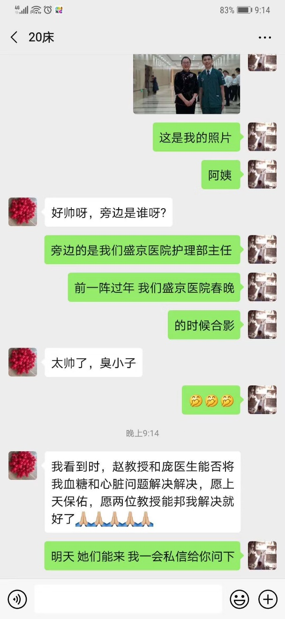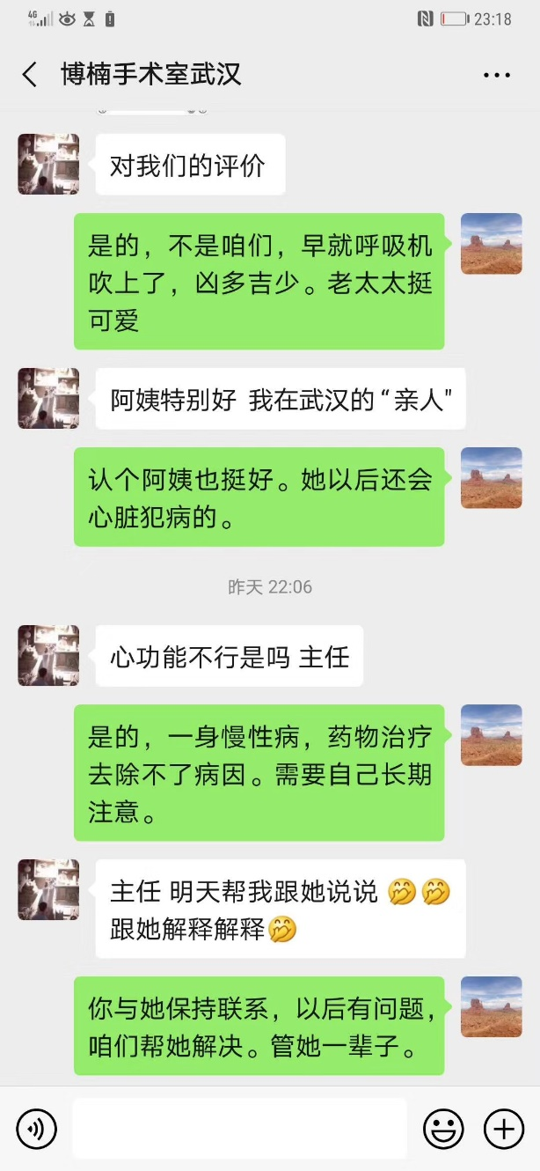Bonan: Also, you must eat well.

Patient: When you see professor Zhao and Doctor Pang, could you please mention my blood glucose and heart problems to them? I hope to god they can solve those problems for me.

Bonan: Okay, they will be back tomorrow, I’ll text you later.

Such caring relation between doctor and patient, it makes me happy.

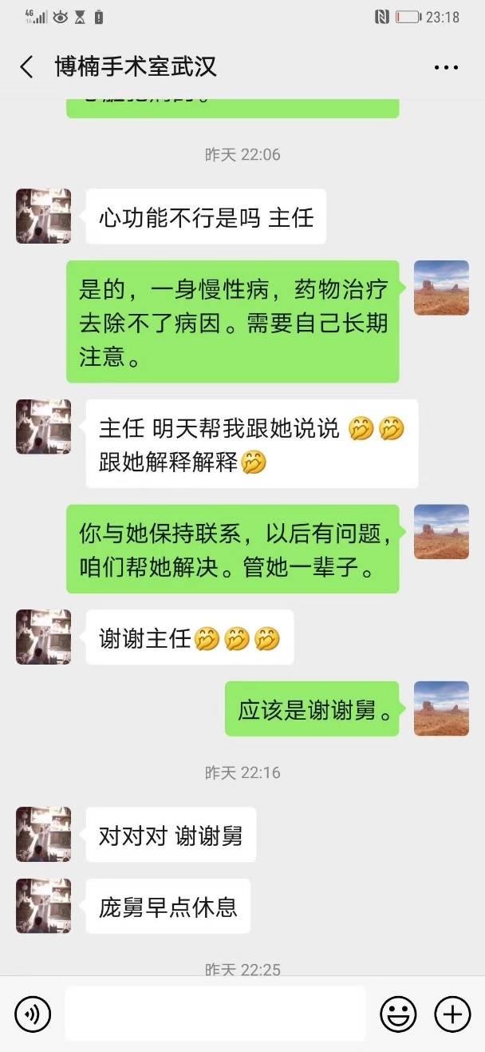

Yesterday 21:54, Messages between Bonan and me

Bonan: Hello Uncle Pang

Bonan: Those are the questions the patient asked.

Me: Tomorrow I’ll talk to her

Bonan: This patient really thinks highly of us.

Me: Indeed, if it was not for us, her condition would've worsened.

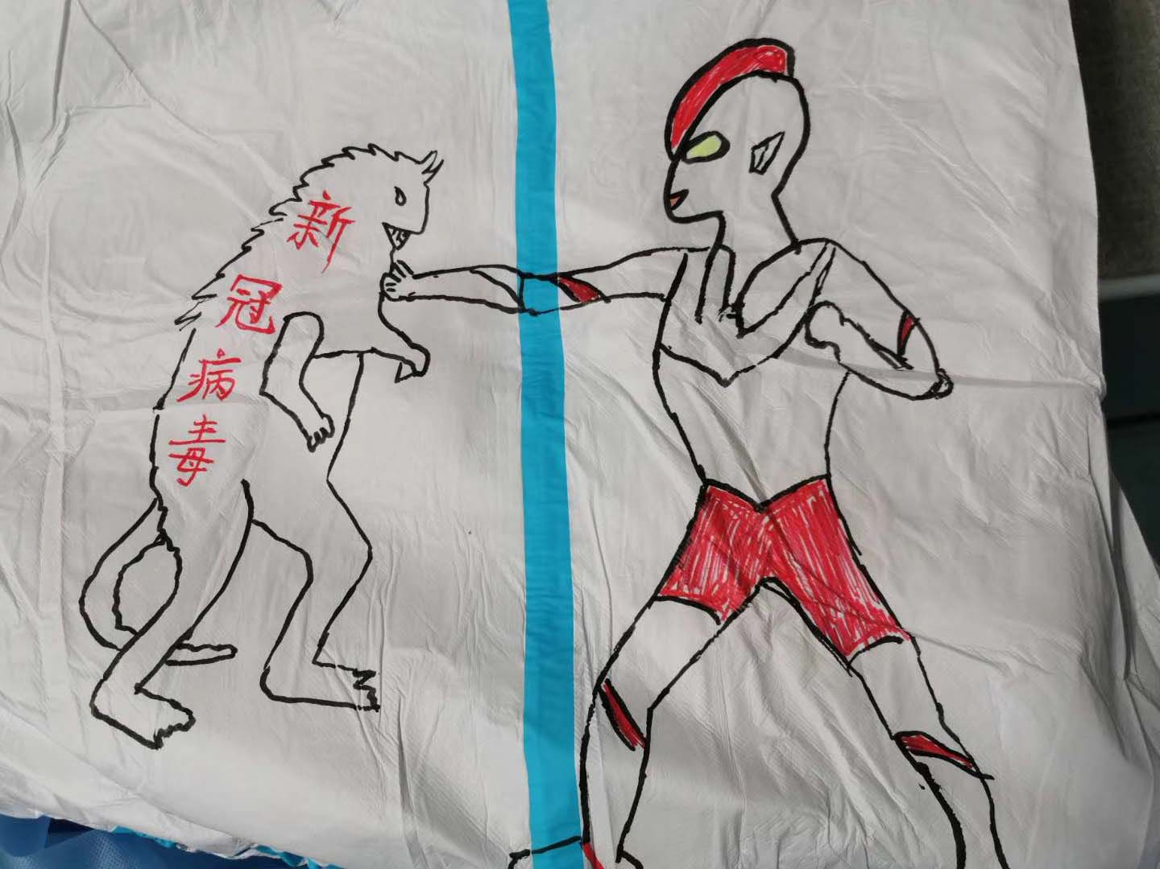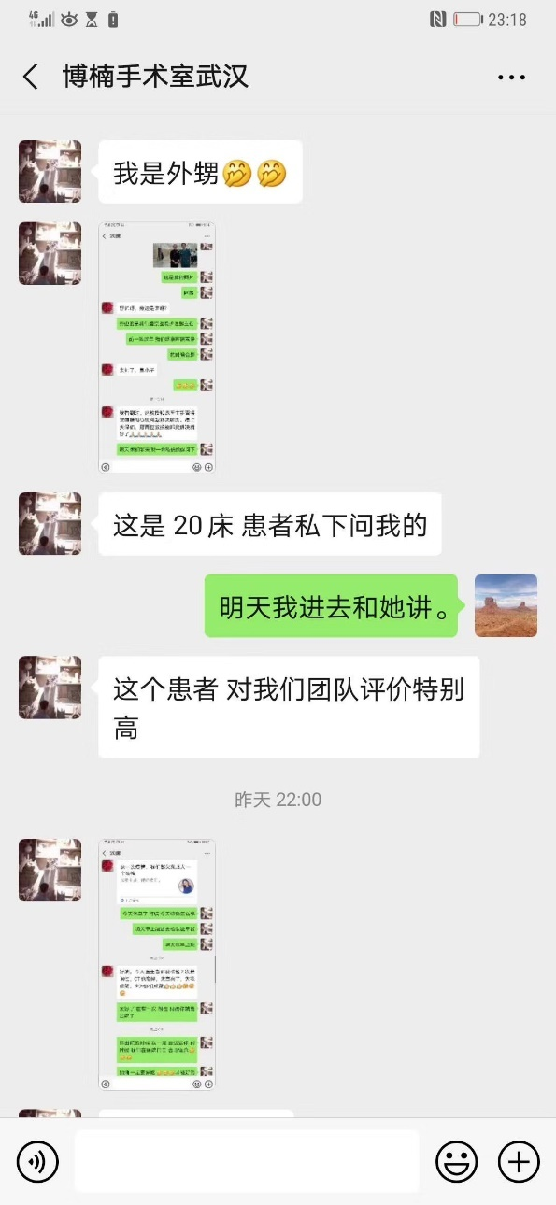Bonan: The old lady is really nice, she's like a relative to me.

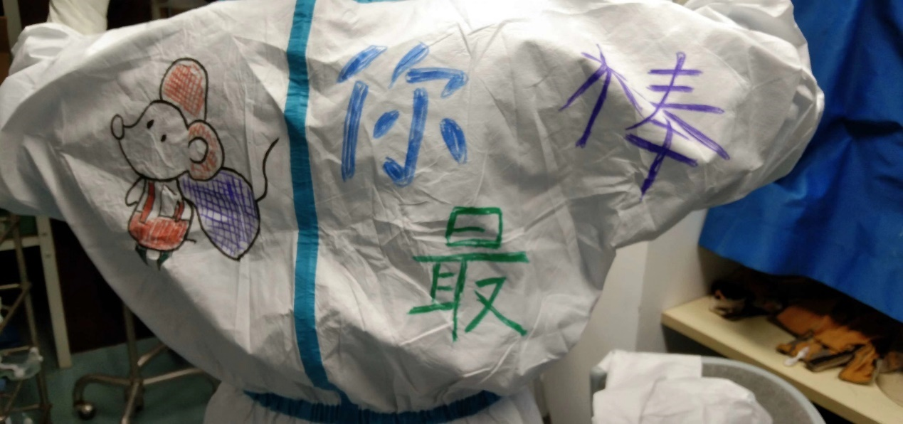Me: This is nice. She might have a heart issue later on.

Bonan: She needs long term treatment and medicine.

Me: You please keep in touch with her, if she has a problem later on, we will help her solve it.

Bonan: Thanks professor.

This is the kind heart of doctors.

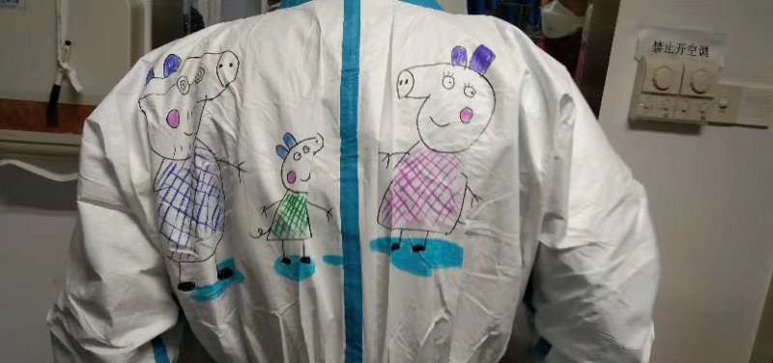Messages between Bonan and the old lady

Bonan: (A picture) this is me. Aunty

Old Lady: So handsome, who's the person next to you?

Bonan: She’s a professor of our hospital

Bonan: It's from a spring break event.

Bonan: Really handsome, young man.

It seems they are already becoming friends.

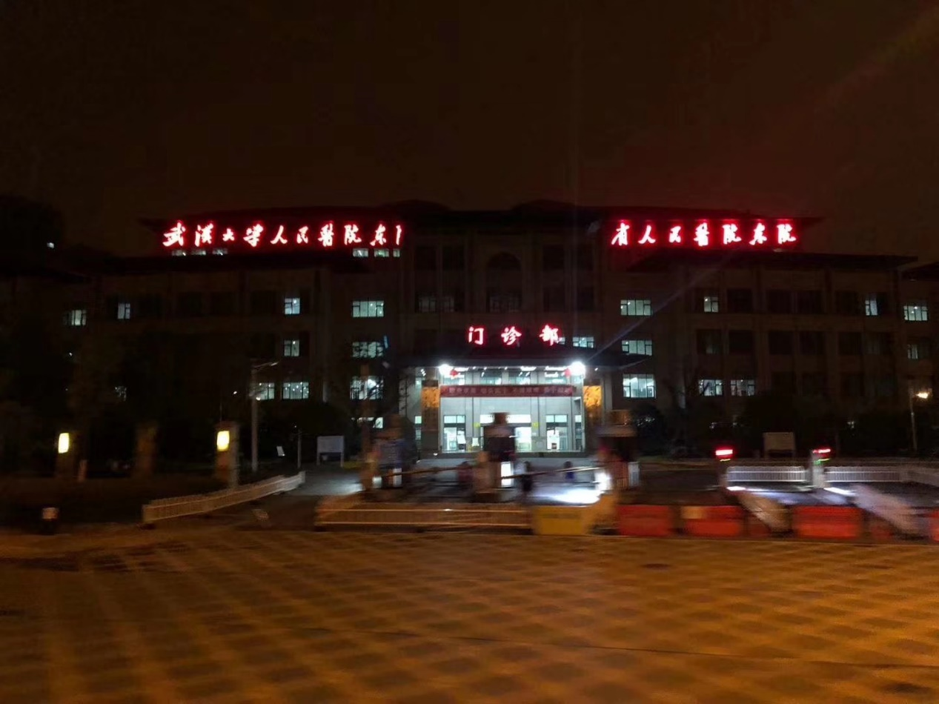Today is a peaceful day in the hospital, still no death. More doctors and nurses from Henan joined us. We decided to give them sensory training, to prevent them from being infected. Today I wore colored protective clothing. It was made in detail by the nurses in our team during their spare time.

21:29 today, a message from a night shift nurse called Jiali

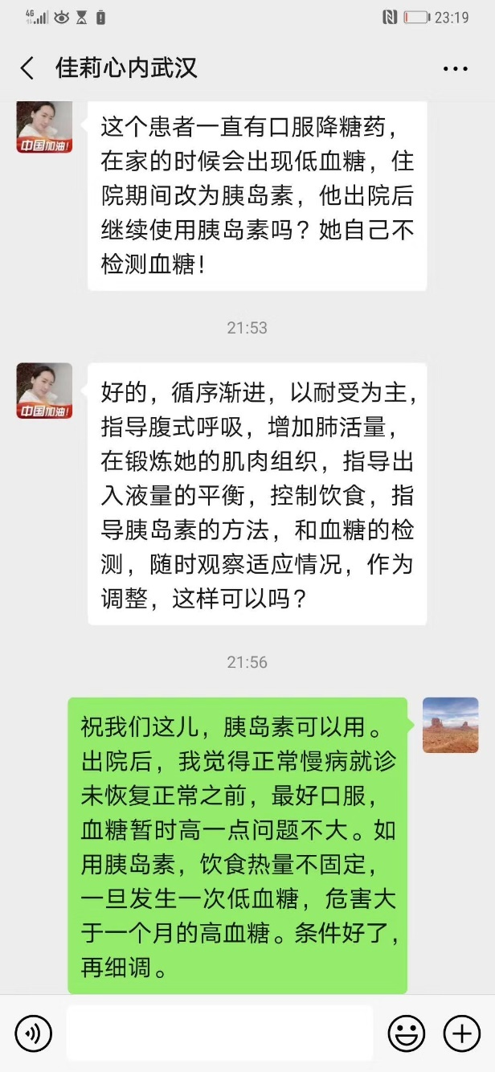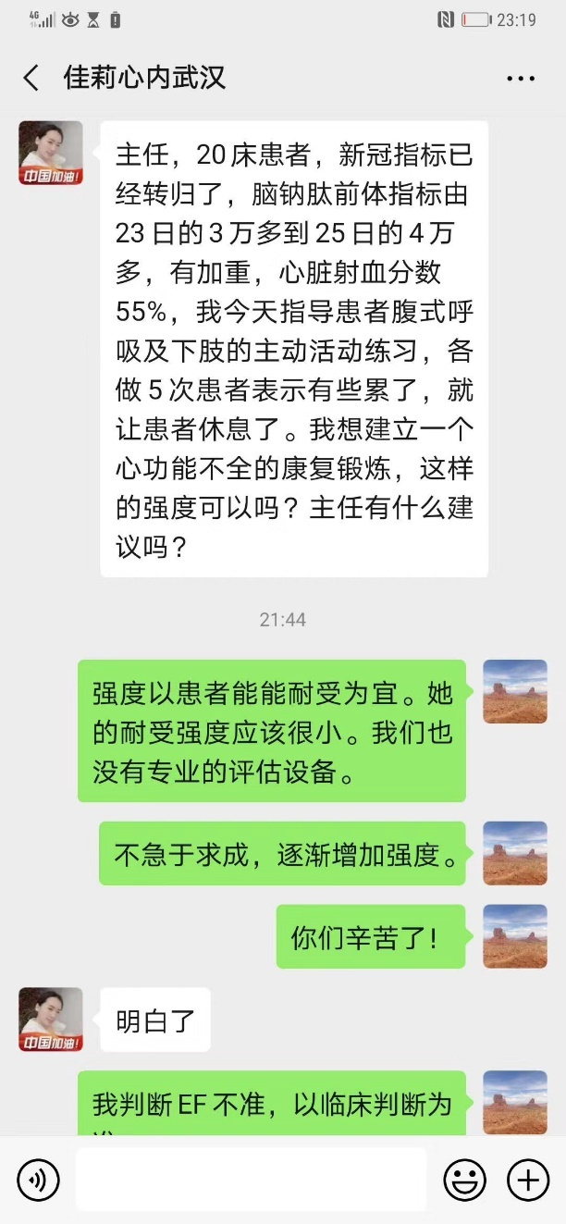Jiali: Professor, she recovered from the virus, but there are still some other problems. Today I helped her with some recovering exercises, I did it in sets of 5. I want to make a personal recovery exercise just for her (The old lady). Do you have any recommendations?

Me: Please be patient, start slow. Thank you for your hard work.

Jiali: Understand

Me: According to my judgment, the ejection fraction was not accurate. We ought to make decisions under the clinical criteria.

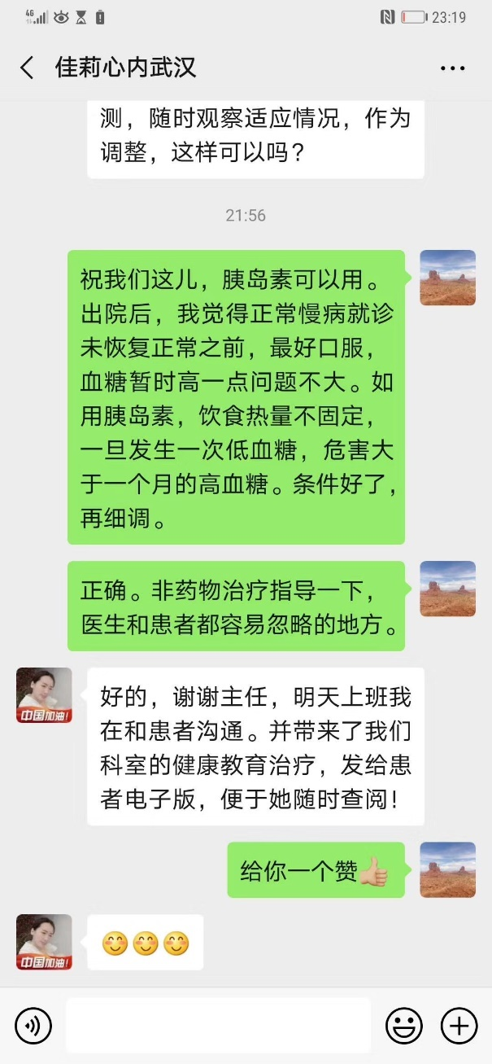

Jiali: This patient has taken hypoglycemic medication these years, and had period of hypoglycemia when at home. We modified the medication to insulin injection during the in-patient time. Shall we advise her to change to insulin after discharge? She had never monitored blood glucose!

Me: During the period we are in charge, insulin injection would be okay. For her discharge period, I prefer to prescribe oral hypoglycemic agents to her before the recovery of chronic disease, so it’s not a big deal for elevation of her blood glucose level. If her energy absorption varies, once a hypoglycemic reaction happens, the harm would be much more than the one-month high level blood glucose status. Condition permitting, I can adjust her blood glucose.

Jiali: Got it. We will adjust it gradually. Tolerant comes the first, and I’ll guide her to perform abdominal breathing to increase the respiratory capacity and practice the muscle tissue. Besides, we’ll also indicate the imbalanced income and outcome liquid, diet control, insulin injection and glucose monitoring. The modulates should be provisional. Are these all right?

Me: Exactly. Non-pharmaceutical instruction should be advised, especially from the aspects physicians and patients can ignore.

Jiali: All right. Thank you, director. I’ll communicate with the patient, and adoption of the healthcare educational therapy will be provided as well. I will also send the electronic documents which will facilitate her to refer!

Me: Thanks a lot!

Jiali: :)

There is no easy success, there is no easy zero death.

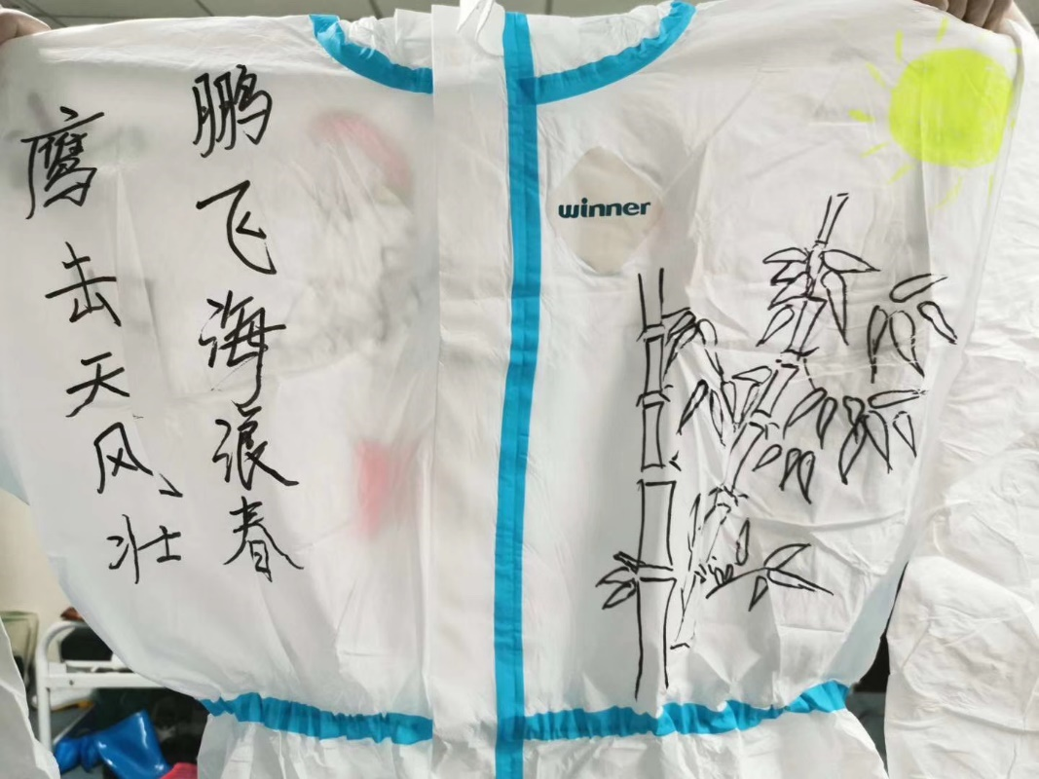Work hard everyone!

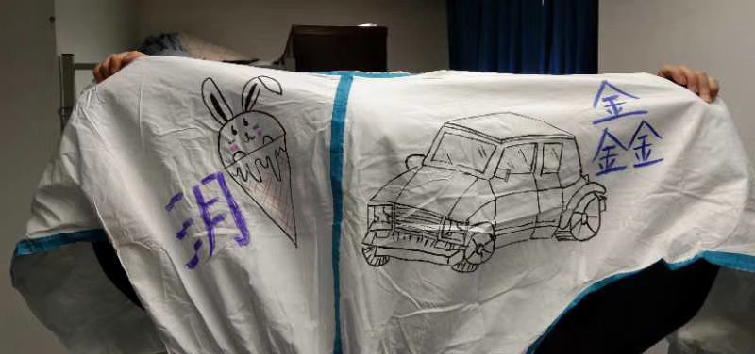

**February 28th, 2020, Friday, Wuhan, Rain**

Today again the hospital appears peaceful, but my heart continues to bother me. We continued the zero death goal for 14 days now. We originally created it to motivate the team, it is a hard goal to achieve. It requires unyielding dedication from everyone.

Yesterday hit me like a false alarm. I always check my phone in the morning to see if anything is happening. And a nurse from the contamination zone texted: “The belongings from a deceased patient were put into the hallway.” When I saw the text, I immediately asked: “Which patient died?” and the reply was: “it was from a very very long time ago, we found it during cleaning.” This calmed me down. This shockingness also hit another doctor during his break time. He too thought someone recently died.

Even with 30 years of medical experience, and every time it still shocks me to hear that a patient unexpectedly died.

The peaceful day was broken by the night. A patient who was transformed here, before I was able to finish reading the patient’s profile, I'm already light headed. 85 years old, besides contracting coronavirus, cardiac insufficiency, renal insufficiency, hypertension, diabetes, old myocardial infarction, severe anemia, acid-base imbalance, electrolyte disturbance, DIC status. Me and professor Zhao texted “We will get there ASAP”. We gave some guidance to doctors at the hospital, we arrived as fast as the patient herself. This 85-year-old woman appears to be in a state of unconsciousness, only murmuring the same sentence over and over: “I joined the army when I was 13”.  The eight doctors worked tirelessly. When professor Zhao Li attempted to Auscultate the patient, when Zhao Li’s ear was close to the patient, her mask was touched by the patient’s unexpected twitches. Worrying for her safety, we convinced her to leave the quarantine zone.

In order to further understand the situation, I called the retirement home she lived in. From there I asked for the numbers of her relative, but when I called, they didn’t pick up. The only way to understand her condition now is to take a long test. We need important information before treatment. When the test result was received, everyone was dismayed. Every organ was damaged, and the hemoglobin was only 40g/L. Although dismayed, everyone is still determined to have the patient. The success rate is low, but everyone is not deterred. The team all have the same question on their minds: Is It possible to save her?

When I left the hospital, the wind was carrying the gentle rain, leaving me with a chill.

Please let us save her.

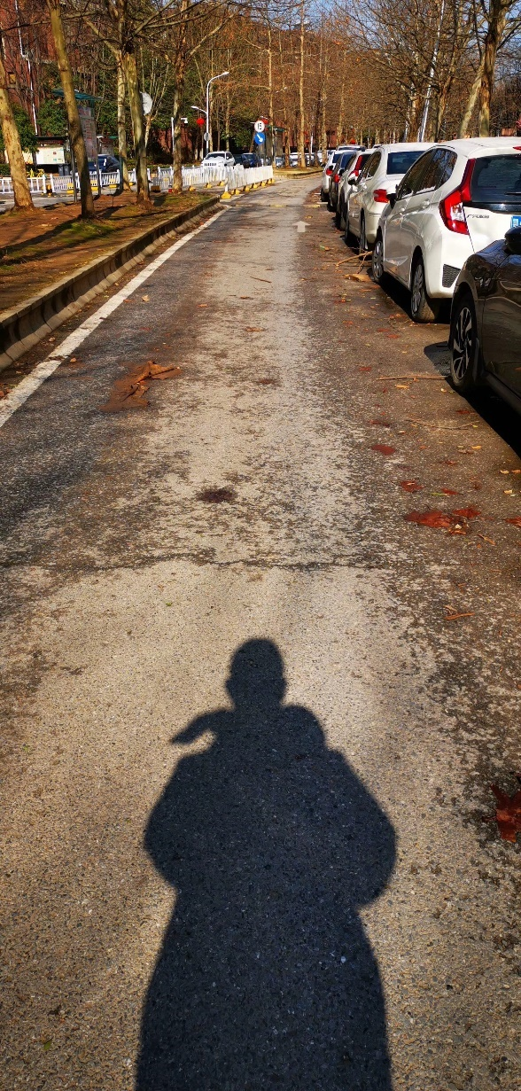

**February 29th, 2020, Saturday, Wuhan, Clear**

Yesterday’s night was a long night, the implementation of nasal feeding, incubation, cardiopulmonary resuscitation, the 85-year-old grandma was able to escape death for now. Many doctors and nurses had to work overtime due to the lady needing special treatments. Many nurses and doctors are assigned to look after her, focusing on her every movement and condition. We were busy performing the sputum suction continuously, adjustments of 5 medication accurate infusion, and ventilator. When I was eating dinner, I saw Mr Liang, department director of Liaoning Commission of Health, he also cares for the lady’s condition, he encourages us to bring her back from death’s hand. This is duty and pride. The team’s hard work was seen by the no death streak of 15 days.

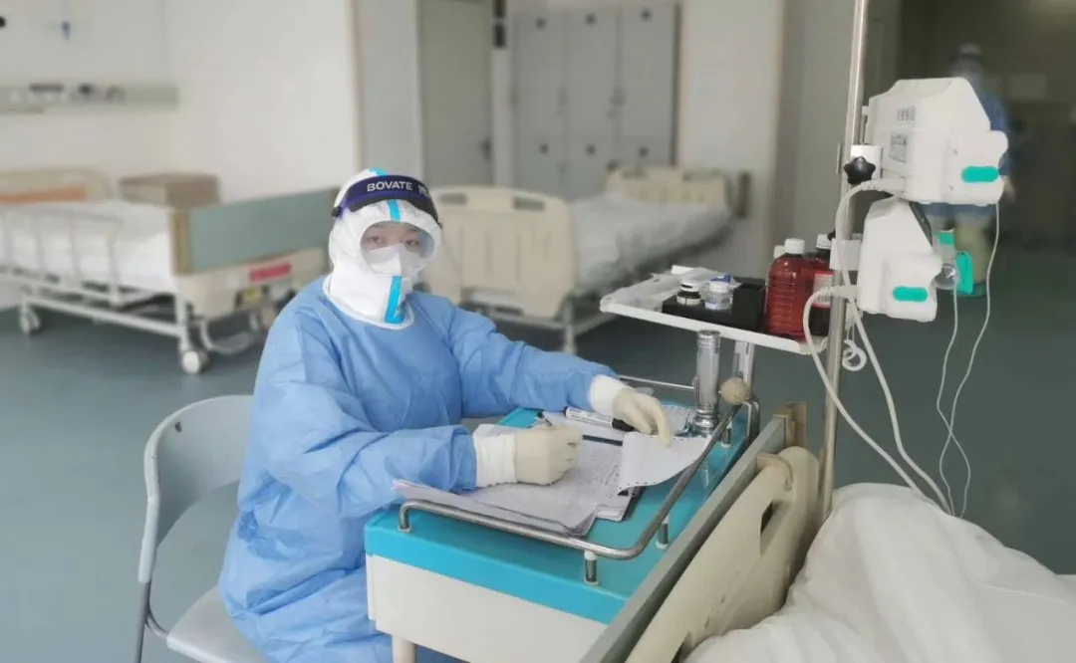Two days ago, a doctor from another hospital was discovered with a fever. Yesterday, the news reported that another doctor from Jiangxi collapsed when he was removing the protective gears. He was discovered 5 minutes later without a pulse. This unfortunate news increased the pressure of our team, and this news caused our team to act more seriously than usual. During the night, many team members requested sleeping pills, especially the nurses. They appeared happy in front of the patients but it is a very stressful job.

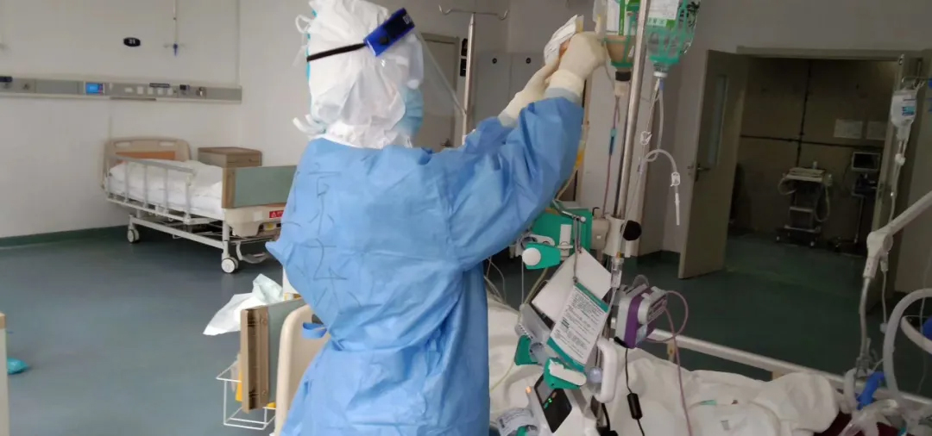The nursing team, they experience more stress and more burden than they normally do, they take more responsibility than ever before. They are all in their 30s, they should've stayed at home caring for their kids. But when the virus came, they left their family, went to the frontline without hesitation, this is determination.

In the quarantine zone, the busiest people are the nurses. Their business can be identified by their footsteps, intramuscular injection and iv drop, our most basic understanding of them. But they are more than that. They can do nearly everything, at any time. They change the bedsheets for the patients, and we can see their figures as ladies everywhere, such as sputum suction after tracheostomy, gastric and urinary tube assistance, pharyngeal swap collecting, blood drawing, feeding water and food, picking feces and urine. They carry oxygen tanks, clean the restroom, and work as an electrician. If you ask them: “Are you tired?” the reply will always be the same: “Not tired.”

They pushed themselves to the limit, but they continue to work hard. They go through stress physically and mentally. If you say, they are lanterns, I’ll say they are the brightest night star.

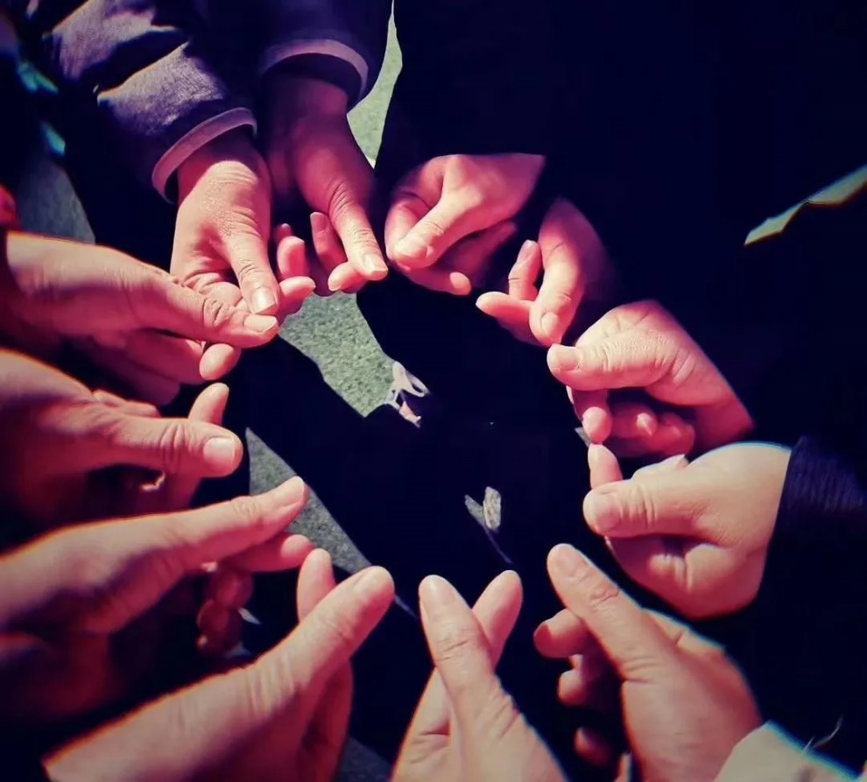

**March 1st, 2020, Sunday, Wuhan, Clear**

When I got up in the morning, I immediately opened the public chat to for news. To look at the hundreds of messages about the various patients. I saw the messages talking about the 85 years old grandma, she is doing okay. Although the night was a struggle, the team managed to solve the problems. She is starting to recover, and she is now relatively stable. Due to everyone’s hard work, we continued the streak to 16 days. I left the hotel after breakfast, to take a stroll outside. I was greeted by the warm sun of March, so warm is like the beginning of summer. We all need lights like these, to chase away the darkness of the streets, to relieve everyone’s worries, and to comfort the young doctors working far from home.

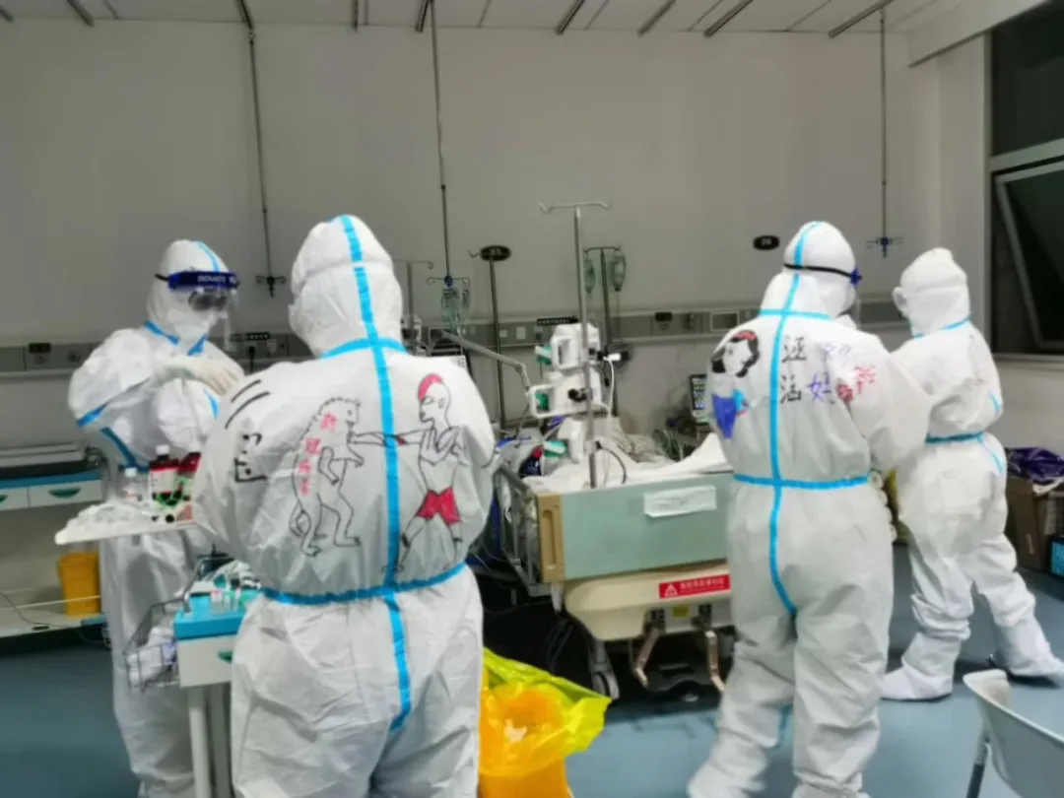I was interviewed by a news channel about the goal of zero death, they asked why it was created. I answered that the goal was set because it shows my confidence in my team. Originally it was set secretly by myself, as a way to motivate myself. I never expected other nurses and doctors to also have this goal in their minds. So everyone quickly agreed on this goal. Achieving no death in a hospital is the ultimate goal of any doctor, this is the goal for any doctor and their entire life, but this is very hard to achieve in reality. And In this special place, we want to try our hardest to stop any patient from dying to the virus. Then, they asked if there was any pressure on the team due to their high goal. I answered, of course there is stress. You have to back everything you say up. But we never anticipated it to bring more stress to the team, we wanted to motivate the team. Since now there is stress involved, we want to turn the stress into more action.

Let's work hard together.

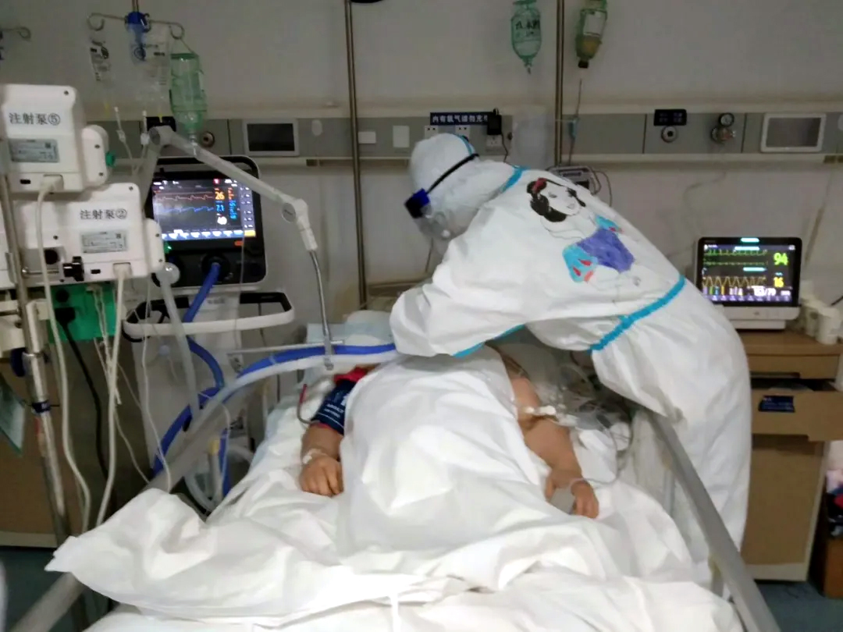

**March 2nd, 2020, Monday Wuhan, Clear**

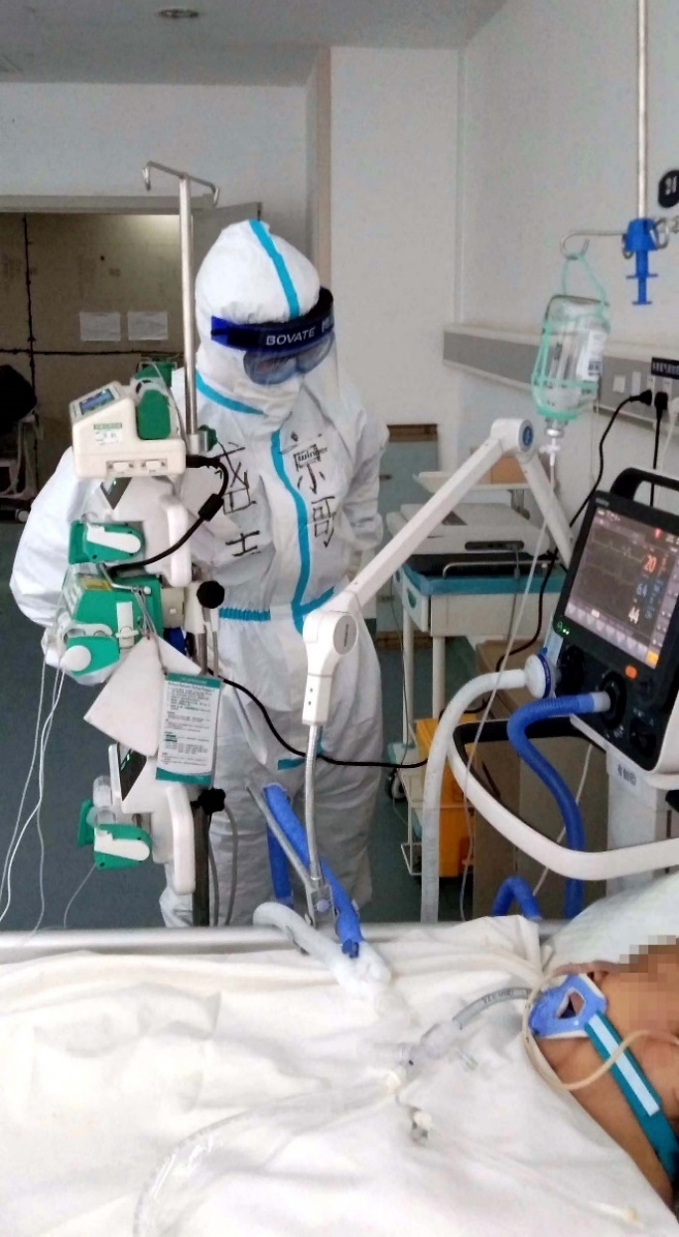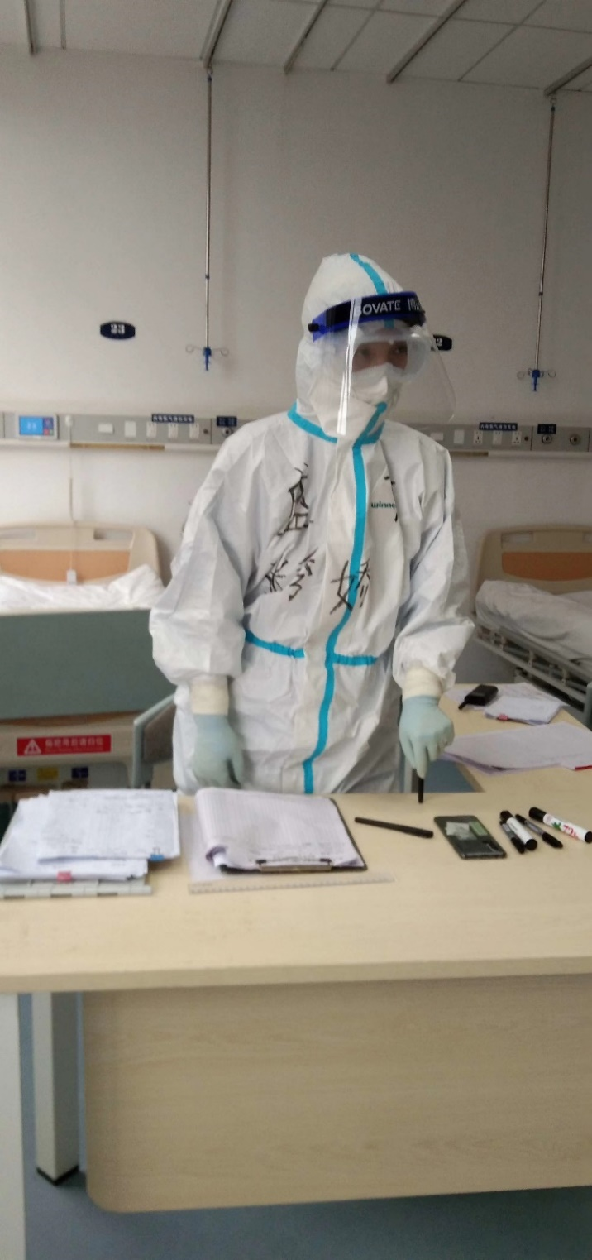We decided the Shengjing sector of the people’s hospital of Wuhan should be renamed to accompany the new doctors coming in from different hospitals, so we name it People’s hospital of Wuhan, Section 4. The number four, in Chinese culture means death, even though the number is unlucky, we still decided to name the ward that. The good news is we continued the no death streak for 17 days now. Two patients left the hospital. The 85 years old grandma is going through ventilator respirating treatment. Her cardiac function and renal function are relative stable. However, the sign of white-out lungs and abnormities of blood ingredients were notifying out teammates the fight with death is still very intense. The bad news is, a stressed patient from another hospital decided to tear the protective gear of a doctor and proceed to jump off the building.  His attempt was unsuccessful, it was discovered, this patient was previously suicidal, he was unsatisfied with the holiday.  In order to prevent this from happening again, the team discussed many different ways to solve this problem.

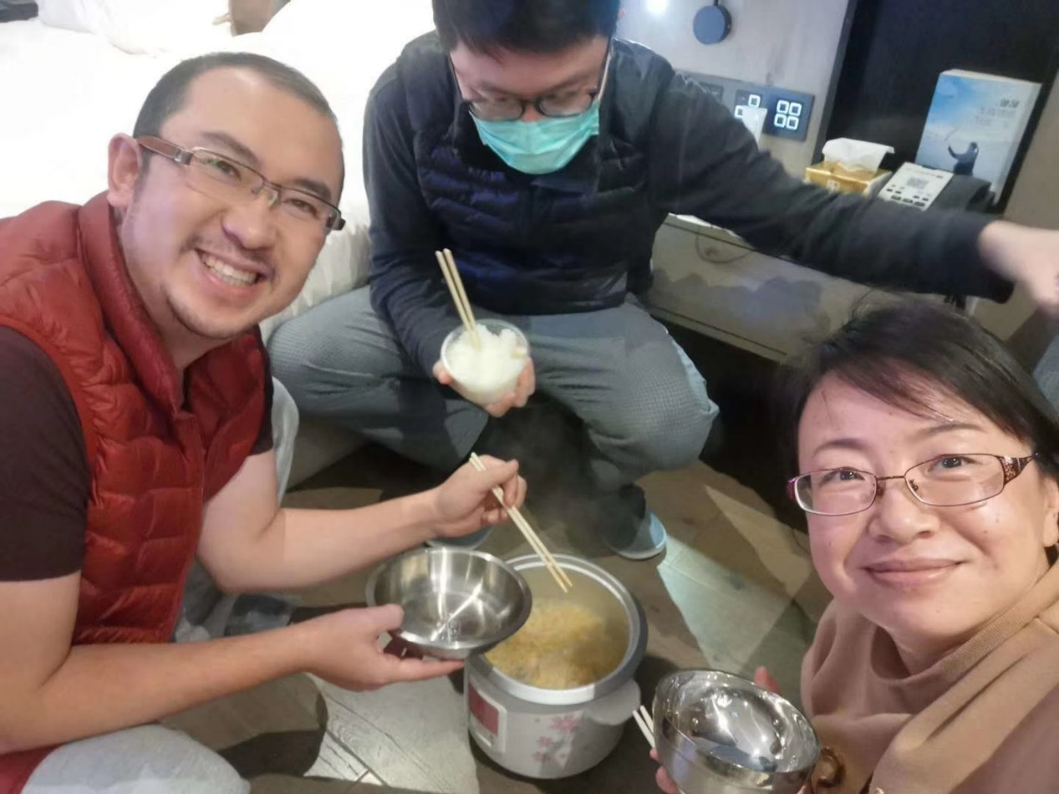Harsh times, for the patients, and for the doctors.

The Spring of 2020, every profession is having a hard time. I saw a message late at night, three reporters stationed in Wuhan, were able to eat their home food, it was a picture of them with a smile. Looking for food, they also need to interview doctors. Because of their lack of knowledge on the medical fields, the pressure on them is immense. I talked to one of the reporters, she said she is not nervous, but she misses her family back home, her friends and her pet cat that is being taken care of by her neighbor.

Although everyone is struggling, this only fueled us to work harder than before. It's evident by the rapid decrease of patients and suspected patients.

So everyone, hang in there, it will be over soon.

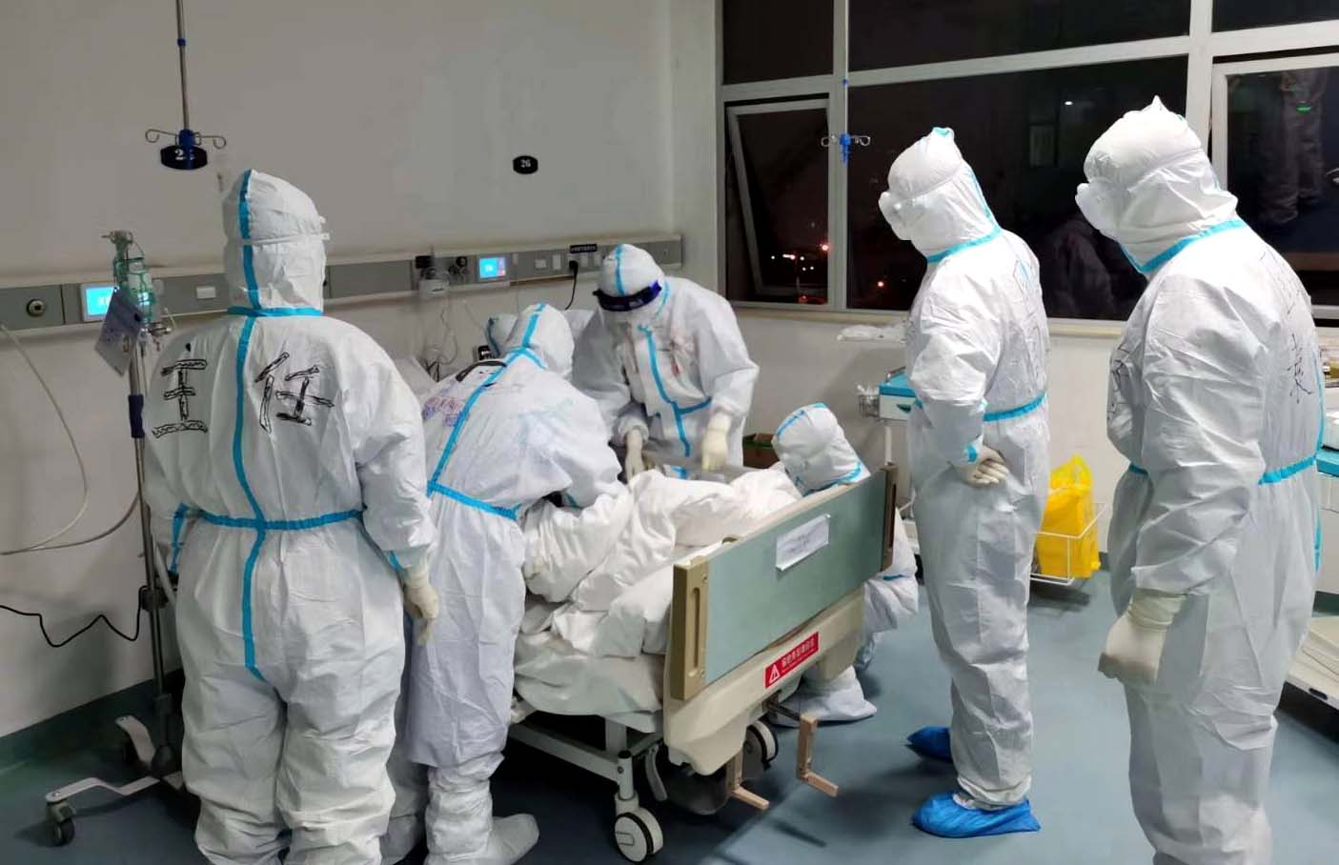Many years later, you will feel like this was only a brief memory.

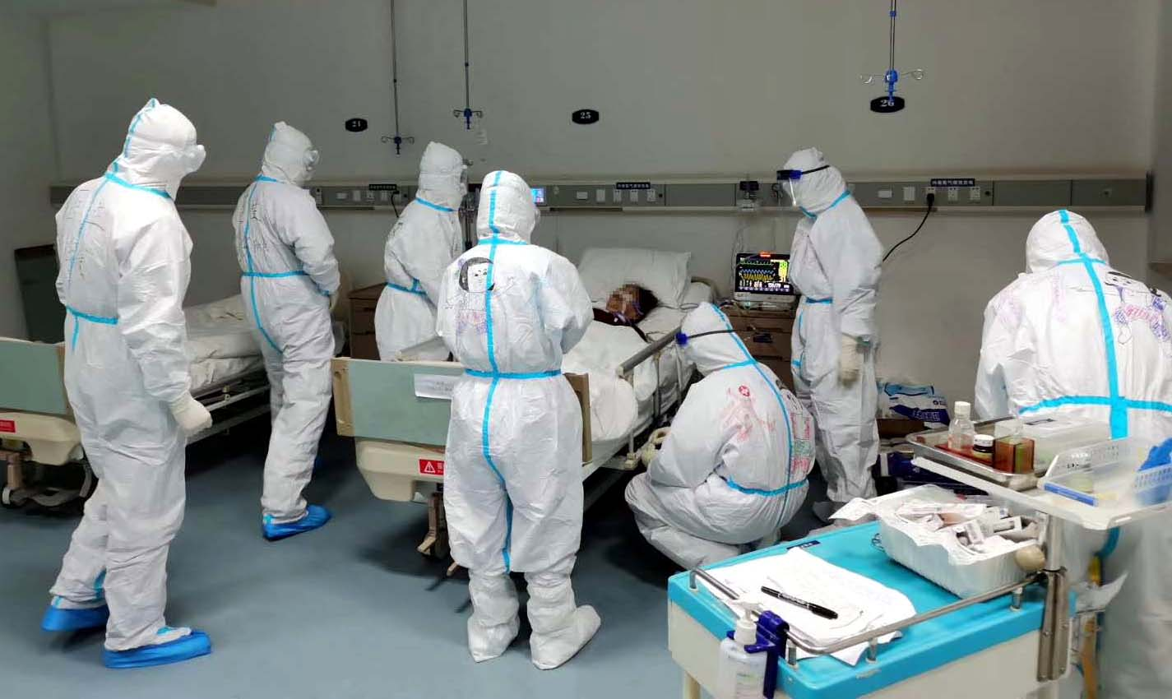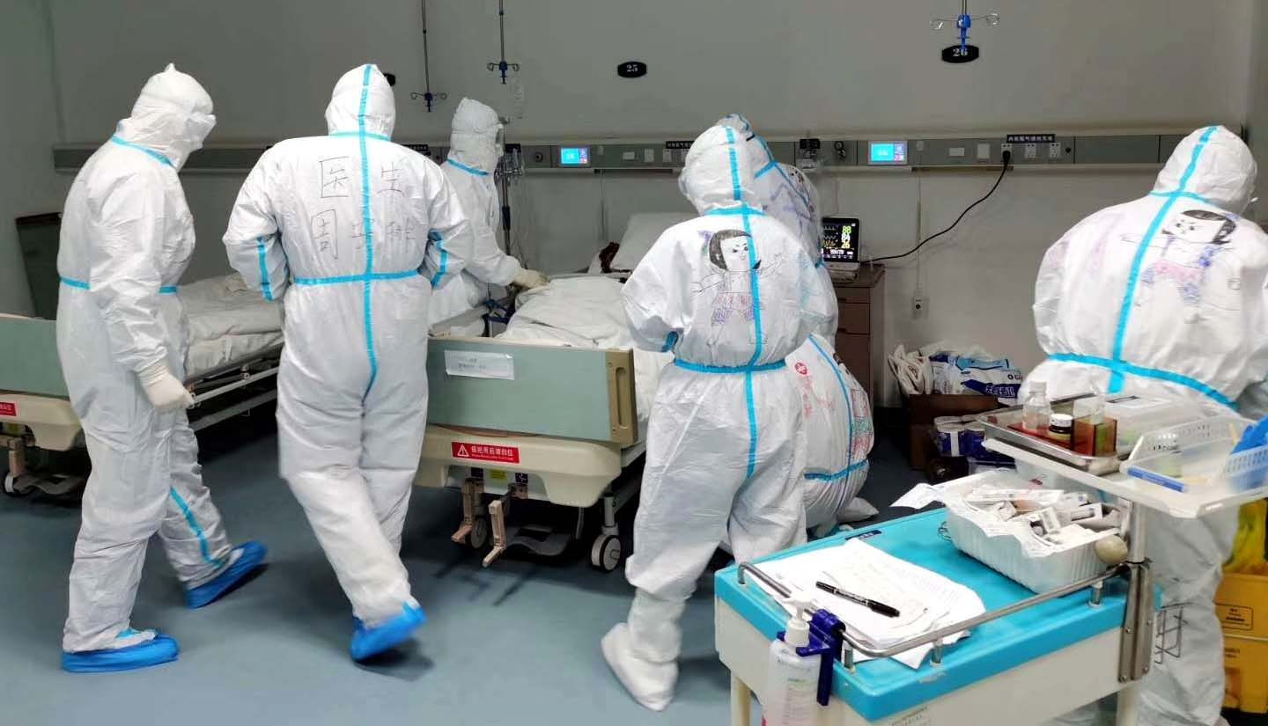

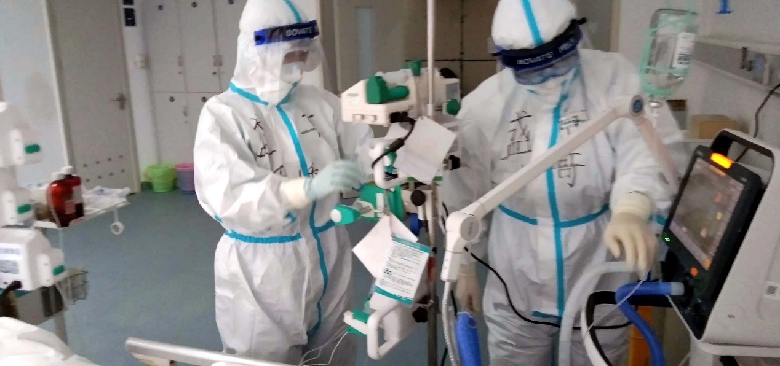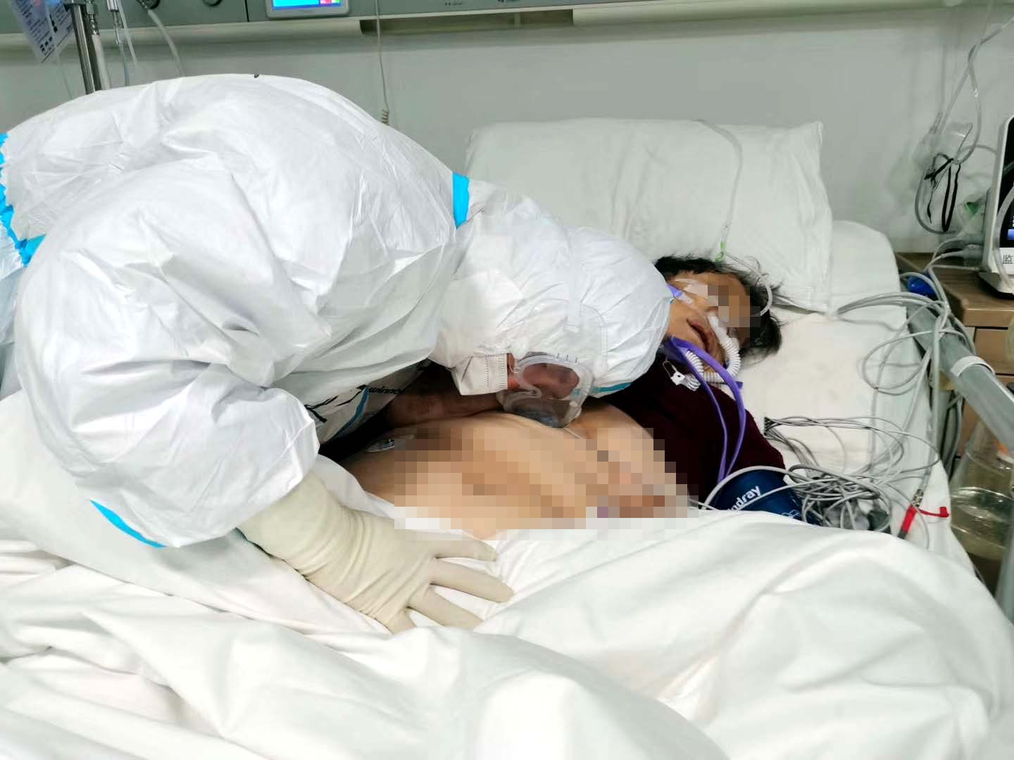

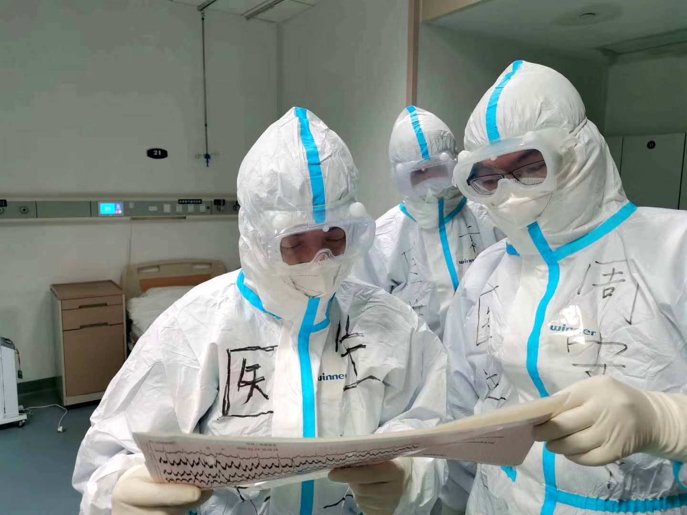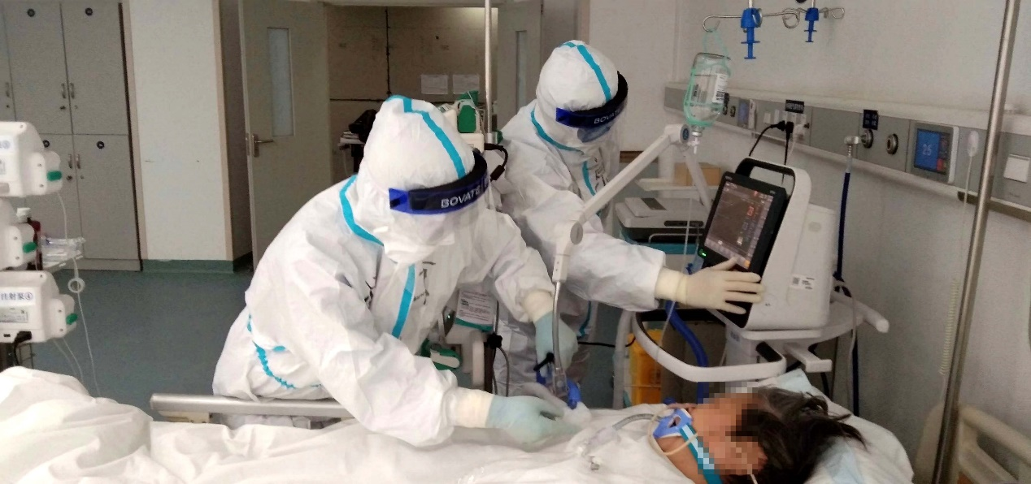

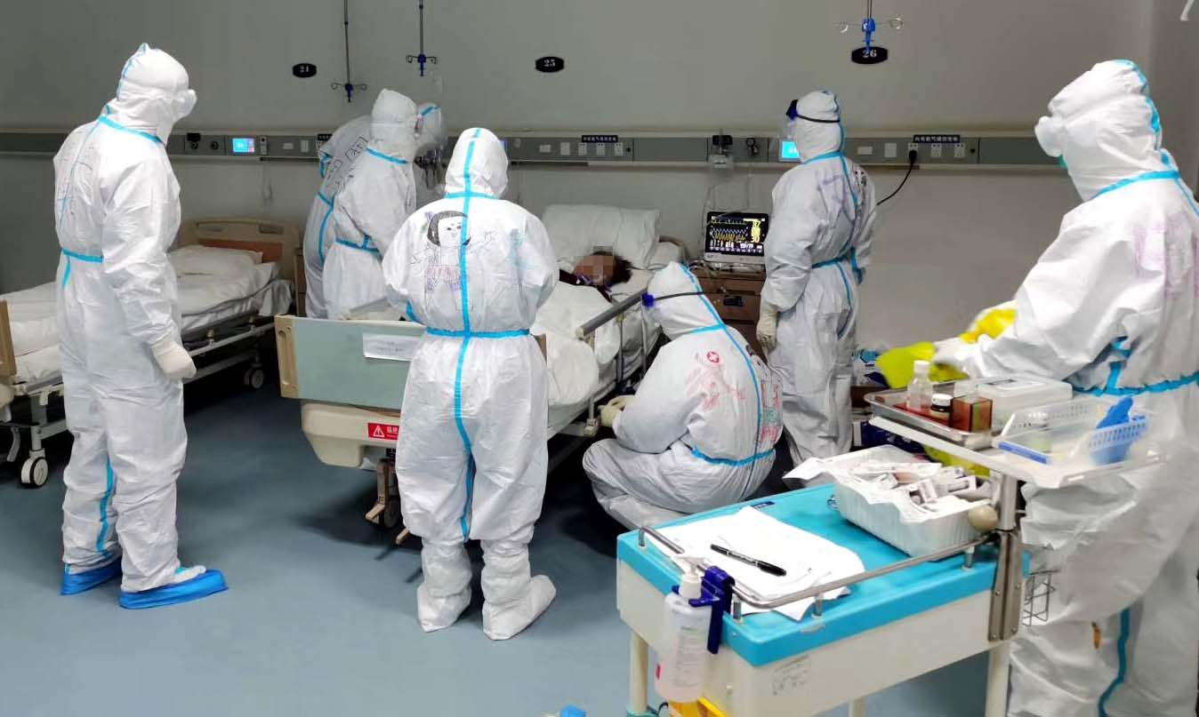

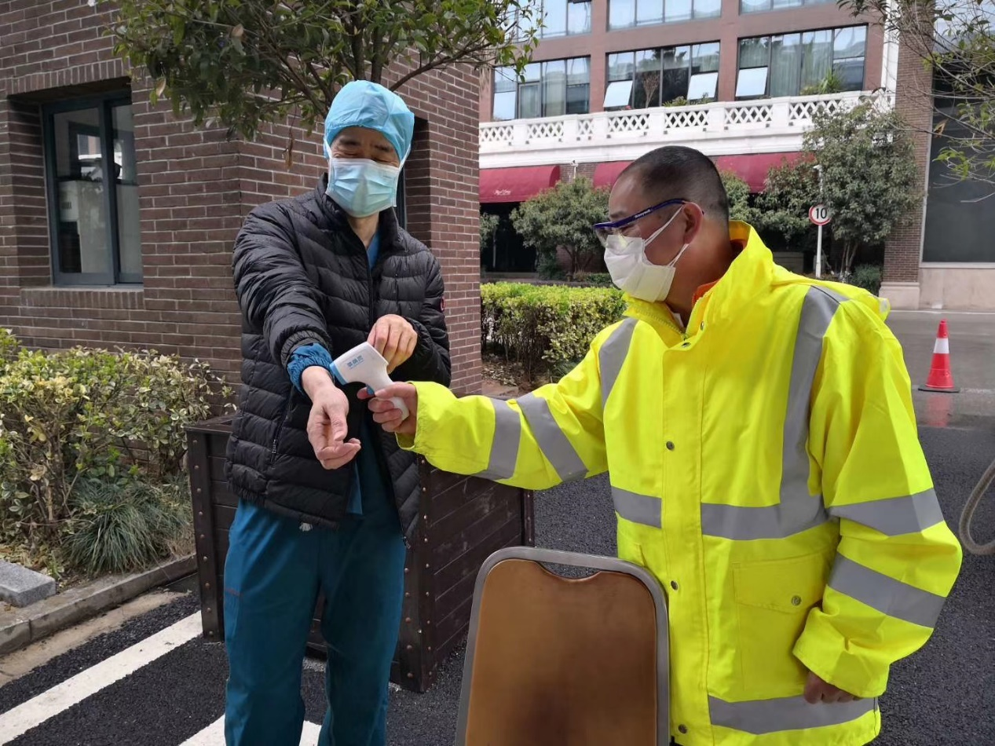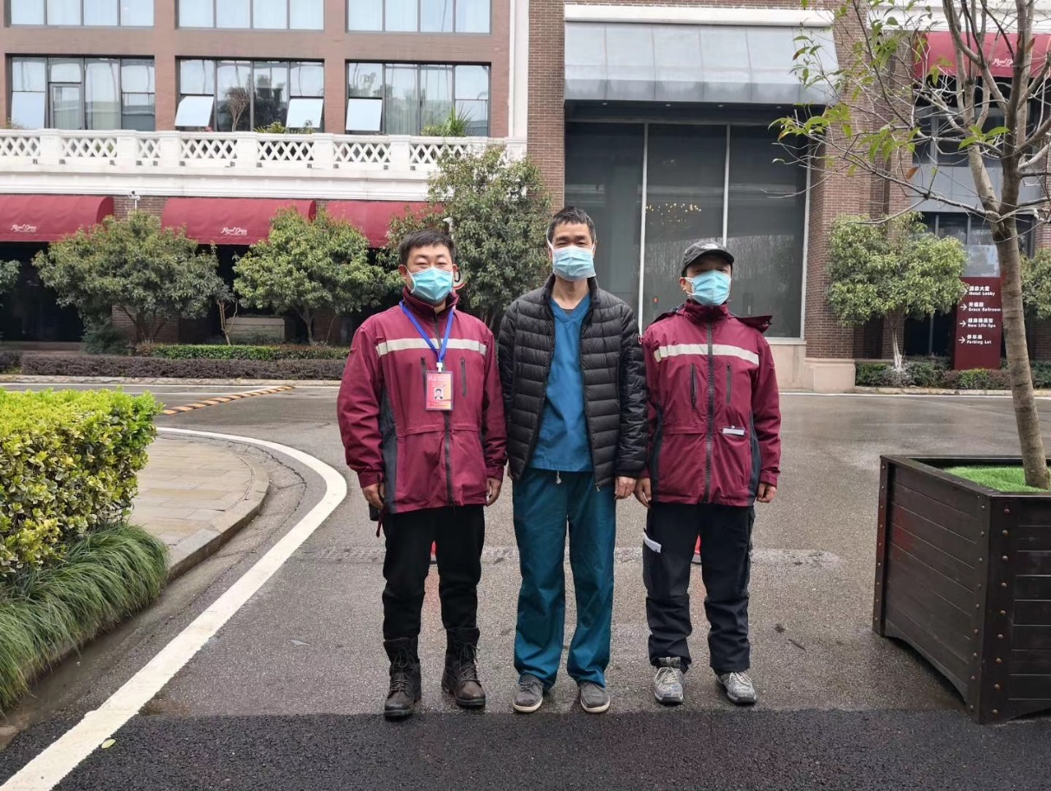

**March 3rd, 2020, Tuesday, Wuhan, Light Rain**

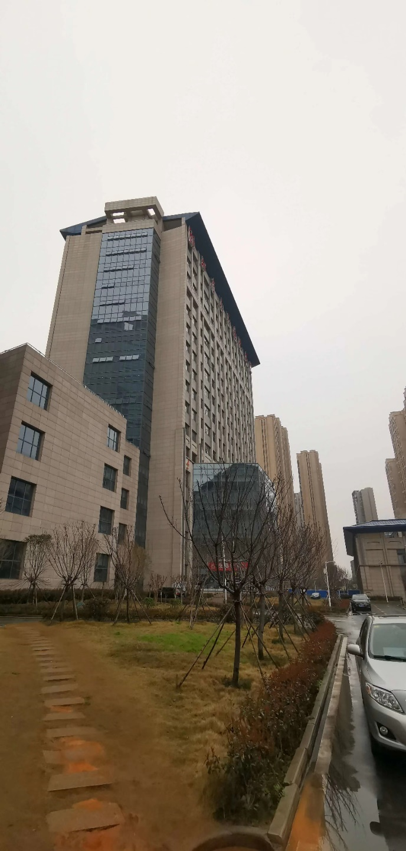Cold, and Dark. Those are the words that describe the city in these couple of days. 6-8 Celsius, the same throughout the entire day. The hotel also feels cold, having no difference with the outside temperature.  Unlikely, an employee delivered an electric heater. And when I look at the brand, I see Dyson, Isn’t it a top brand? I don’t know if the hotel brought it themselves or it was given to them. Regardless, it warmed my heart and the room.

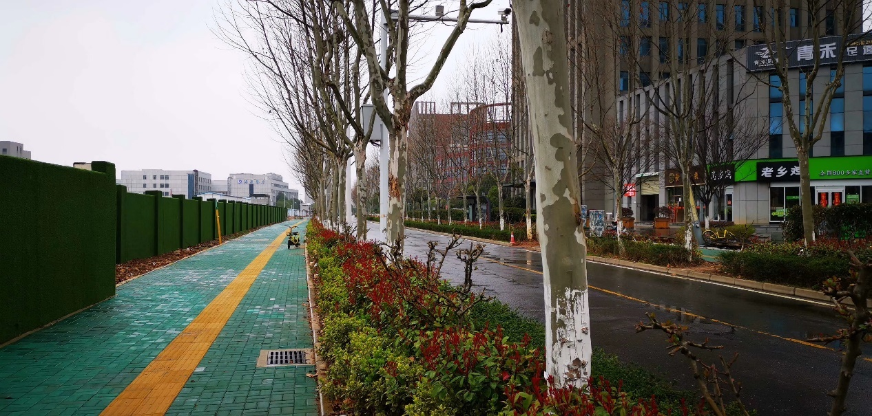Now after returning back to the hotel, I don’t need to immediately go into the bed, I can finally sit on the couch and browse my phone. And I found a blog made by a nurse. They originally wanted her to make a blog because of her positive nature, but instead when she started the blog, tears dropped immediately. I wanted to comfort her, I even felt a little bit guilty. The tears fogged her protective glass wear. After crying, she should feel better. I also found blogs made by the citizens of Wuhan, now people thought Wuhan as a city of sadness. In the Spring of 2020, there are more than 9 million stories, stories of sadness, tragedy, loneliness, but there are also stories of hope, help. They will experience happiness soon.

Time always passes, everything will come to an end. If we continue to work, endure the struggle. Then the rainbow will also come.

33 percent of the patient has recovered. Our sector four only have 30 more patients, three left the hospital, and gained only one new patient. One of the critical patients, a seventy years old lady, is now full of smiles. She wrote a thank you letter to the team, and she also tried to inspire other patients in the ward, to encourage them to not give up. The 85 years old grandma is now stable. During noon, many doctors is considering to remove her ventilator and what the effect will be. Unexpectedly in the afternoon, the grandma started to show symptoms of gastrointestinal bleeding. It seems new problems will always rise. But the team continued, their hopeful future is closing in.

The warm room can easily cause sleepiness. Thank you everyone, have a good night.

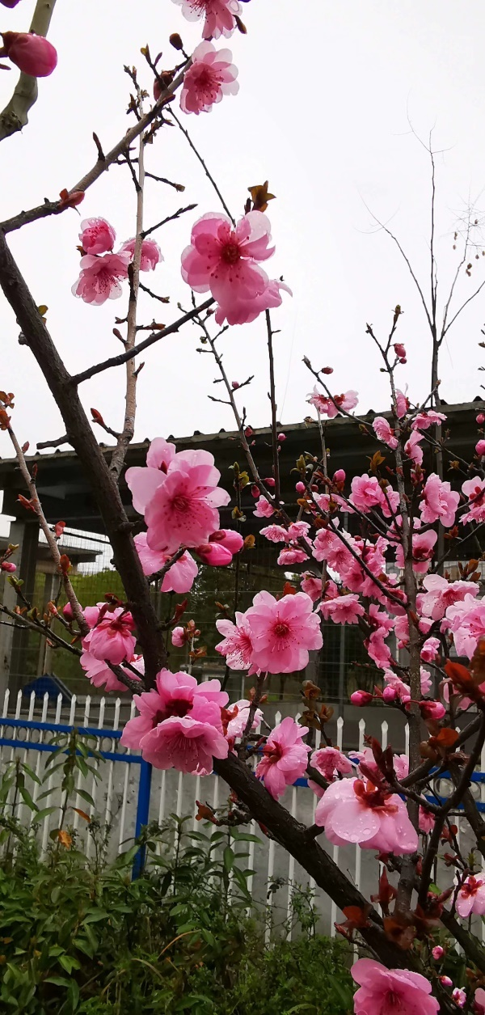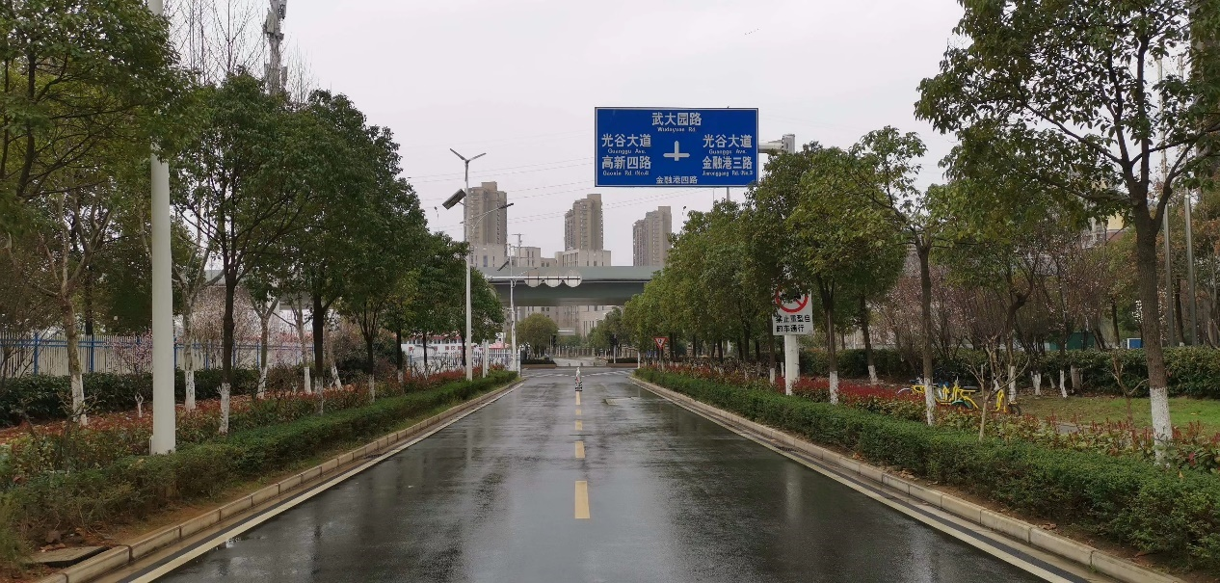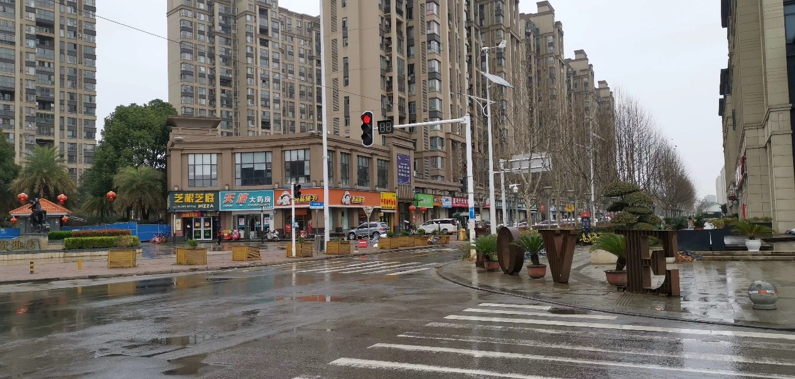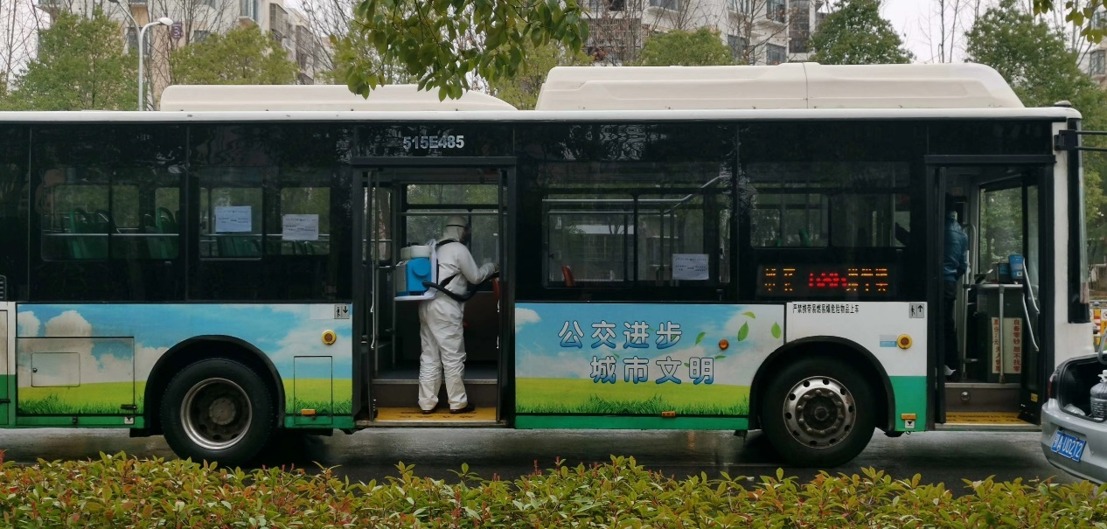

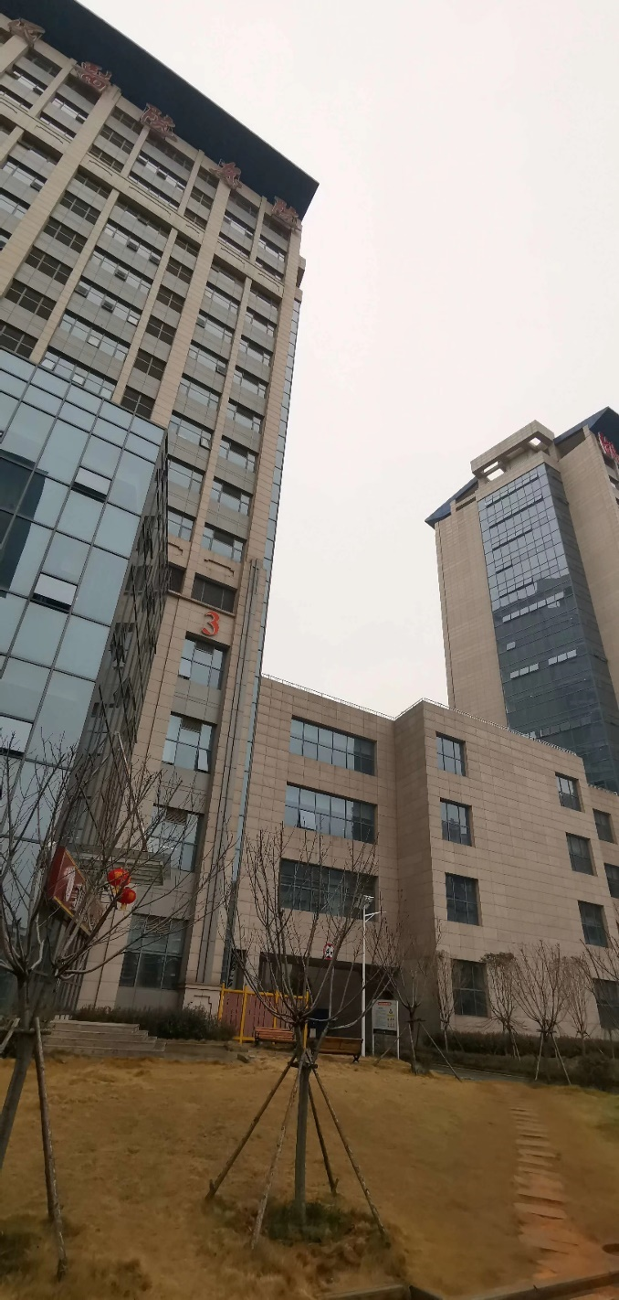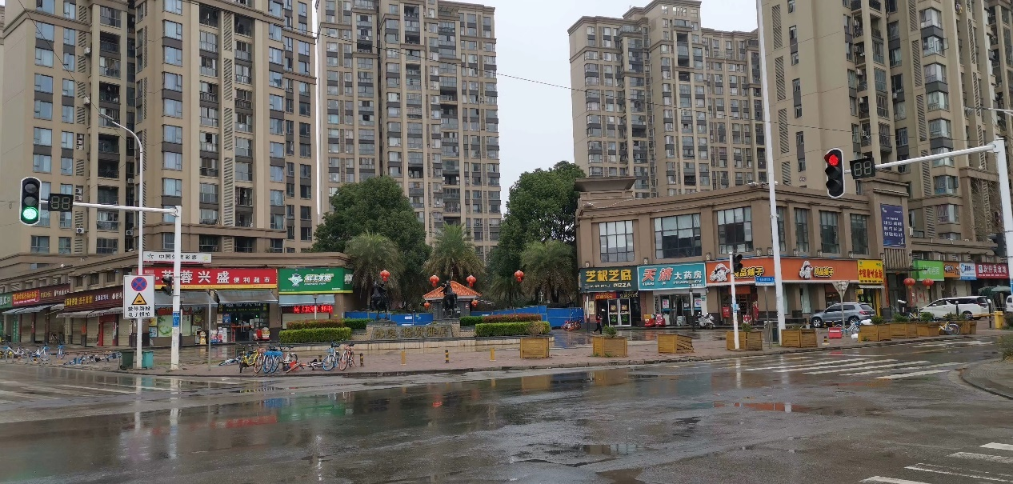

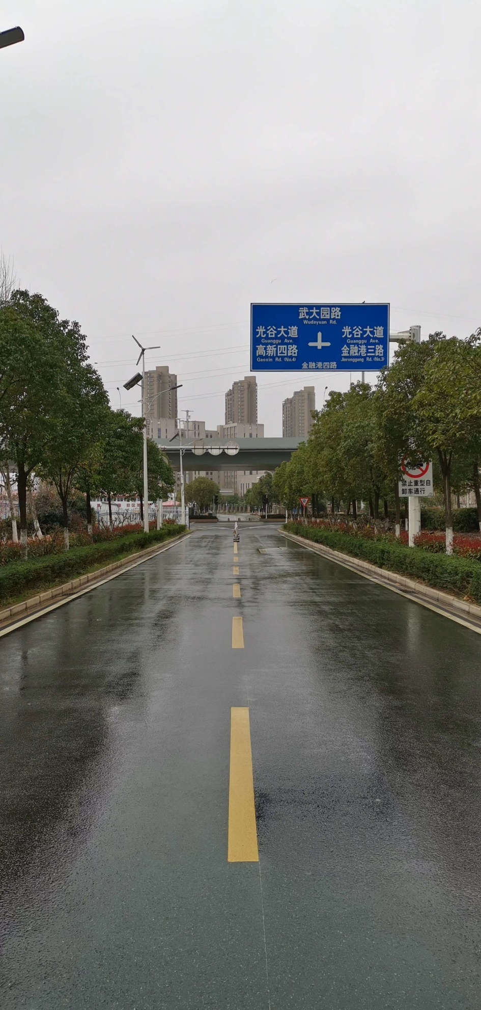

**March 4th, 2020, Wednesday, Wuhan, Clear**

Since the arrival of the heater, the room finally feels like the warm Spring. I was invited down stairs to play badminton. I haven't exercised in years now, plus I had work to do, so I declined. But since my arrival at Wuhan, I was able to walk 5 km every day. Looking out the window, the outside is now becoming greener, flowers are blooming. This is what Wuhan is supposed to be.

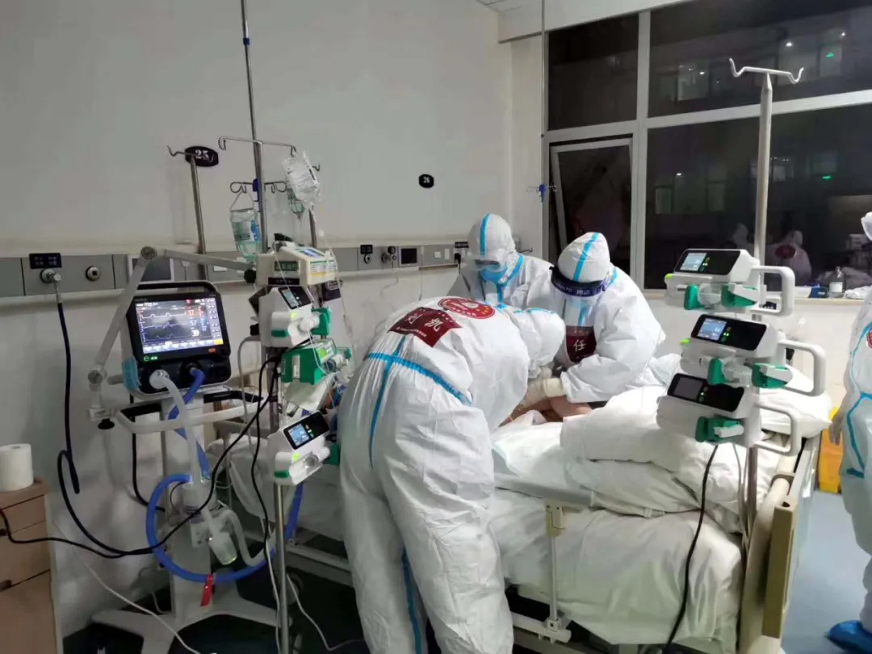Couple days ago, my son finally knew I went to Wuhan. Every day he sends me simple messages. This caused me to consider the doctors and nurses who may be at most 10 or 15 years older than my son, and what they are like as individuals.

Passion was the first word that came into my mind. When the virus came, ravaging the Spring holidays, it was them who volunteered to fight, came here without hesitation, rushing into the quarantine zone. They said they are not scared, but it's hard to believe. Many of them in their dreams fear the loss of masks and the breaking of protective gear. But they are passionate towards their duties. A nurse had a three-day fever, as soon as she recovered, she went right back to work. Her reasoning was that staying at the hotel is holding her from using her skills and knowledge for the cause of good. And doctors 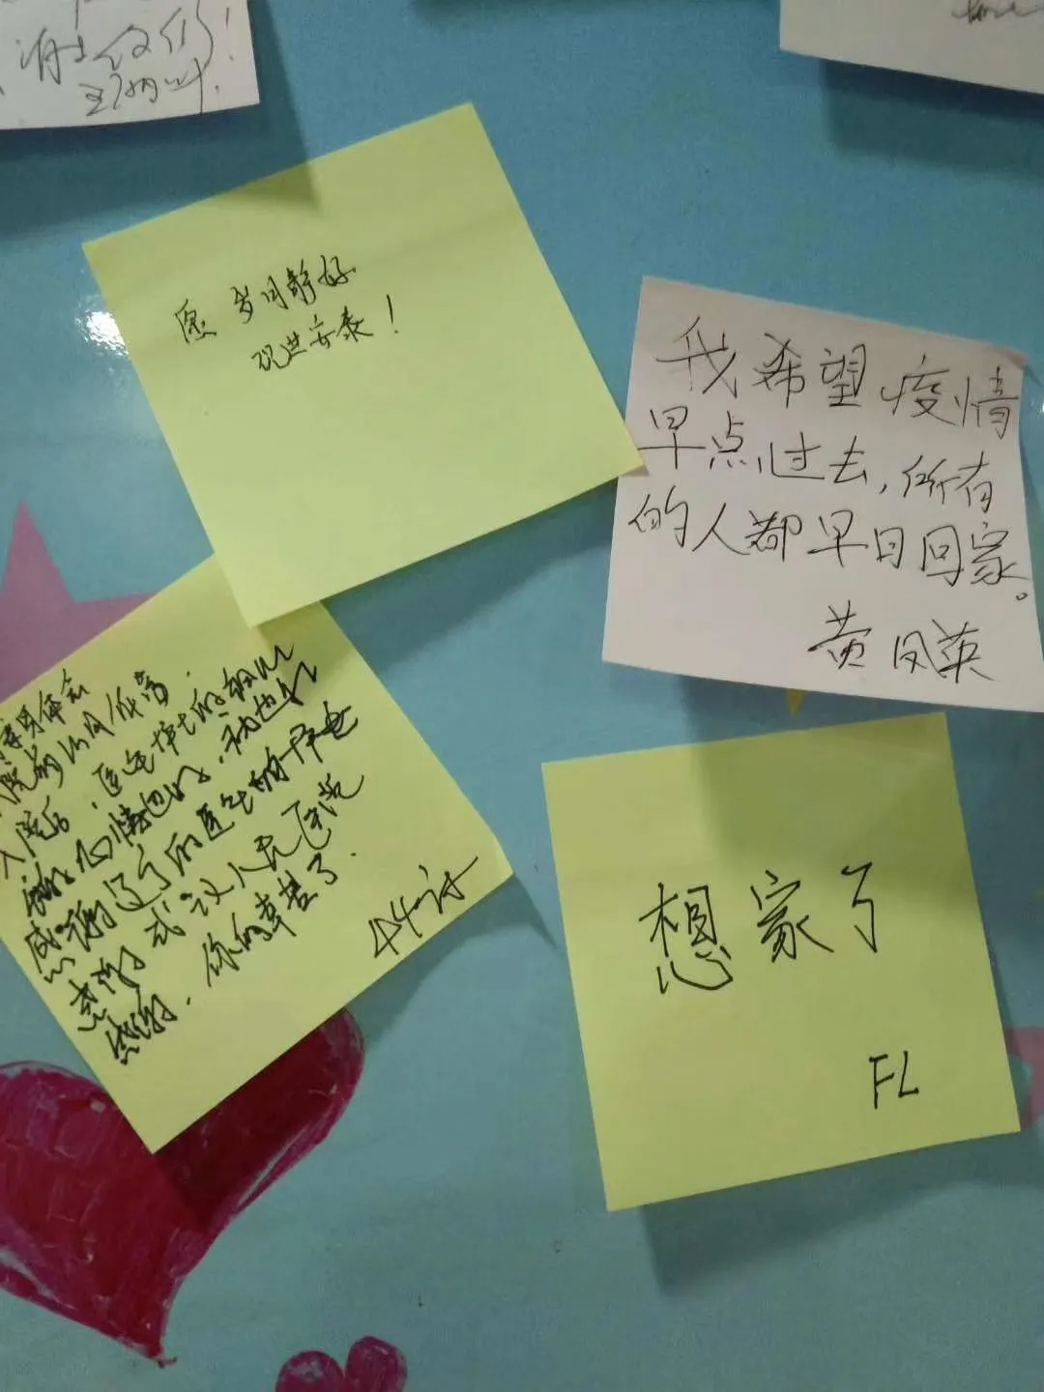believe only in hospitals, they can truly freely express their skill.

Responsibility, this never lacks in the profession of doctors and nurses. They use knowledges that they stored up through time and effort to treat patients, it's from the tiredness they use to delicate operations, they hide their tiredness with smiles and laughter. But their tiredness can be seen by their sweat soaked cloth, and the naps they took on the bus back home.

Positivity, this is a similarity between the 80s and the 90s. Even after a hard day of work, they can still sing, to see who can sing the best, some songs are sung like heroes, others sung like the soft river and others sung like their life depended on it. Only after rest, can they make videos that make you laugh like never before. After a full belly, they start to joke, pointing fingers to see who did the best job. Making up a slogan saying the world is like a mountain, the good or the bad, we are all sharing it.

The people’s hospital of Wuhan section four, is still receiving new patients. Our team treats our patients with utmost focus and duty, they are not scared of the difficulties. Everyone is confident they are able to treat any patient. The 85 years old grandma in bed number 25 is still stable, so if you believe anything can become better, the future is soon.

Day 19 of zero death.

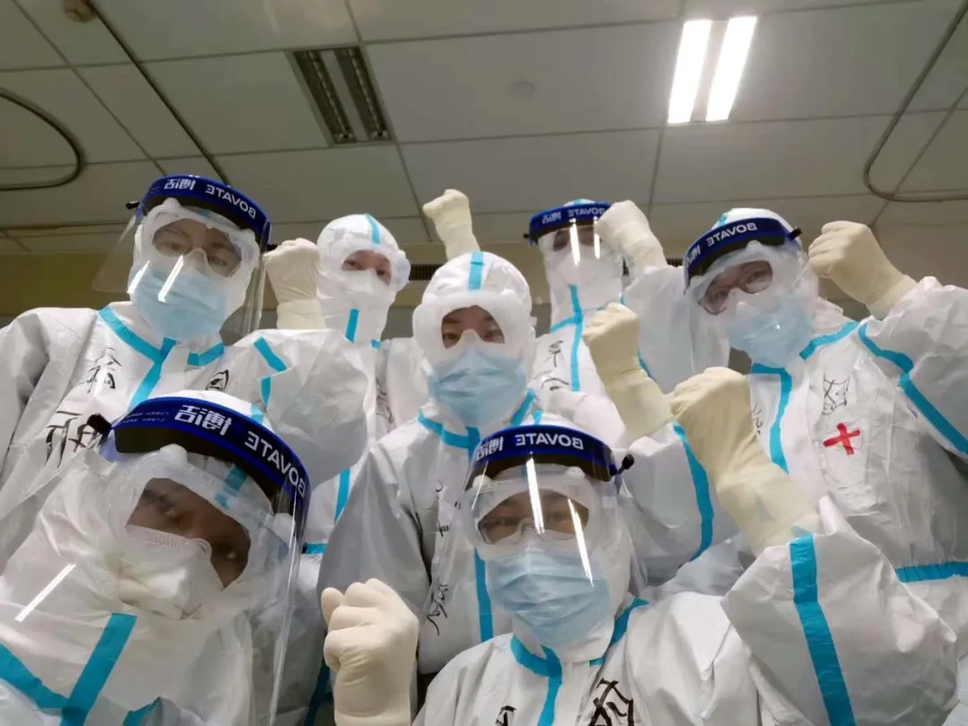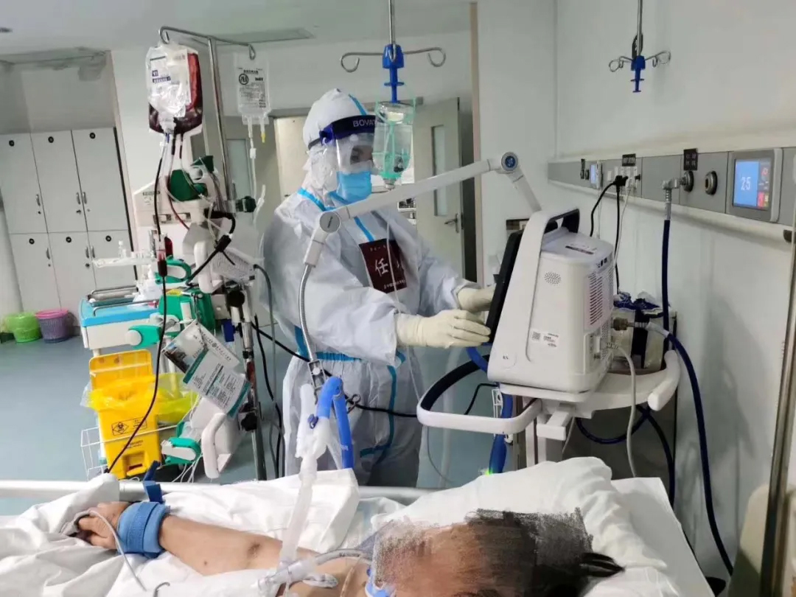

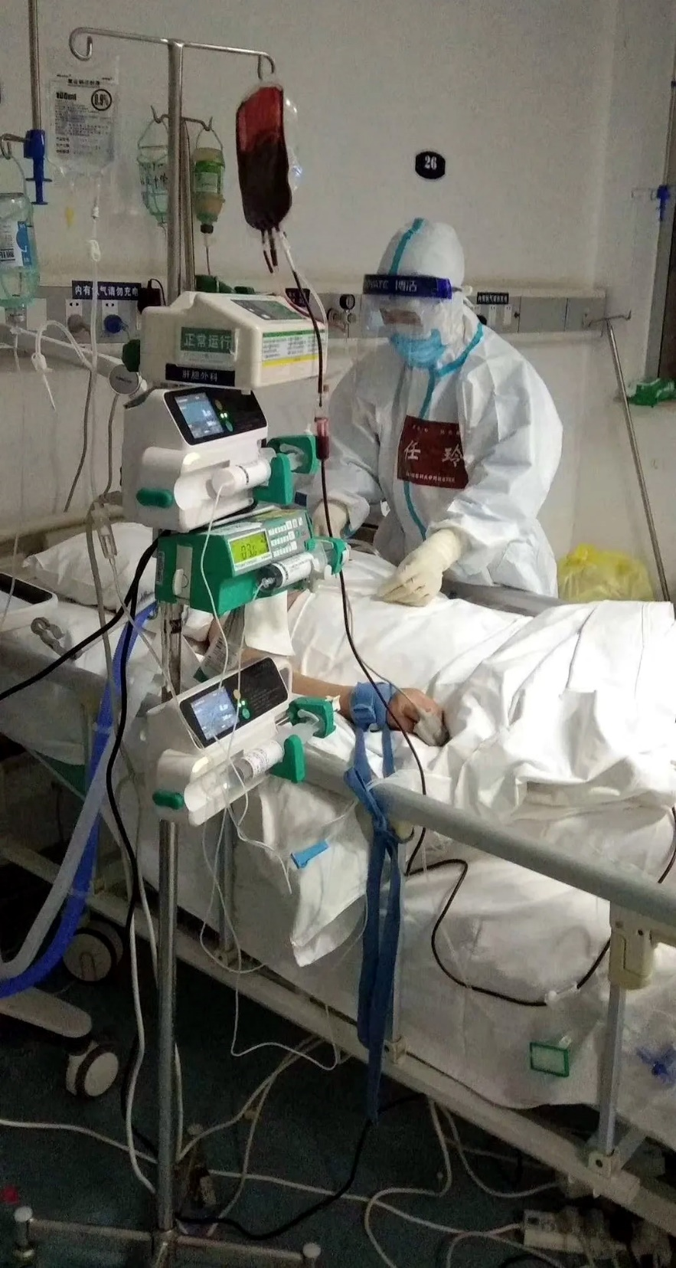

**March 5th, 2020, Wednesday, Wuhan, Clear**

The sunny sun gives this special day an extra warmth.

The hospital sector four is still busy, we received new patients this few days. It puzzles me why we are still getting new patients; it turns out they were transferred from different hospitals which were cleaning house, preparing to go back to normal hospitals. It seems my goal to go back home must wait. The grandma at bed 25 succeeded weaning from the ventilator 6 days later since tracheal intubation. But still face struggle, I believe the team thinks so. For the grandma, we added 66 more shifts of doctors and nurses to say on guard.

Everyone is tired but happy.

About the streak, many team members believe it’ll hurt other hospital’s morale, so please remember it for us.

The happiest thing today was my son’s 17th birthday. I'm proud and ashamed. In another 365 days, he will become a man. I’m ashamed that in the 17 years we rarely meet, I spend more time with my colleagues than my only son. When my son was born during the 2003 SARS epidemic, he was sent to relatives only 52 days old to his relatives living in the rural part of the country. He finally returned back when he was 8 month old. When he was one years old, I was given an opportunity by my mentor to send me to work in Shenjing hospital. I still remember the old hospital building with seven floors. I also remember the bridge next to the hospital that I named newly-added-slope. The campus of current hospital now changes a lot.

I originally planned on being there for only 6 months, but I decided to live there under a mysterious force. I changed the book of Beijing registered permanent residence to Shenyang registered permanent residence. Since then, I can only see my family on the weekends, sometimes, he and his mother visit me on plans. Because of that, I sometimes say he's seen many places since he was young. But meetings every weekend become difficult due to school. Six years ago, 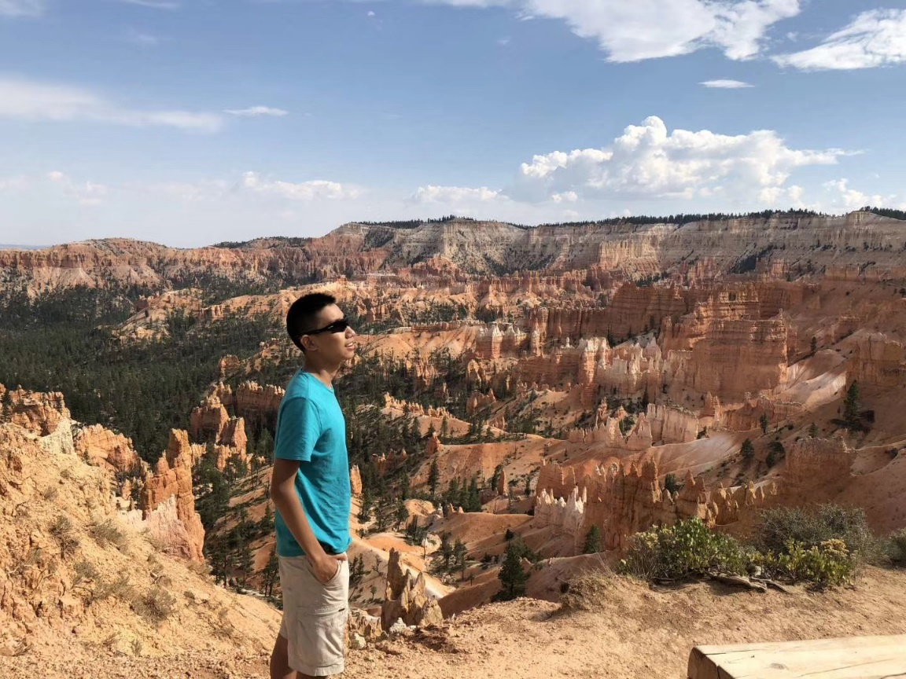he convinced his mother to live in America, now we can only see each other few times a year.

My memories are long, but they are all fragments.

I remember when you were one, taking my phone to trade for a balloon. So smart and brave. But of course you cried when the plan failed.

I remember when you were one, seeing your grandma for the first time, you give her a kiss, making your grandma so happy and proud.

I remember your first time going to the country sides, mistaking a pig as an elephant.

I remember you protecting your mother when you just started elementary school.

I remember you telling me your first crush in elementary school.

I remember that the girl also liked you too.

I remember you protecting that girl from trouble even though she was the one who stated it.

I remember your first trip to Disney, having the courage to try the roller coasters.

I remember your struggle when you came to America, and the way you turned awkwardness into humor.

I remember when your teacher said you are a history buff, you simply replied it was only the teacher’s encouragement.

I remember when you created a birthday party for a single parent friend of yours.

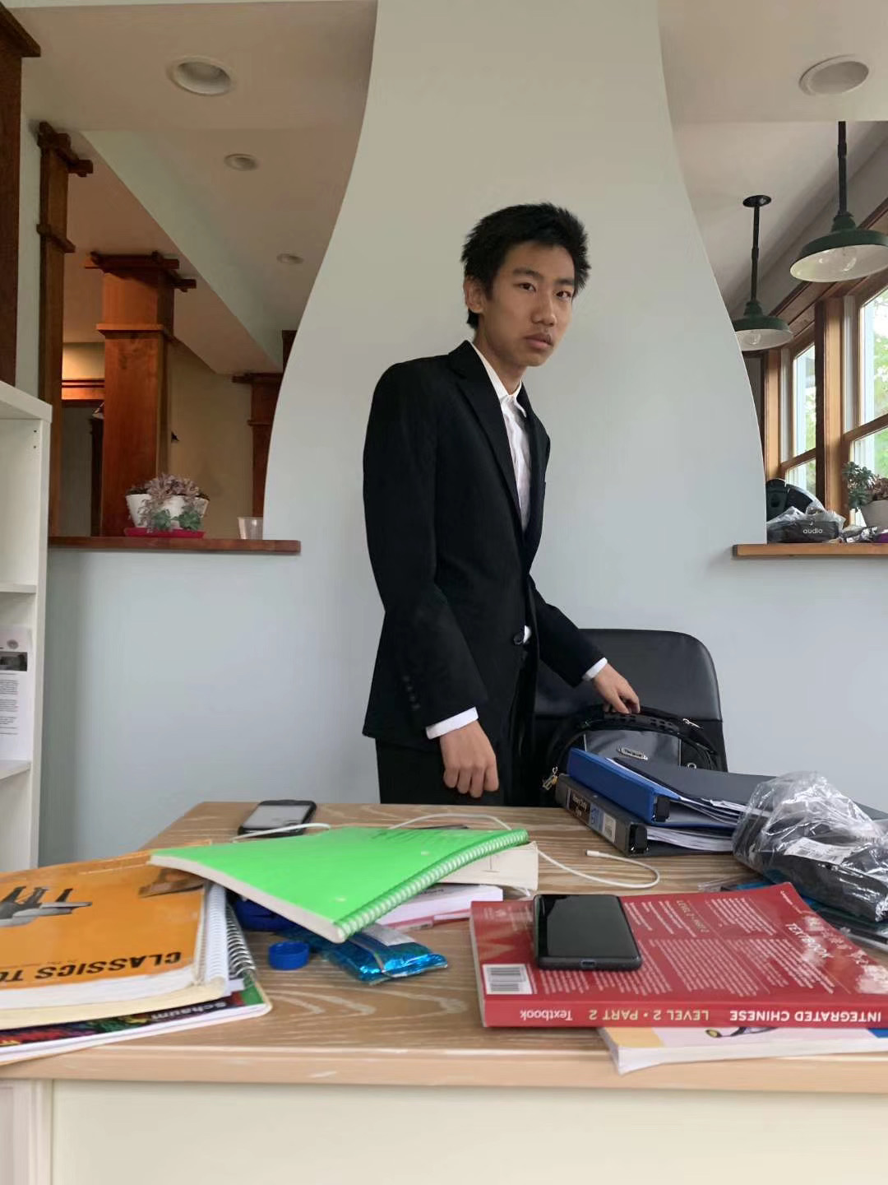I remember when you said you clean the cleanest dishes in the retirement homes.

So many memories.

Couple days ago when you realized I went to Wuhan you said: “Why didn’t you tell me this important news?” your dad did not respond. I want you to have questions, so you can learn.

I’m used to you calling me big Pang, and me calling you Little Pang. I’ll give you a message for your birthday: I hope when you are growing up, please do not hope for perfection. But love, positivity, determination and responsibility are something essential.

Today you might not understand those words, but you tomorrow will. Because you are my son.

Happy Birthday!

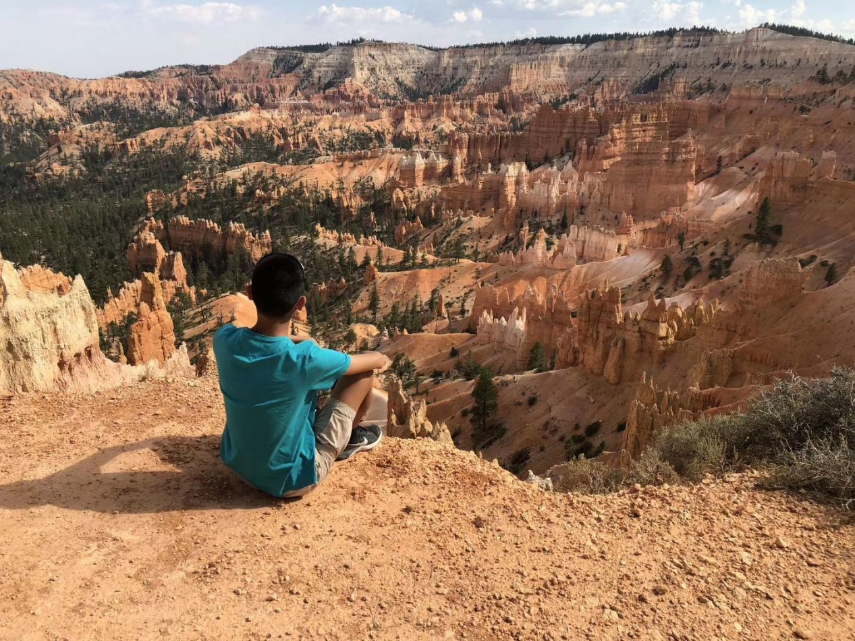

**March 6th, 2020, Thursday, Wuhan, Cloudy**

A sleepless night.

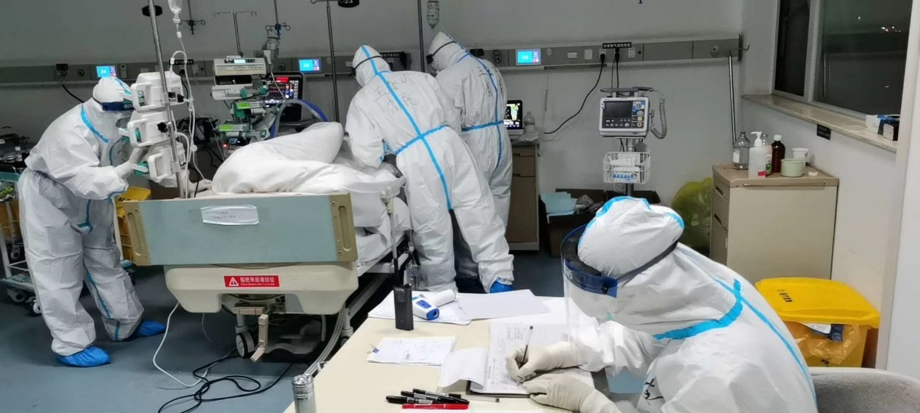Yesterday at noon, professor Zhao Li and I entered the quarantine zone, and plan to remove the tracheal intubation tube from grandma on bed 25. Her eyes looking at a group of doctors, I cannot say if it's a good thing or a bad one. After 20 minutes, she appears well. This made the team happy; we even took a group picture. But her sputum tinged with blood. After discussion, we decided to postpone the weaning from ventilator. We decided to use the time to “clean” the respiratory tracks, then we will remove the respiration cube at night.

The team who came at night is called Xu Man. We all worked in the same hospital, but we are not close. She is a very talented individual, very observant and clever. Us working together for the past 20 days conferment those traits. It was also known she is a fan of food.

Just like that, her team successfully weaned the ventilator. Even more surprisingly, her team did while covering their head with plastic trash bags, the reason being the bags is added protection. This will never be in any text book or a recommendation from an expert, only someone in the battle field can come up with this 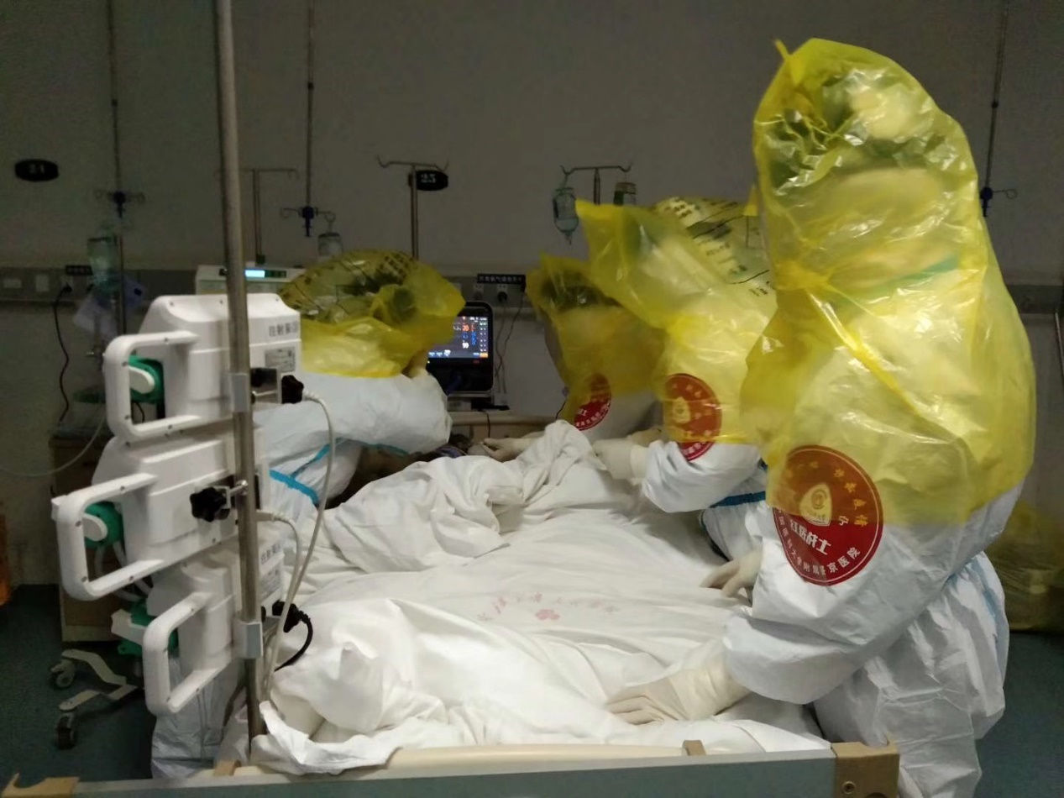idea.

Everything seems okay, but the storm soon came.

March 5th

6pm: Succeeded withdrawing the tracheal intubation tube. Cheer and congratulation messages appear one after another in WeChat app.

7pm: The blood pressure rose to 190/85mmHg. We adjusted the anti-hypertensive medication.

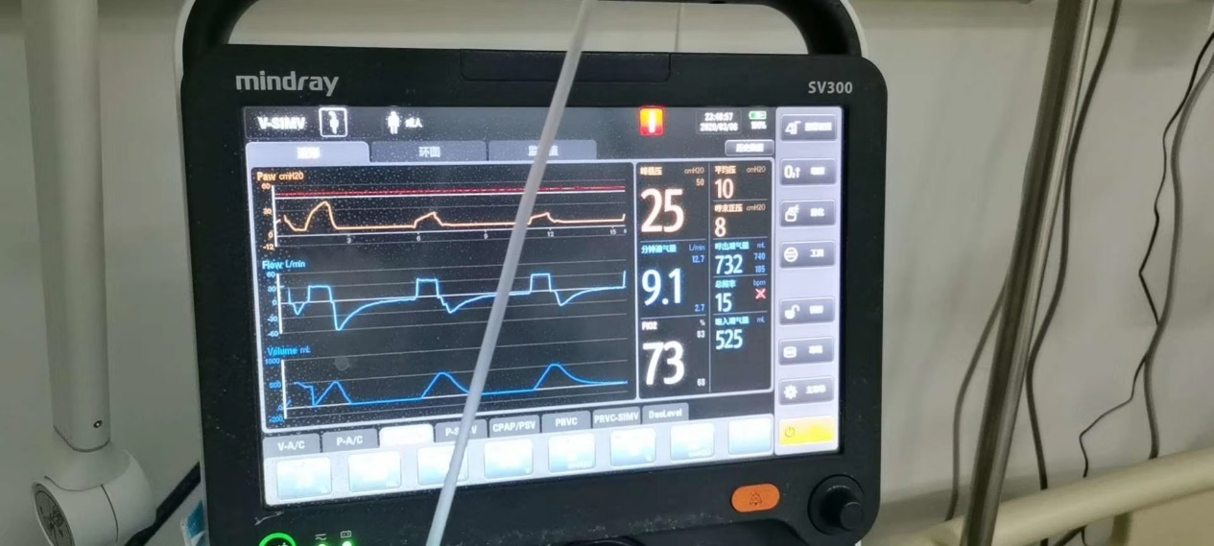

8pm: The patient was consciousness. She cannot get our verbal expression but can understand our gesture meaning. Her ability of expectoration was poor, but the sputum was not so much. Fortunately, her blood gas analysis result were not bad 2 hours later after intubation weaning.

9pm: The monitoring shown that heart rate was 71, BP 140/75, blood oxygen saturation was 97%. There was some bleeding in oral cavity.

10pm: Blood oxygen dropped down. We increased the oxygen inhalation flow to 60L/min.

11pm: The patient felt dyspnea, but the blood gas analysis was normal.

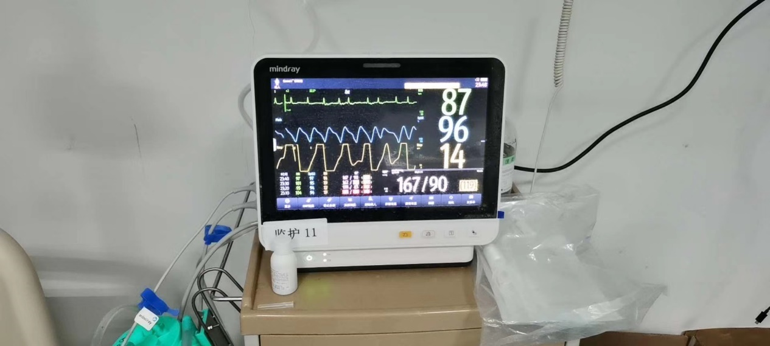

March 6th

0am: She was restless and disturbed but can open eyelids.

1am: The heart rate was decreased (we name bradycardia in terminology). We prescribed with some medications. The sputum tinged with blood. We discussed what’s the reason of the bleeding and administration in the WeChat group.

2am: The dyspnea didn’t aggravate. We prescribed the platelet transfusion.

 ……………

A sleepless night for everyone in the hospital and the hotel

10am: Intubation and mechanical ventilation again.

………………

3pm: Heart rates dropped to 40 bpm.

4pm: Electrocardiogram (ECG) was abnormal.

4:49pm: Electrical shocks were delivered twice.

4:54pm: Heart beats paused.

4:55pm: Resuscitation succeeded.

5:22pm: Hematochezia (blood in stool).

5:30pm: Blood pressure decreased. The medical assisted staff were preparing body treatment outside the quarantine zoon.

5:40pm: Resuscitation succeeded again.

I started to write this at 23:41, in the 18 hours, the chat had a total of 800 messages involving the case.

It was more than difficult, and stressful.

But we will not easily give up.

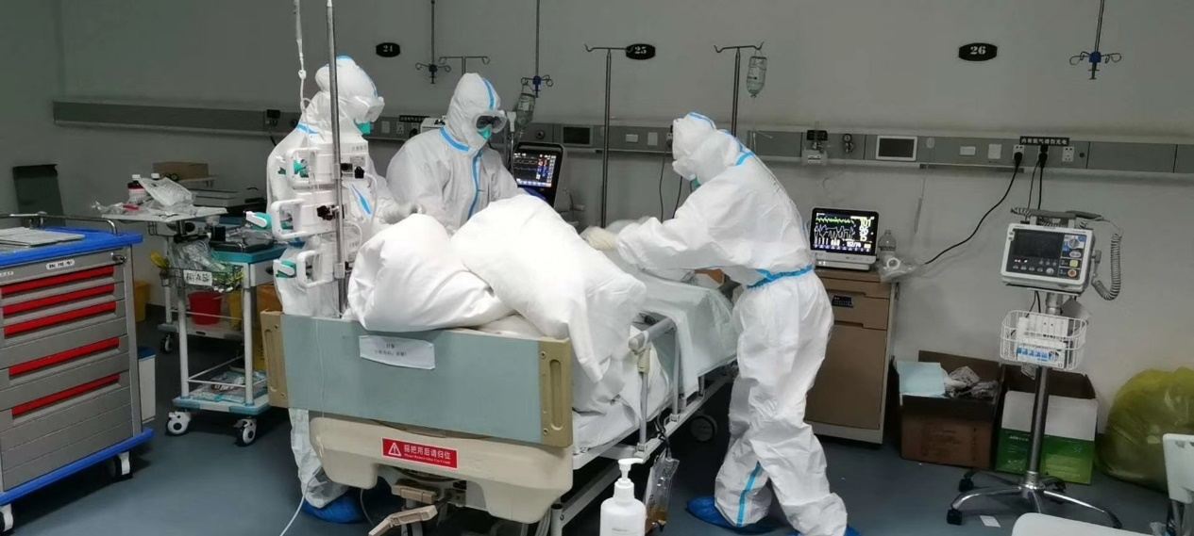

**March 7th, 2020, Friday, Wuhan, Clear**

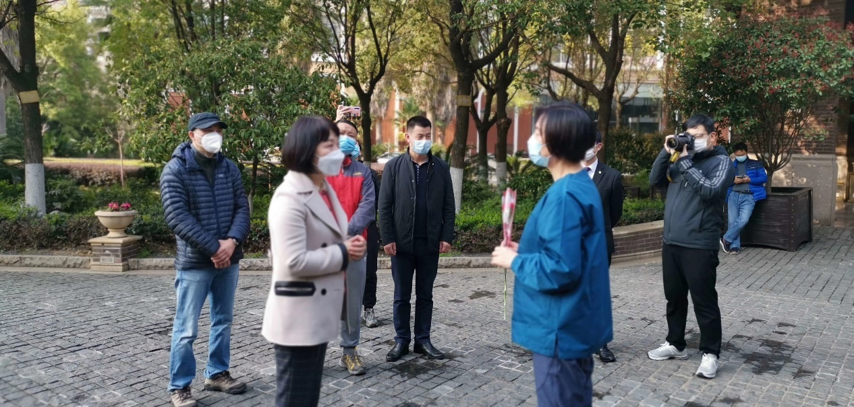The Sun hangs high above the sky, I manage to sweat from walking. It seems there are more people on the streets. This is the first time from all my walks where I saw a restaurant reopen, The first time I saw three cars together on the road, the first time to hear a car horn. It feels like, for all of a sudden, the total patients dropped to only double digits. In the Hotel yard, many embrace the festivities of Women’s day. Groups of nurses and doctors make different poses for pictures, each received a bundle of pretty flowers. Even the district mayor sends gifts, the mayor is a hard working-lady, like many other ladies, she too is a person worthy of praise.

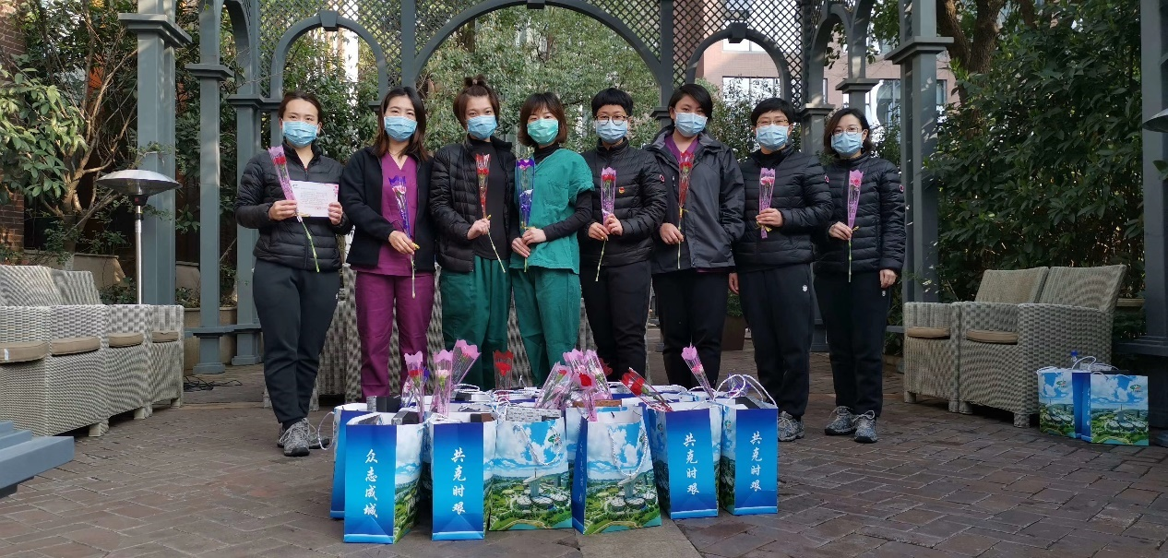

We saw the news at night. It was about the doctors of Wuhan, 73% of medical staff who came to Wuhan are women. This makes them the main force of defense. In the afternoon a man was interviewed, his wife was working in the frontline, but she was infected. When going under treatment, she was still very caring of her husband. Another lady, after the death of his parents, she decided to help treat patients in the frontline.

Ladies, especially doctors and nurses, are a unique group of people in China.

In their homes, they care for their elder, children, and husbands.

In work, they care for the patients, colleagues.

We are only a spark in the galaxy, but we never lack famous women. But ordinary women show true beautifulness.

In the harsh cold of Northwest plateau, In the broad green plain; In the night less city, in the stormy island, there are always women’s smile, commitments, tears, and sweat.

Remember a quote from Maxim Gorky:

 We should praise them, ladies. They used their body to nourish the world. Without motherly love, there will be no poetry, then no more love.

Happy Women’s Day!

People’s Hospital of Wuhan sector four, we continued to receive transferred patients. The grandma at bed number 25 continues to fight the virus alongside doctors, although the pulmonary function, cardiac function and renal function was exhausted, although her bone marrow was not able to generate blood cells, although blood, plasma and platelet need to be transfused, although every doctor tried their hardest. We still hope for a miracle!

I held my tears and said: 22 days of zero death.

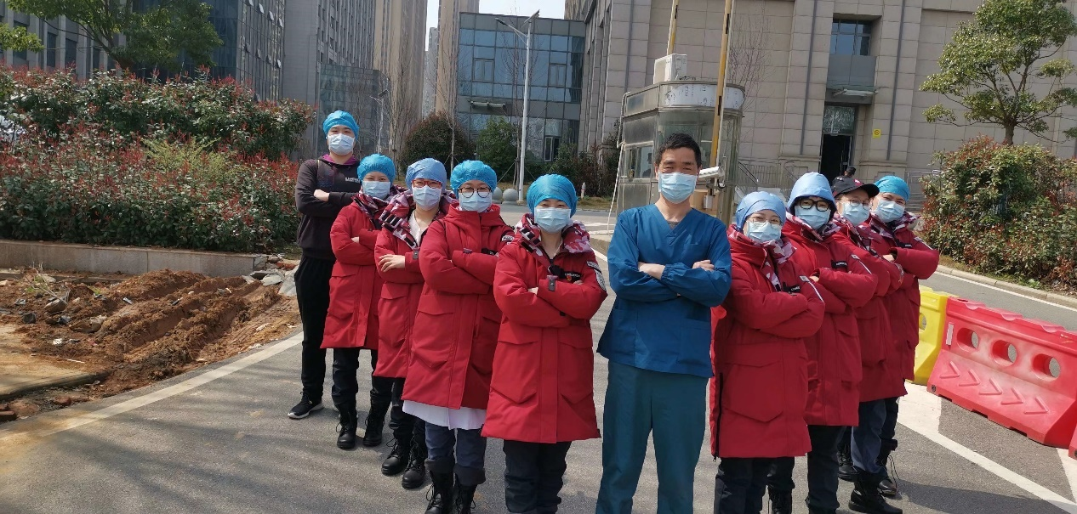

**March 8th, 2020, Sunday, Wuhan, Light Rain**

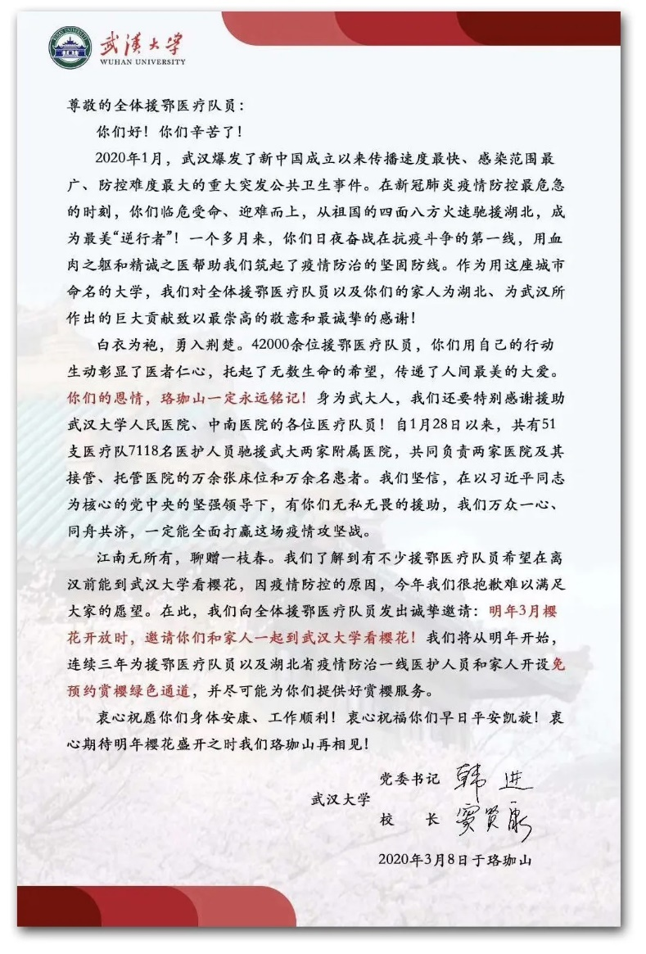A rainy day, the hotel is much quieter, but the online chat continues to be busy. Holiday congratulations coming from one to another like the endless rain. The principal of Wuhan University sent letters of invitation to see the cherry blossoms next year, and it seems Uncle Pang can save money on college now.

The number of patients in the past two days decreased at an incredible rate, there were only 50 new cases. Although our hospital ward receives more patients every day, it is because other hospital are now preparing to go back to normal. The Situation of Grandma from bed 25 is still critical, but today is a peaceful day. Or in another word that everything is running smoothly. At three in the morning, professor Zhao issued the patient analysis and offered new methods of treatment. She said this morning, she felt ominous in the night if left the patient for two hours. Many people are now invested in the state of the old lady, I’m afraid to get the answers immediately, because of the 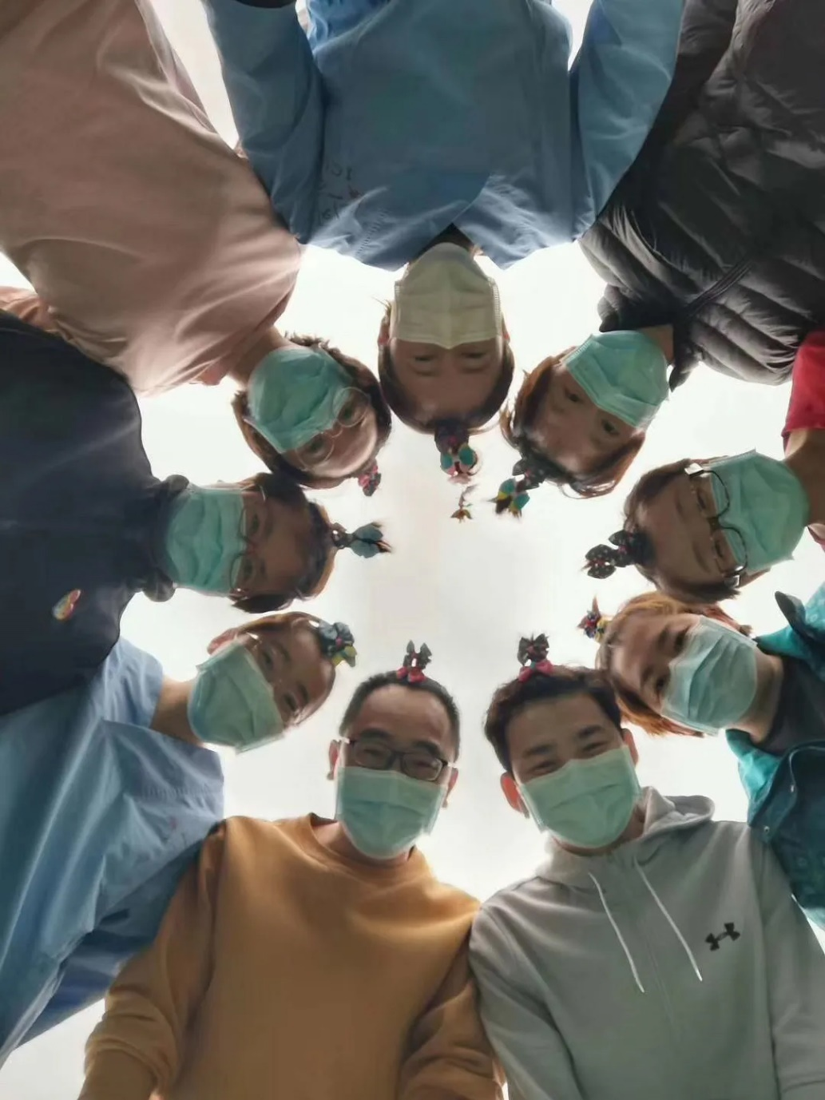unwanted answer.

When things are calm, I can only think of the few important patients. The patient from bed 20 who is relying on nasal feeding to support life, now has recovered. he doesn't want to leave the hospital, maybe he's getting to comfort here. The patient at bed No. 35 with pneumonia are feeling much better, but can pulmonary cancer and deep venous thrombosis let him go for a second chance? Three patients we called them “troublemaker trio” cooperated with each other well every day, and it seemed like they would always desire much more than you could give them. We should treat them like three little naughty kids. Does the father, mother and kids feel better, and they insisted to discharge together when they would be recovered all. Is the sister still blaming herself for the transmission to her classmate to cause her passed? Does the buddy in the sector downstairs eventually be infected, who has already accompanied with his infected wife and reluctant to leave her from the very beginning several weeks ago?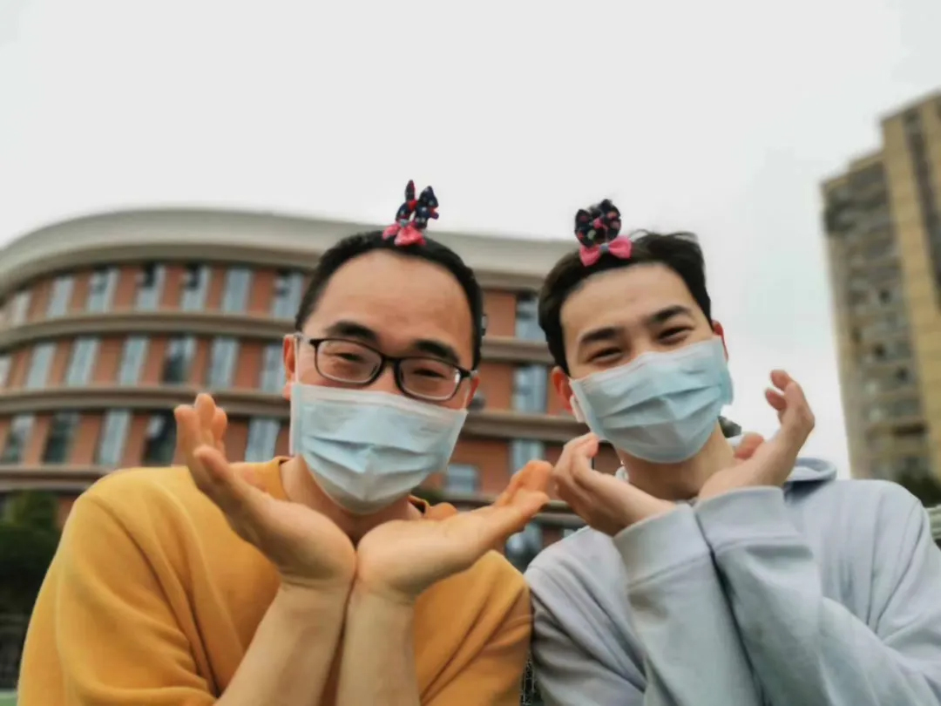

Everyone has their own story; nobody can experience others’ stories. There is no good or bad, no right or wrong. Many years later, a person can sit under the fading sun, beside a window, drinking tea, recalling his life long journey, isn’t that a treat?

It must be a pity without a story.

**March 9th, 2020, Monday, Wuhan, Rain**

New cases in Wuhan totals 36, 28 suspecting cases. Even better news was in China, there are no new confirmed cases elsewhere. 13 of the 14 Wuhan emergency mobile cabin hospital (Fangcang Hospital) have been retired, and the last will be planned on closing tomorrow. People’s hospital of Wuhan university will receive many referral and transported patients from the emergency hospitals tomorrow, but luckily we will not receive any more referral and transported patients afterwards. When that happens, will we become bored? With nothing to do, then time will seem to slow. I dislike these types of days.

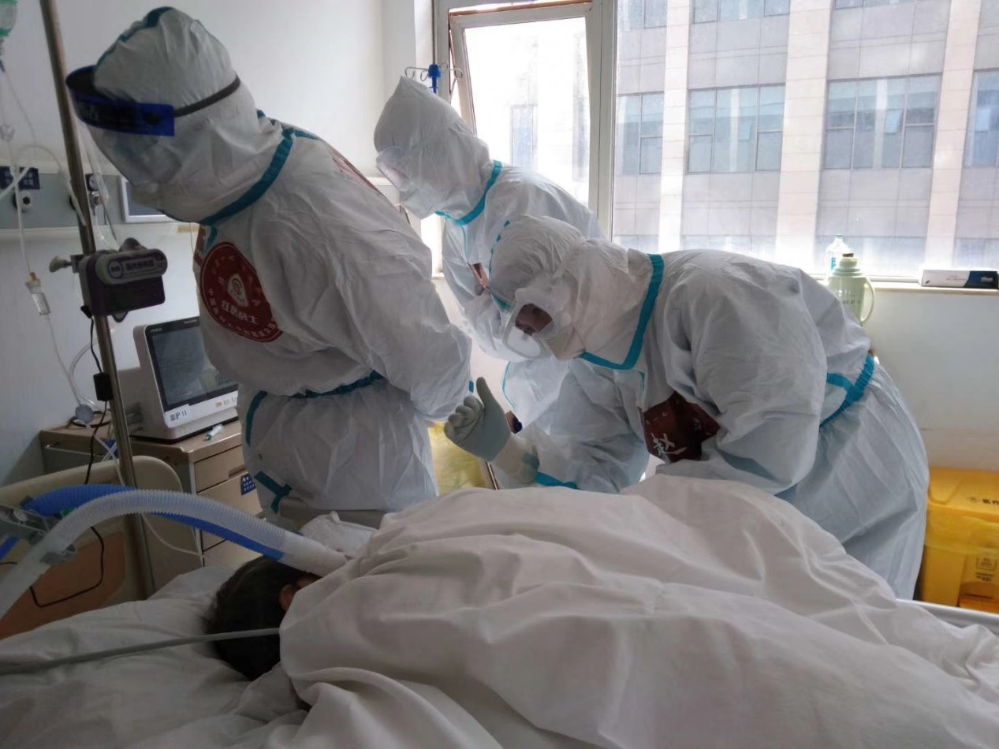

In our sector, we average 30 patients. At noon, I found out that of all the critical patients in all 22 sectors of the hospital, no other patient’s condition is more severe than our patient in bed 25. Grandma is really unlucky; her condition can be the top three most severe. Her condition is not worsening, but is also not getting better, this is very puzzling. This makes you feel helpless, even useless.

The other seven team members sing songs on their way to the hospital. Then they were changing into protective gear, they were fighting joking about the colors of their gear, saying red top green bot, saying this way, work will not get tiring. When they were entering the quarantine zone, they wanted to take a selfie, as a memento. Other teams have their own nicknames, like “nine tail fox” and etc.

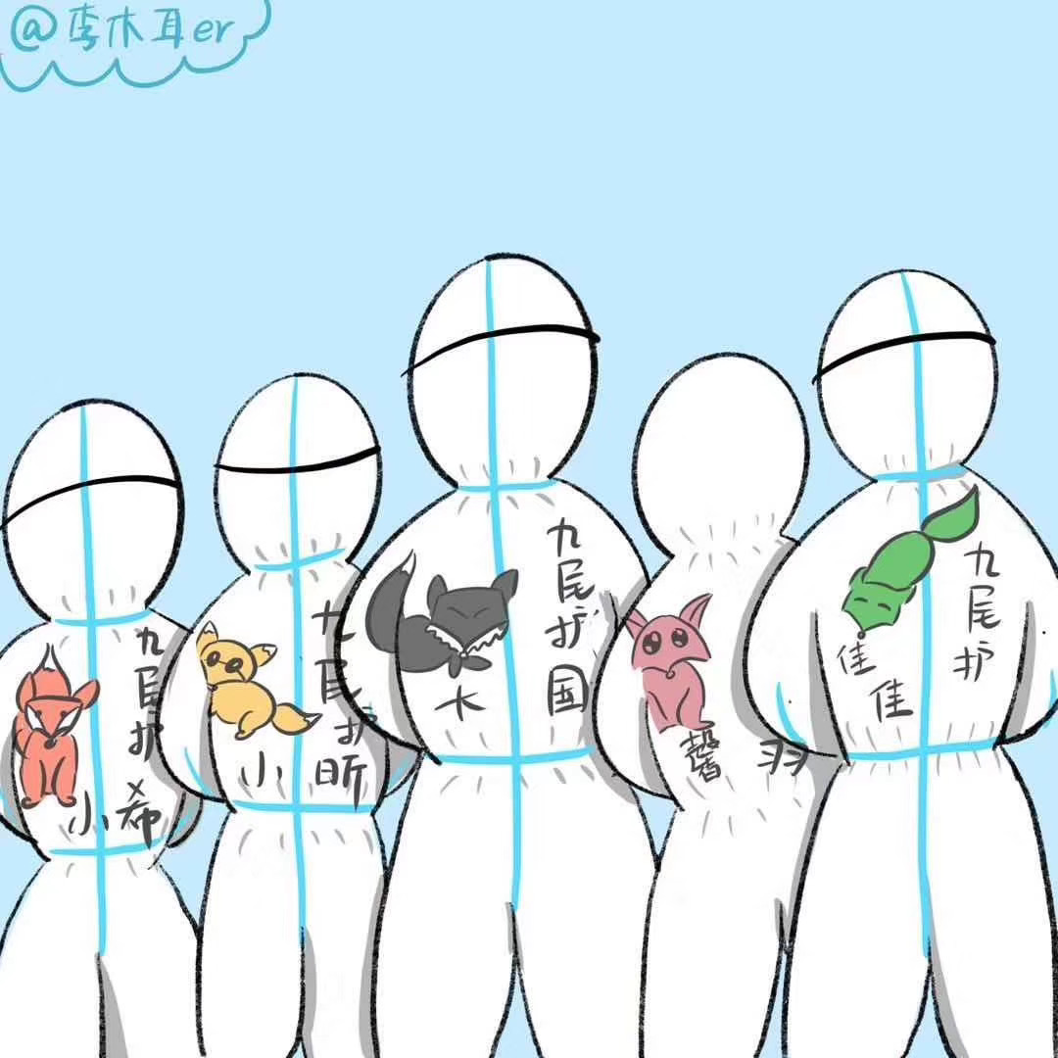

A group of younglings, they are a generation of lovely people. Normally, they act dutifully. When disaster strikes, they step into the frontline to protect their country.

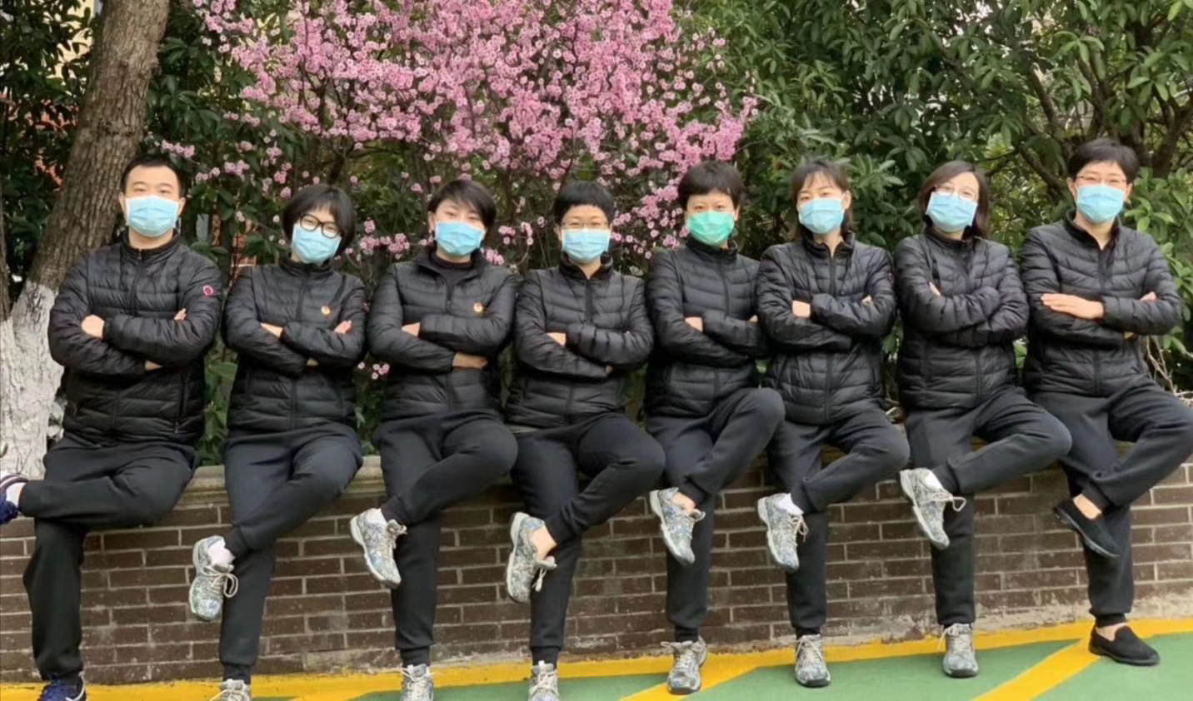Two more days and I will be here for an entire month. I remember Wuhan located in Jianghan plain, it also has rivers, lakes, mountains, and hills. A river goes through the county.  Blue sky, white cloud, jade rivers, being all connected, looping rivers, dense forests, god rays, it all looks magnificent.

If there was no epidemic, the Wuhan now would be a bustling city. It is located in the center of China, passing through the rest of China. The culture here is very wide, diverse.  Before there was a colleague who lived here, he said the people of Wuhan can endure suffering, can enjoy, elegant, worldly. They can endure the hotness of summer, and the freezing winter. He didn’t say this time, they also showed that they can have tears and perseverance, fighting spirit and helplessness.

It won’t be long before Wuhan’s prosperity will return. Children’s laughter, Youthful strides, hustling adults, and relaxing elders.

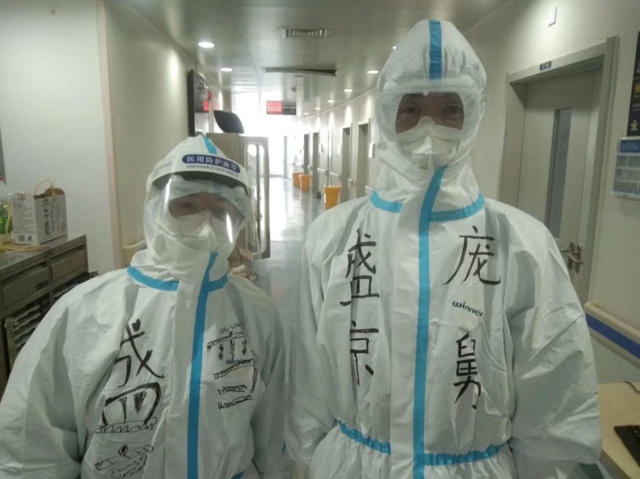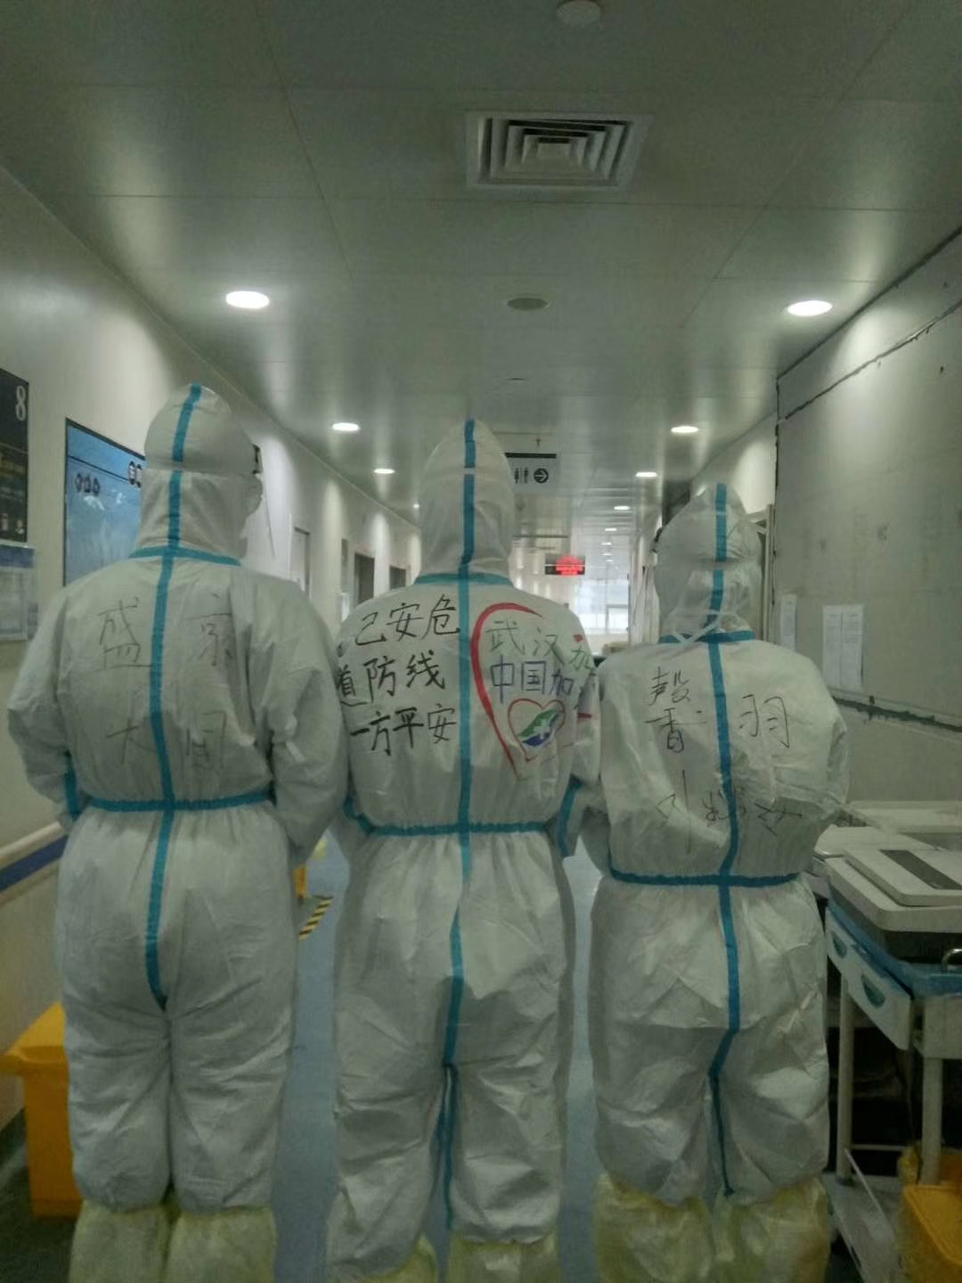

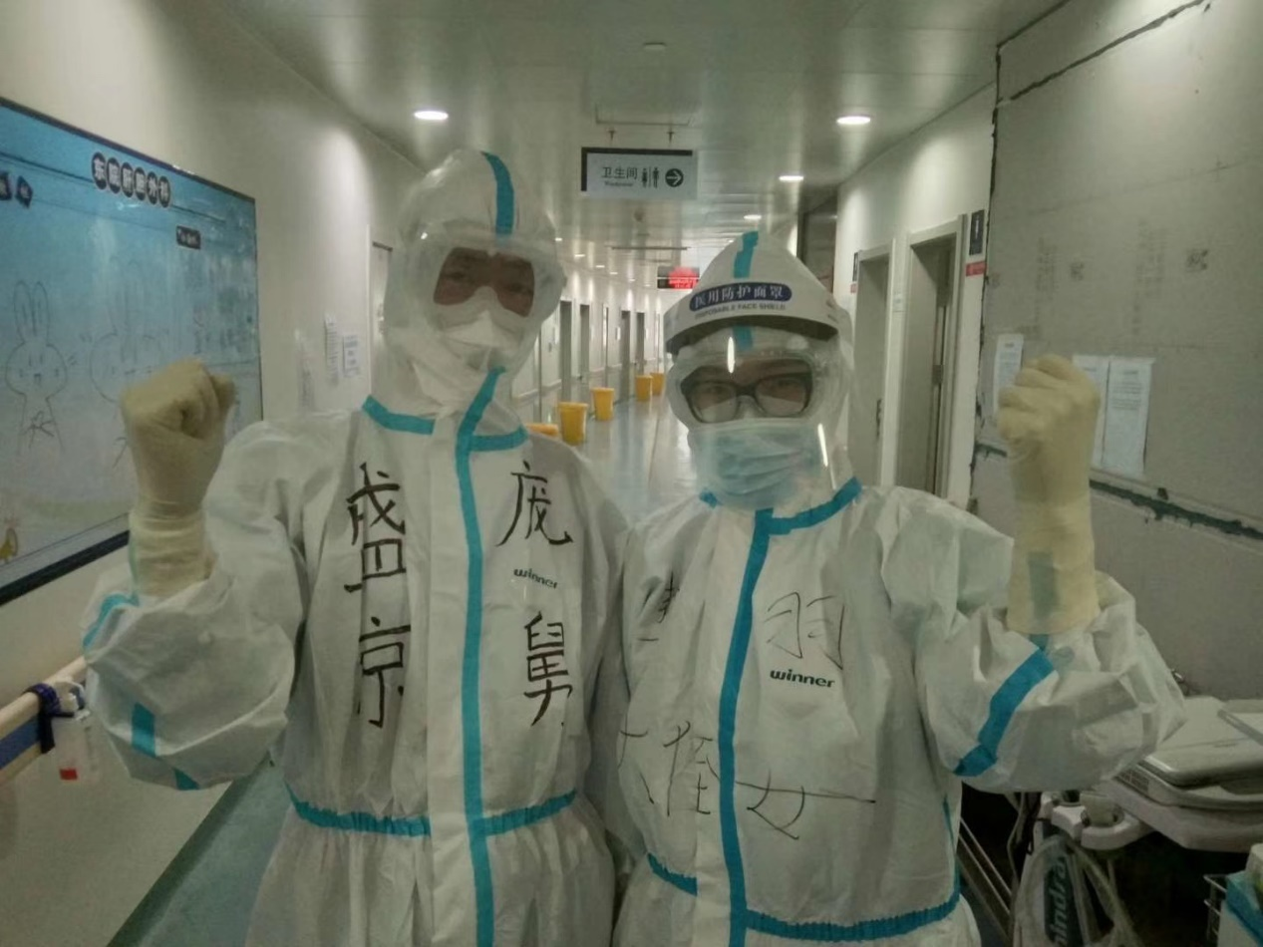

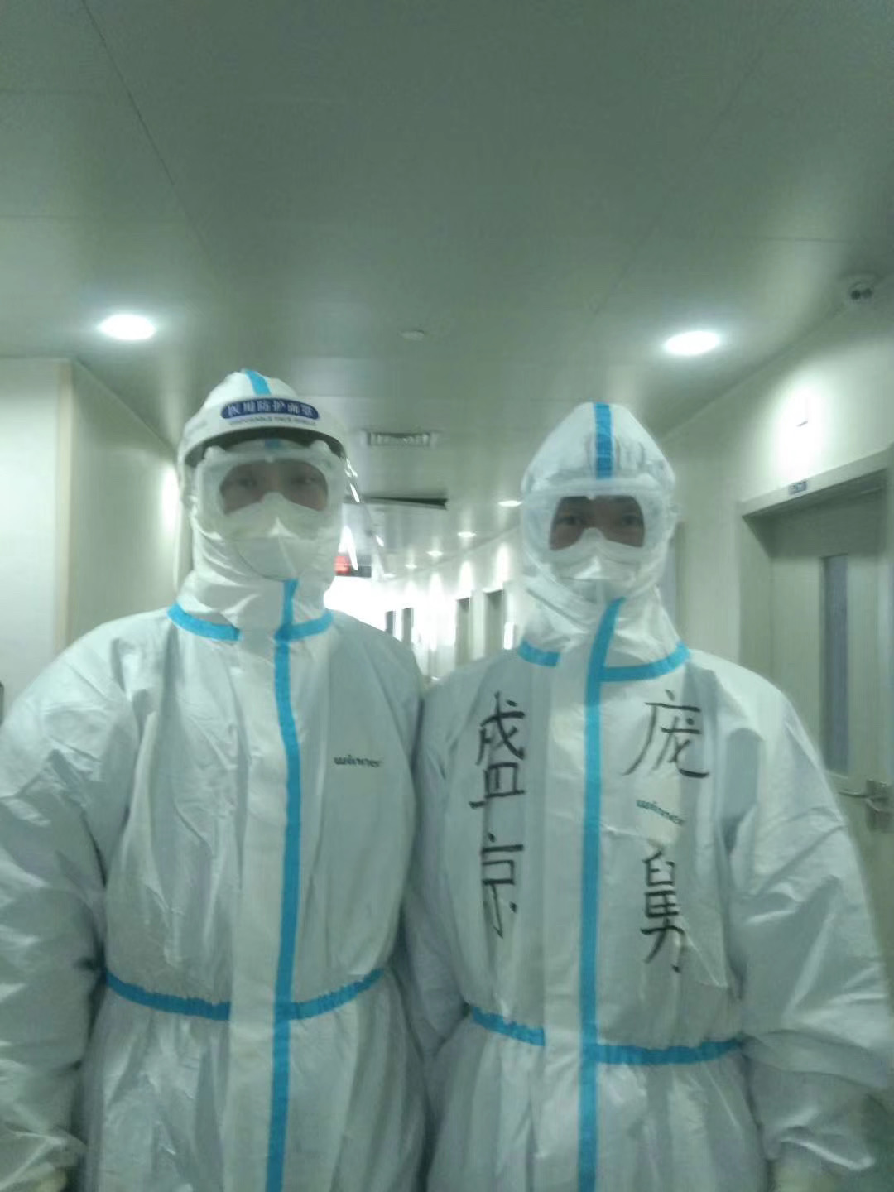

**March 10th, 2020, Thursday, Wuhan, Clear**

Today at noon, the Chairman flew to Wuhan, he went to a hospital to learn the medical procedures, the patients, and the condition of the staff. He kindly visited the patients and shared his condolences to the medical workers in the frontlines. He encouraged everyone to stay confident and to overcome the epidemic. Afterwards, he organized a meeting, listened to reports, and delivered an important speech. The speech is probably already reported by the news. I was very fortunate to be there in person, very honored. The Chairman said: “People of Wuhan love to eat fresh fish, so I will think of a way to deliver fresh goods to the markets.” It was very heartwarming for everyone to hear this. As the commander in Chief of the fight against the epidemic, besides making strategies, he also controlled the tiniest of details. Truly admirable.

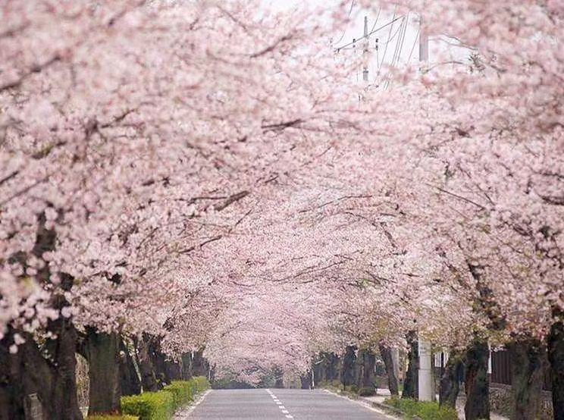Wuhan is becoming warmer by the day, when I was passing the Second bridge of Yangtze river, I saw the reflection from the water. Only 17 new cases in Wuhan today, the last emergency quarantine building (emergency mobile cabin hospital) was closed. The numbers of patients in the People’s Hospital of Wuhan decreased to half. Half of the sector four critical patients also recovered into mild patients. Only the grandma on bed 25 is still fighting against death.

Feeling a bit relaxed, can’t help but to daydream. I remember a goal that was canceled by the frontline, to see the cherry blossoms, now I can only view them online.

University of Wuhan was created in 1893. It was officially called Nation University of Wuhan in 1928. Then the name was changed again after liberty of China, it was changed to just Wuhan University. The earliest cherry blossoms appeared in 1939. It was planted by the Japanese during WW2. Then in 1972 when the two countries established diplomatic relations, the Prime Minister of Japan gifted 1000 cherry blossoms, the Chairman then sent 50 pairs to Wuhan University. In 1973, Wuhan University purchased some more, they replaced the old Cherry Blossoms that were planted during the war. In the 80s Wuhan University started to focus on environmental, the school discovered the cherry blossom trees have become a part of school campus. They continued to add more and more trees to the school, from different sizes, to different colors. Now there are thousands of Cherry Blossoms in the entirety of the campus.

Yesterday the snow is like the flowers, today the flower is like the snow, flowers are like beauty, but all beauty fades. Isn’t it just like Wuhan this year?

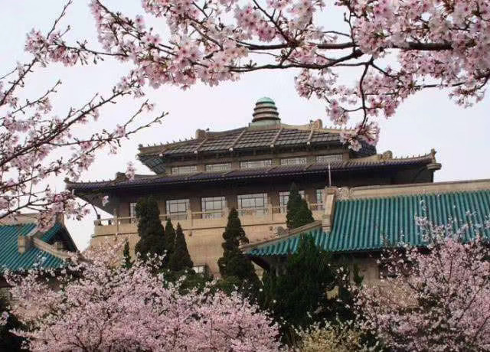Wuhan, welcome us next year.

The Cherry Blossoms of Wuhan, See you next year!



**March 11th, 2020, Wednesday, Wuhan, Clear**

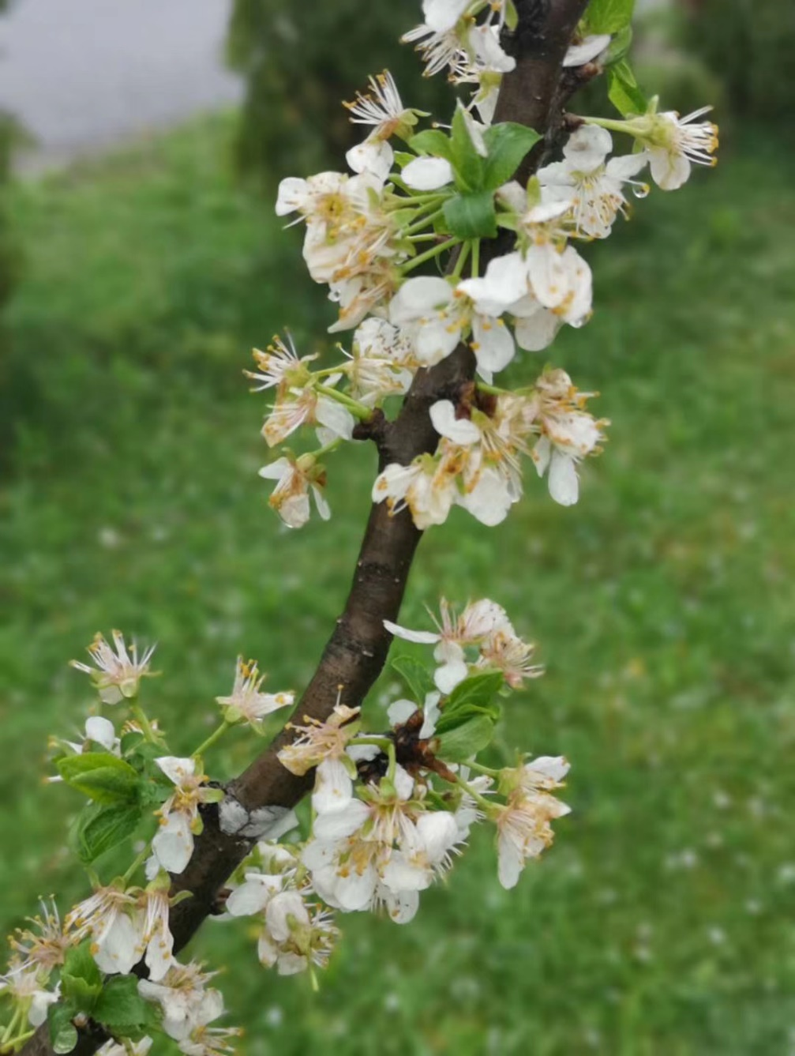The weather in the Hubei province is sunny. Wuhan is the only country still having new patients. Liaoning group’s Xiangyang section only has 43 patients, It must mean our fighting power is high. Wuhan’s sun is rising, yesterday there were 13 new patients, which is relatively relaxing, only a small task for our multicultural doctors. An expert from Huaxi hospital was sent to Italy, I believe he was the first to leave Wuhan then.

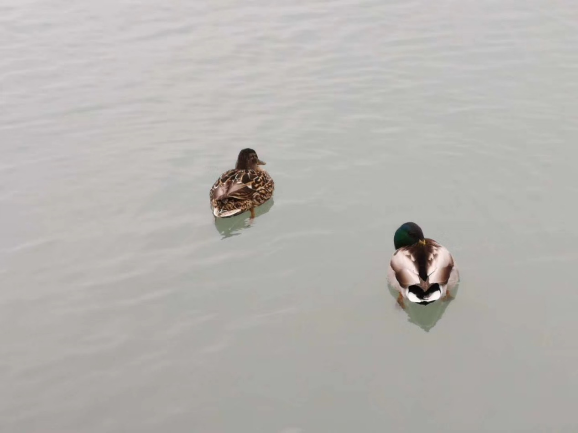We still have struggles with our critical patients. Our sector has good and bad news. The patients in ward sector 3 has succeeded to wean from ECMO (Extracorporeal Membrane Oxygenation, a device can sustain patients alive if his/her heart beat and/or breathing stops). The patient in ward sector 4, whose bone marrow didn’t have hematopoietic function so that white blood cell counts only 4 X 10^8, need thoroughly transfusion of hemoglobin and platelet, and the oxygen flow of ventilation requirement are increased. After discussion, we decided to perform the therapeutic plasma exchange treatment, today the first operation went successfully. We also used sector three’s ECMOs which was just weaning from the patients. Honesty, I really hope we do not need to use it again here.

Our team is now used to living here. Someone once said, a habit can be formed in three week, and we’ve been here in Wuhan for a month now. Even though it's tiring, we still stayed positive. Our team used that happiness to aid the patients. Patient from bed 39 said “Team Liaoning, no problem.” That video reminds me of Northeast sketch, every hospital from the country all feels that the members from Liaoning are talented individuals. I think, if we don’t get to go to the Spring Festival show, we will disappoint that aunty. Shengjing’s emergency Brother Tao also sends TikTok on food topics. If he doesn't send one every two days, then something is wrong.  Also people doing reenactments of their favorite Chinese TV shows.

Wuhan’s streets are now more lively, the hotel employees can’t help but to show smells that were hidden for a long time.

Looking forward to when Wuhan will open gates again.

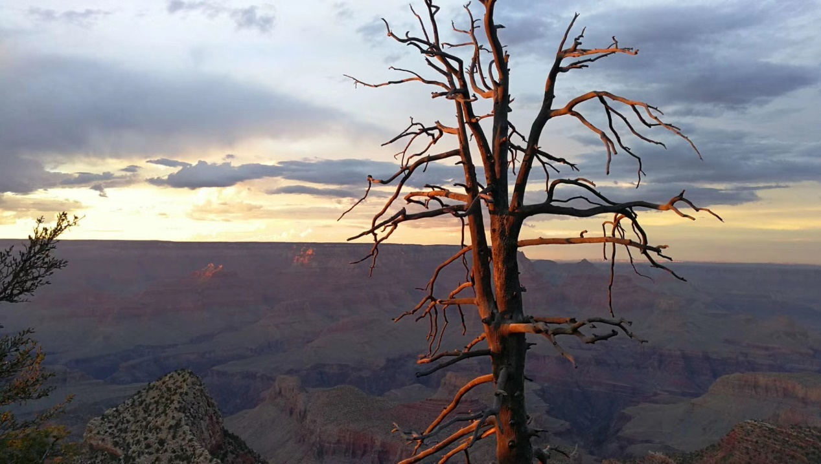

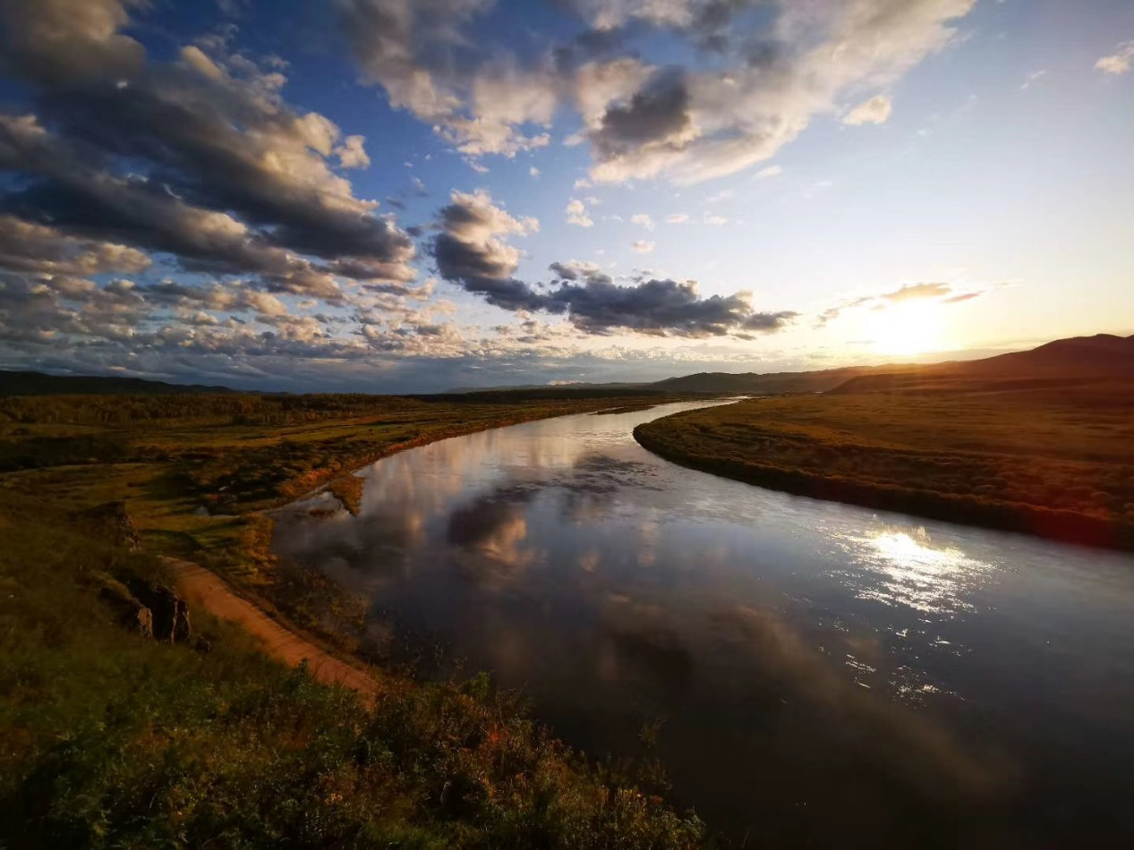

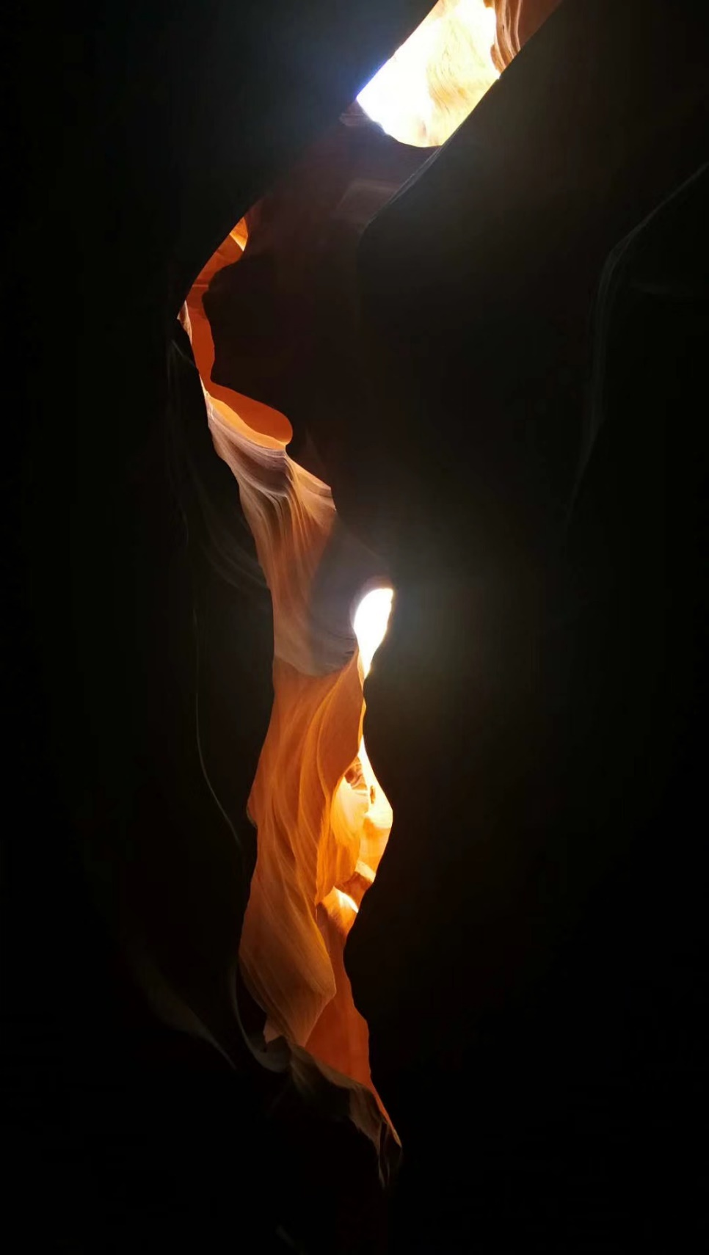

**March 12th, 2020, Thursday, Wuhan, Clear**

A month ago, I took a nameless ticket, I boarded the plane without looking back, but it felt like yesterday. I only thought about it for a brief moment, but I realized time goes fast. One month, only a split moment in life, can go fast, gone before a flash.

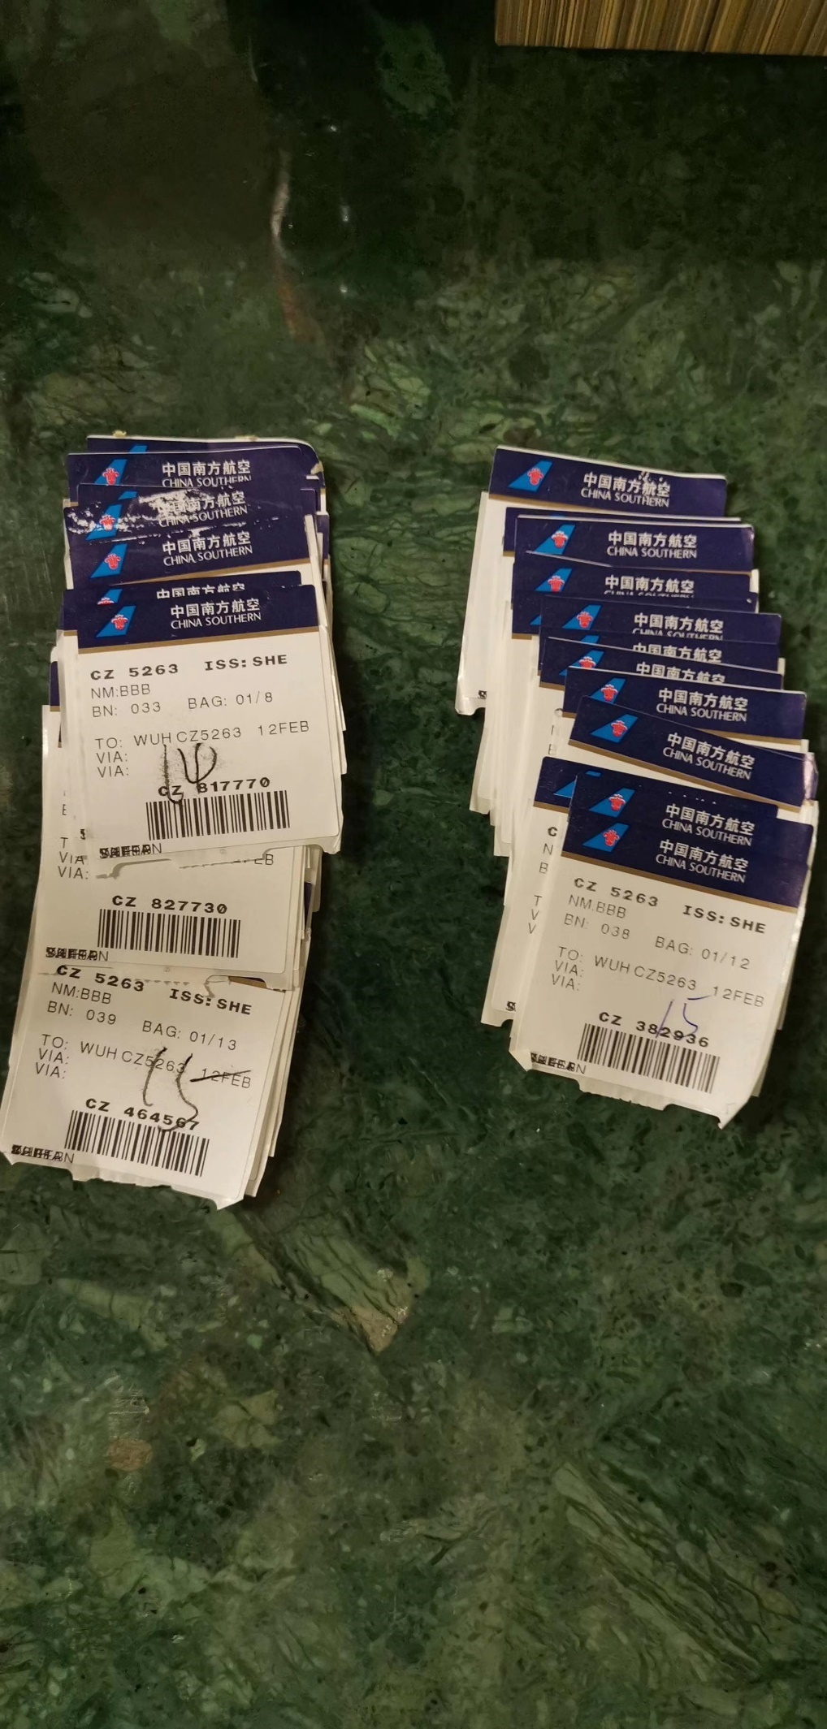

43,000 brave medical staff are still fighting here, with sweat and tears. Finally, it's time to relax and embrace the rising sun, because the ever so bright dawn is lit right on the horizon. Yesterday Wuhan only received 8 new patients altogether. But the 4003 critically ill patients are still fighting the ruthless battle. The virus, although resistant, will meet its end soon.

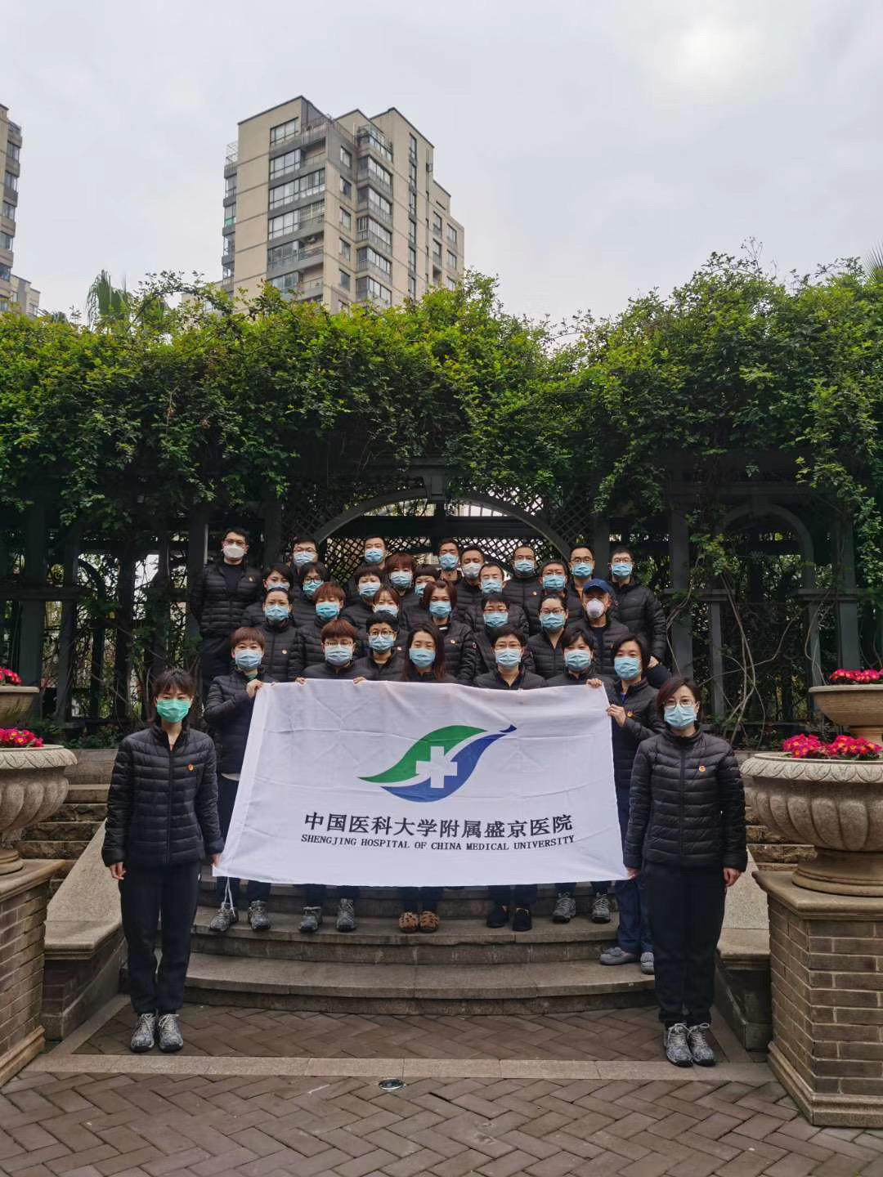

People’s hospital of Wuhan section 4 didn’t receive new patients today, Most patients had already escaped the grasp of death. Laughters between the patients, arguments, even quarrels. No matter the type of sound, it is always better than the voices of suffering caused by the virus. It is not that we doctors like to listen to arguments, it's because they have the energy to talk, the energy which fills the hospital becomes the hope for the future. Doctors and nurses then only need to only break up fights. But the grandma at bed 25 still hasn't recovered. Facing death, when you can’t stop it, you can only pray.

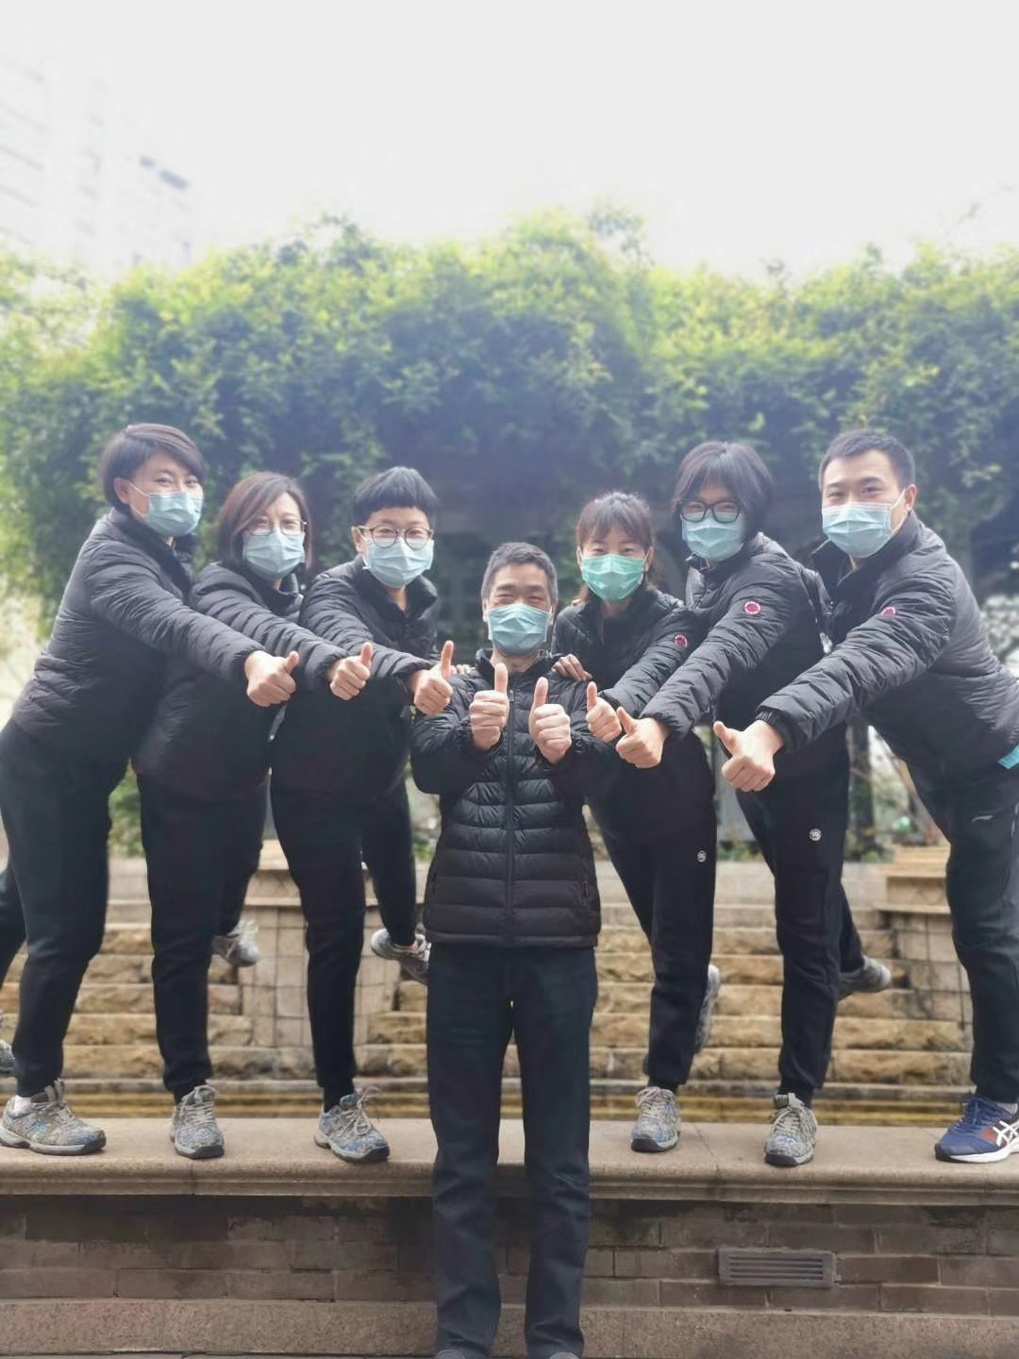Sometimes destiny is already set for a person, it can’t be controlled. Just like time, it can’t be taken back. It reminded my previous volunteers that were more than three months, like the always spring city of Panzhi Hua in Sichuan,  the city of Cangzhou in Hebei, the city of Tonghua in Jilin, the county of Taihe in Anhui, the city of Xianggelila  in Yunnan. I remember the happiness of a grandpa after we treated  his grandson’s congenital heart disease, or seeing a child run after bring him from the brink  of death.

No matter who, you will have difficulties in life, disasters, annoyances, you will also experience success, luckiness, and happiness. Those are all treasured memories for the future. So when life is going good, you must stay humble. When life is going bad, you must take it lightly.

Both the good and the bad must be faced with honor.

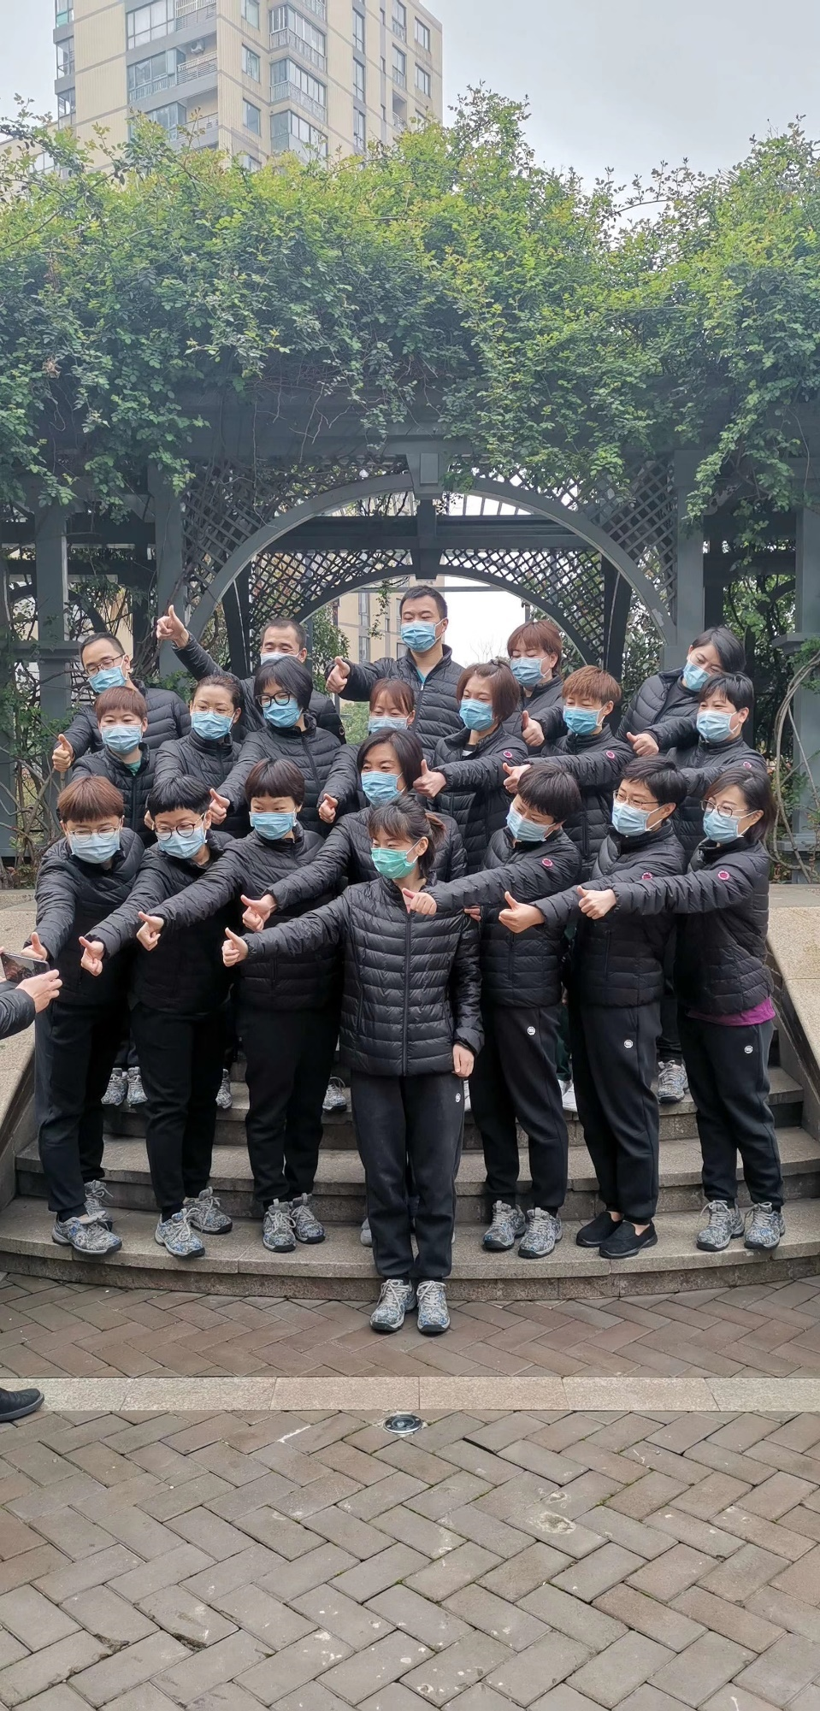

**March 13th, 2020, Friday, Wuhan, Cloudy**

We received the case summary of Wuhan late tonight, and the late news bothered me very much. I was curious about the rate of recovery we had here. I even wanted to believe that no new patient will be added today. When I received the summary, it turns out there were 5 new patients, 1 suspected carrier, all products. Starting tomorrow, I will be mainly focused on the old patients and the critical patients. We still have 3793 cases of severe infection, I’m afraid there will still be hundreds by the end of the month.

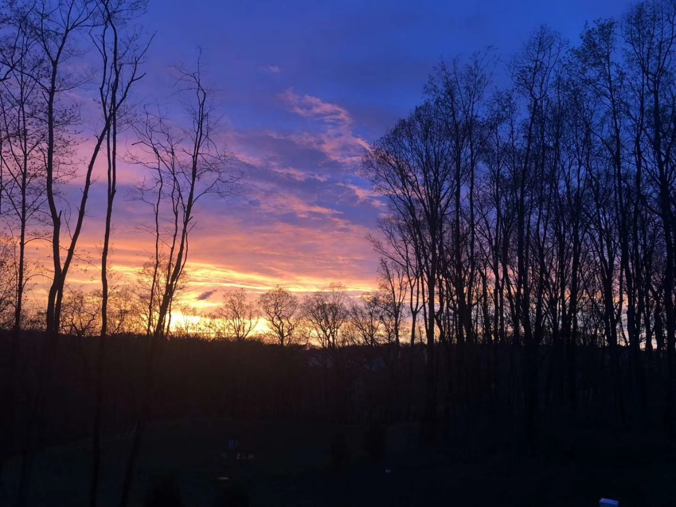

Yesterday afternoon, the Hubei province government announced its four step process to transfer all COVID-19 patients into 10 organized hospitals. The fourth step will be completed by march 31, the People’s Hospital of Hubei Province (East Campus), Leishenshan Hospital, Wuhan Jinyintan Hospital, Wuhan Pulmonary Hospital, and others.  The People’s Hospital of Hubei Province and People’s Hospital of Wuhan is the same hospital, one place, but two names. It will be a place that fights for life. Although the number of patients in the country has decreased, we are still fighting. We will work our hardest, it must be done, we can only succeed.

The lady at bed number 25 still hadn't gotten better, we felt helpless.  The writing below is a recorded diary from nurse Wang Qinqin, a little comfort for people who care for the grandma.

The Grandma is still using a Ventilator, the condition is bad but stable. I observe the grandma follow seven common rules. I kept eyes on her pupil size, vital signs and the condition characteristics, on the other hand managed the prescription carefully. The airway administration is crucial for the intubated patient with ventilator, and we take care of the condense of the piping system. But during the process, I realized  many ignored oracle care, oracle care can offer the patients comfort and good hygiene, it also prevents respiratory infection, which reduces ventilator related pneumonia. “Grandma, I will now clean your oral cavity, please cooperate with me.” From cleaning the oral cavity to the change of cavity fixation equipment and tapes, all procedures well performed are all hard works. Every time I’m doing this procedure, I always try to start to conversation, like “you are currently having anemia, I’m going to give you a transfusion of red blood cells”. “Today is March fifth, and its seven in the morning, I’m going to wash you.” “Grandma we will push through together, everyone is wishing you to recover.” “I hope you heard and remembered our conversations.”

This also represents the dreams of the entire hospital staff. Although we had no death this month, but death is right around the corner.

The Cherry Blossoms in Wuhan are blooming, but they are sad and lonely.

.

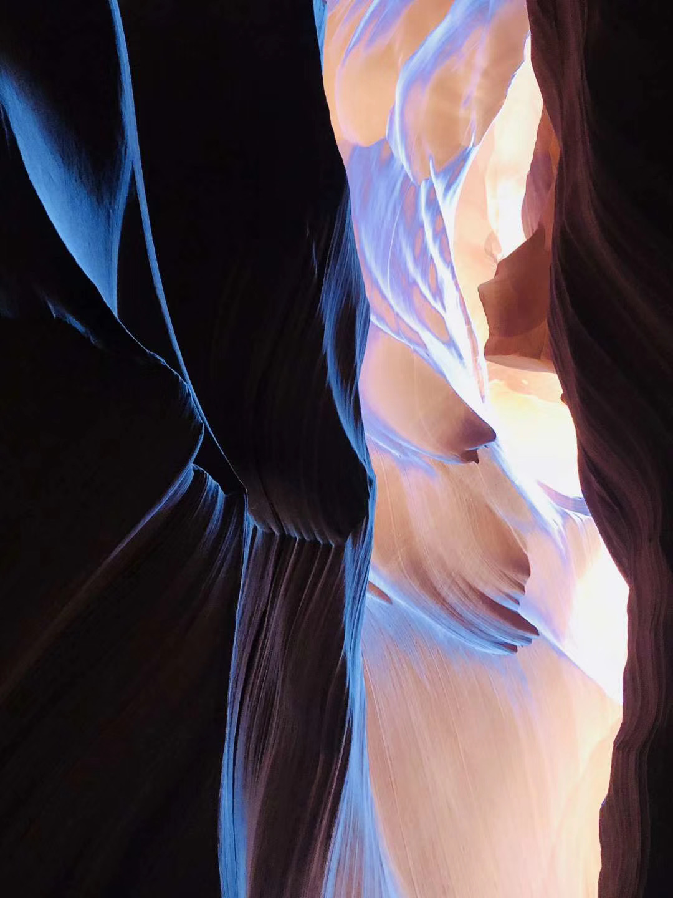

**March 14th, 2020, Saturday, Wuhan, Clear**

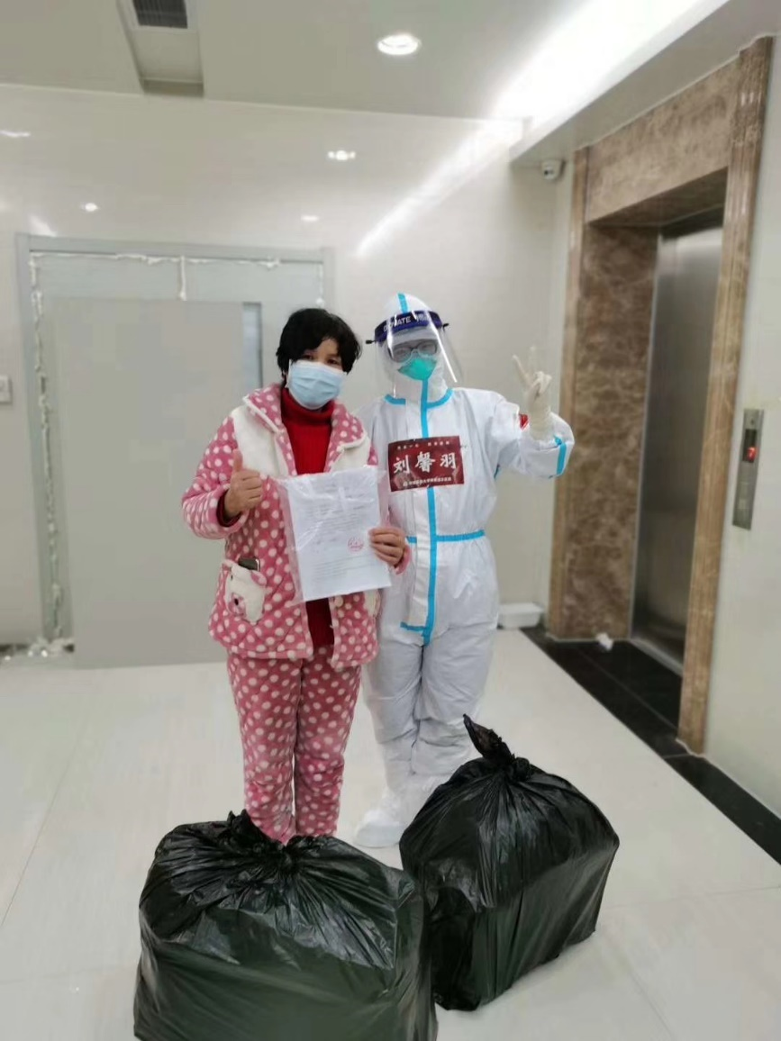Wuhan in March is no longer cold. Sometimes the sun hangs high above the sky, sometimes rain gently falls onto the ground. I dislike endless rains, because the rain makes the dreams cloudy. Wuhan has been quarantined for two months now; Wuhan citizens must yearn for the bright sun. Even if it rains, it should rain gently with minimal sound. Let us search for a sweet memory. When we came here in the Winter, we were given a short notice in fighting the virus and the fear. Facing an unprecedented event, we can only hope to achieve victory.  When the people of Wuhan saw doctors flooding in from every direction, they must be in tears because their long wait was over, now there's hope.

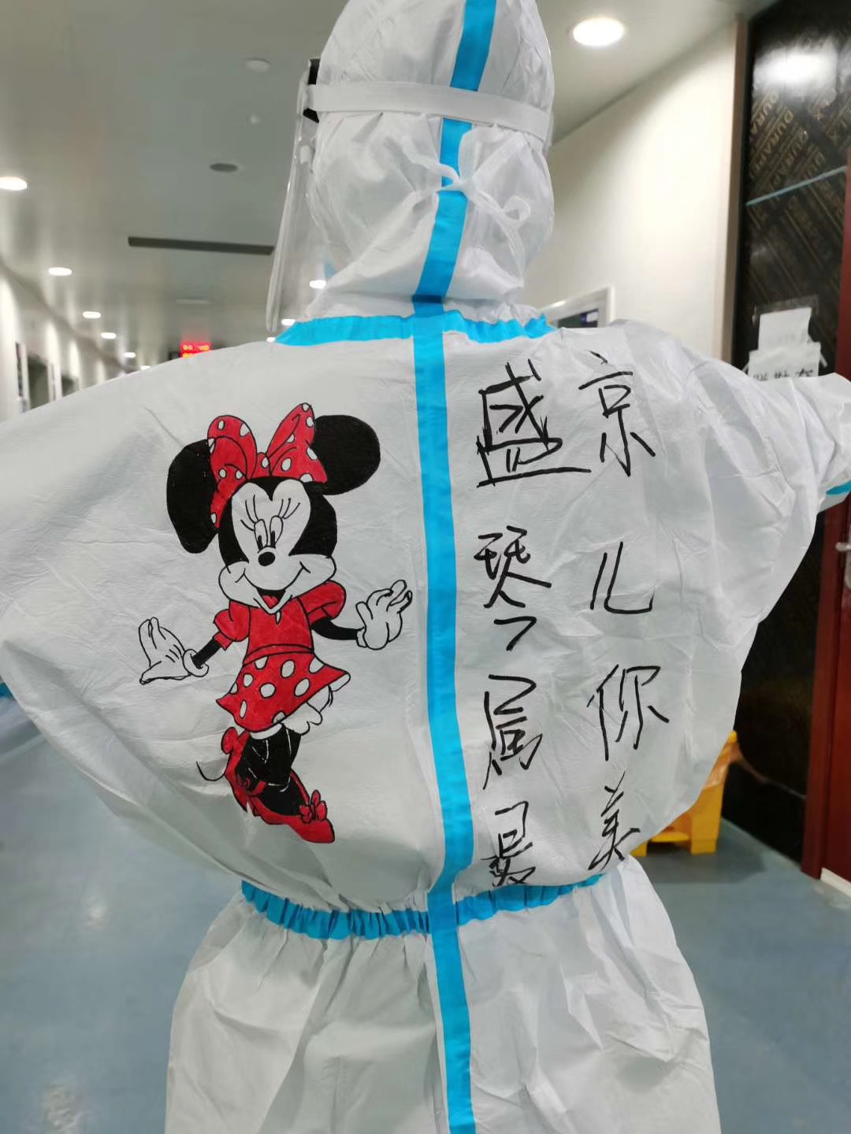Just like the citizens of Wuhan, we must act like them too, to not give in hard times. Life is a difficult thing, there will always be times where you are beat down. From youth to old, there’s always struggles. But looking back on every struggle, you think it was nothing. Wuhan next year will be a warm place. Walking on the city streets, you can see Willow tree, and the newly blossomed cherry blossom.

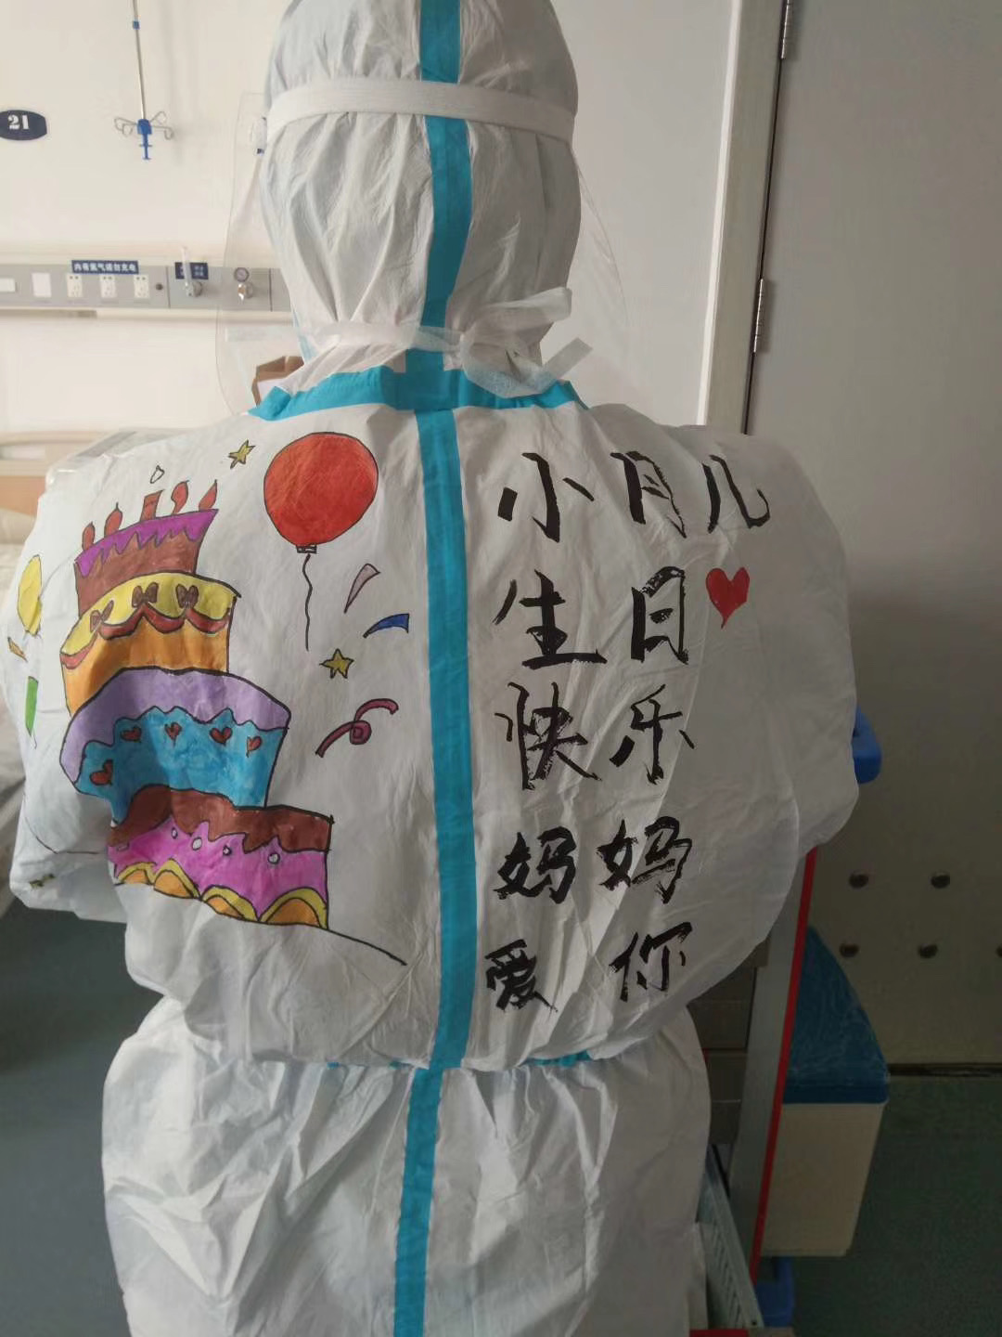The cherry blossom, the spring rain, the Yangtze river bank, all makes the city of Wuhan much more pretty. This is the city the people of Wuhan live in. Us doctors must succeed.

Tracking today’s case: Four new patients, 0 suspected cases, 3410 critical patients. The grandma in bed 25 is still the same.

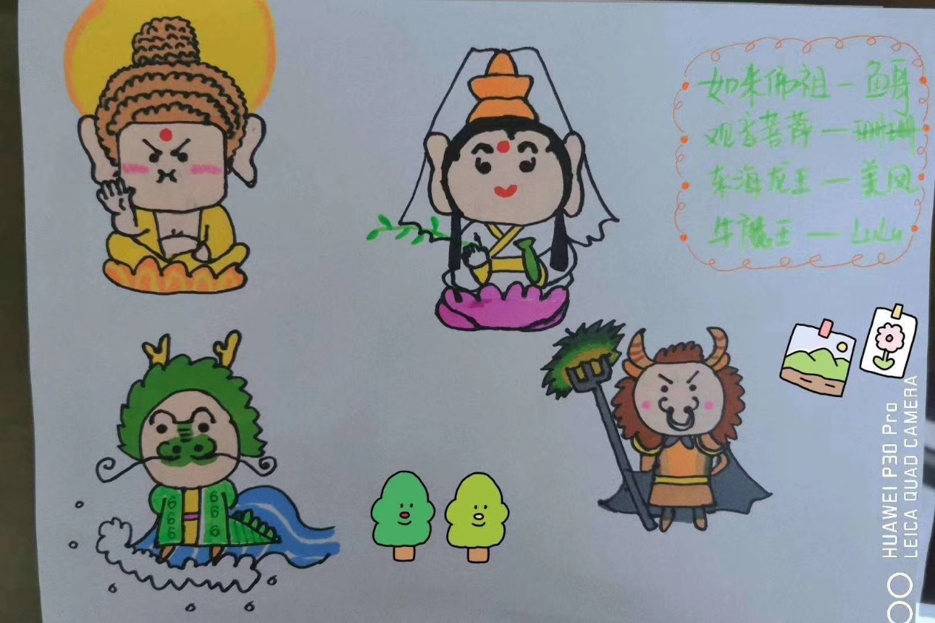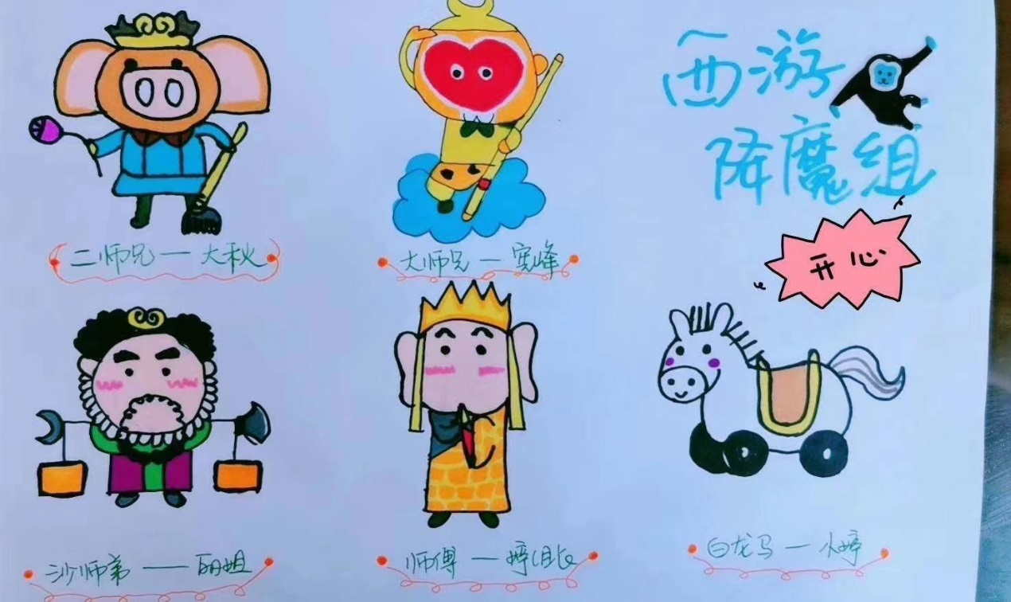It’s the final battle, we hope for a victory.

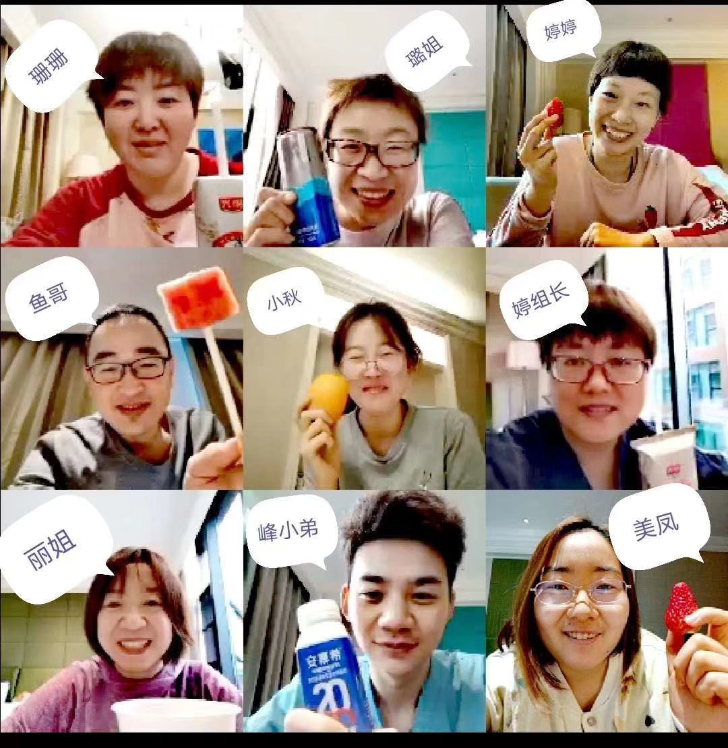

**March 15th 2020, Sunday, Wuhan, Clear**

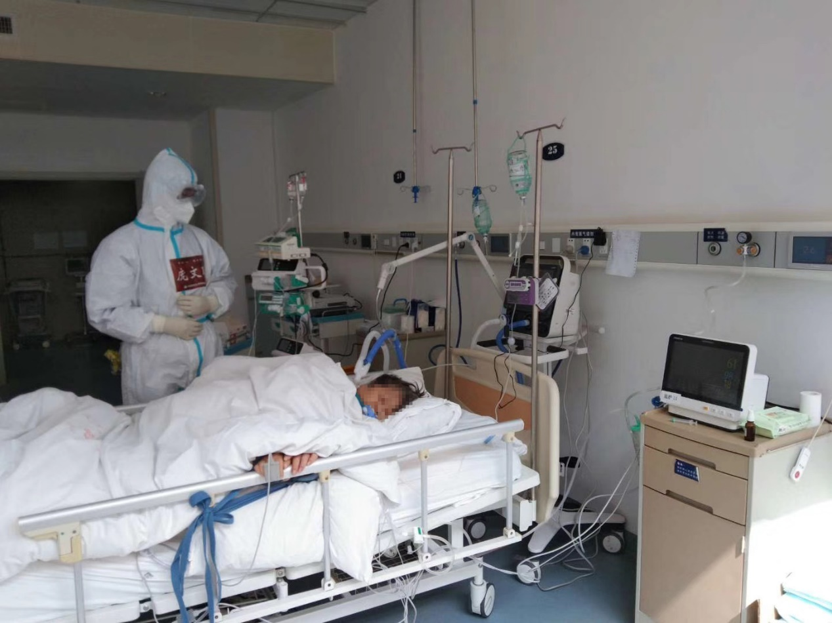Today’s news, because of the nation wide support for Wuhan, the condition here is getting better, patients can be transferred to better hospitals. Light patients are transferred to Huoshenshan Hospital, Leishenshan Hospital and Wuhan Jinyintan Hospital, and seven others. The critical patients are transferred to Tongji Hospital (Guanggu Campus), Union Hospital (West Campus), and People’s Hospital of Wuhan Province. Our Liaoning team is located in one of the critical patients hospitals, we are responsible for two sectors. We now added Henan team, so we changed our team name to Liaoning-Henian Medical Team, the teams welcomed each other. We have empty beds here, but the increase in transferred patients from 56 other hospitals all changed that soon, it seems we must continue to work hard. The team is calm and confident, but now we will not be able to go to Israel or Italy.

Yesterday, the two sectors released 9 patients, the highest amount for us. It seems more and more people are recovering. Today Wuhan received 4 new patients, there are 3058 critical patients still, and 569 patients in dire situations. Of course, the grandma in bed 25 counts as one of the 569 special patients. None of our treatments showed any effect on grandma, a test shows no improvements, it's like she's hibernating.

So, let us hang in there.

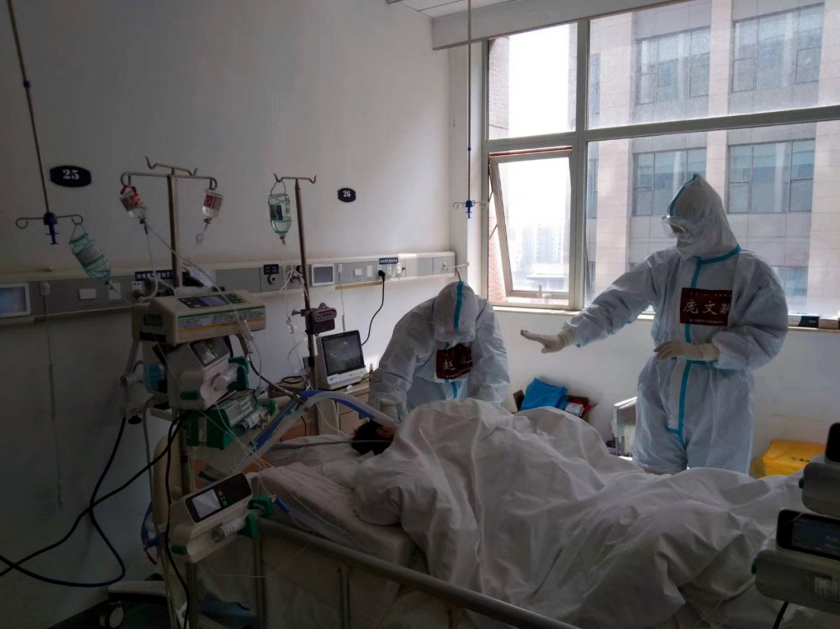

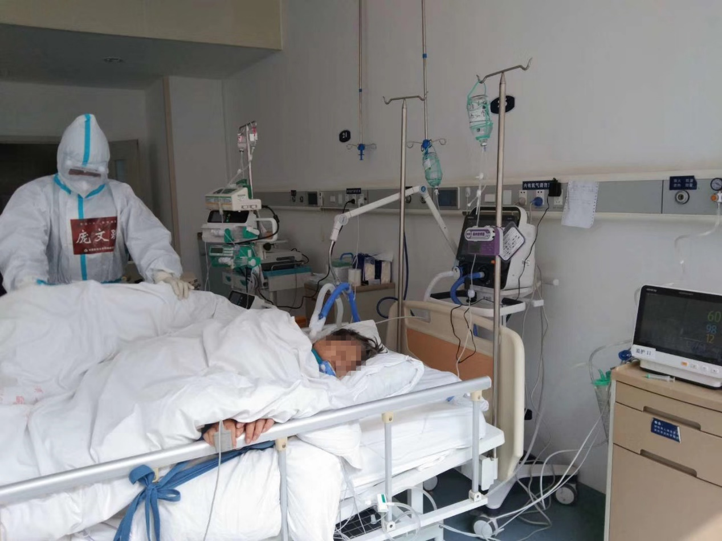

**March 16th , 2020, Monday, Wuhan, Clear**

You left. Unable to defeat the virus.

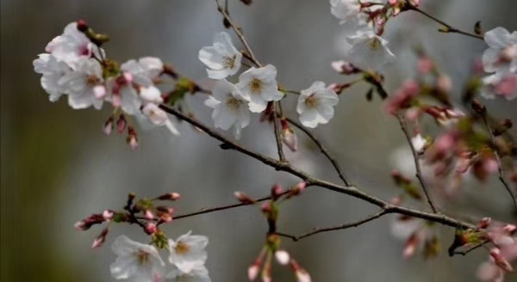2020.03.15 22:43, you stayed at the hospital for 16 days and 5 hours, we’ve worked in the hospital for over a month and 14 hours then. I remember when you arrived, already in a state of delirium, saying only one sentence “When I was 13, I enlisted for the army.” I believe you are a warrior, at least when you were fighting with the virus, you showed the fighting spirit of a soldier. I remember the first time to attempt to wean from ventilator脱机试验中, you looked at us with a wide eye, lost in your own train of thoughts. I still remember you with a ventilator looking calm and peaceful, there was no pain nor happiness, no craving for life nor the fear of death. We only know you by name, age, the retirement home you stayed, and a phone call with your daughter, we don’t know close. We’ve only met for 16 days and 16 nights, we have not met each other in the past, we will not meet in the future.

Although we are strangers, we still hope for you to have a safe trip, and we lit candles in order to light the road for you. Now, us doctors and nurses who came here to Wuhan also must stay strong like you did. You will be remembered by all of us, thousands of discussions, countless sleepless nights. Even though we can’t stop the inevitable, we still fought with you to the very end.

You, please have safe travel! We will be marching too!

I couldn’t sleep yesterday, so I walked around the hospital. It was an empty night, there were no stars in the city. The city lights, my emotions can’t be described, there were sorrow, pained, dazed, disappointed. I have seen many deaths as a doctor, but there will always be some you remember.

Life is like flowers, they blossom, they fade, leaving only the smallest scent of fragrant.

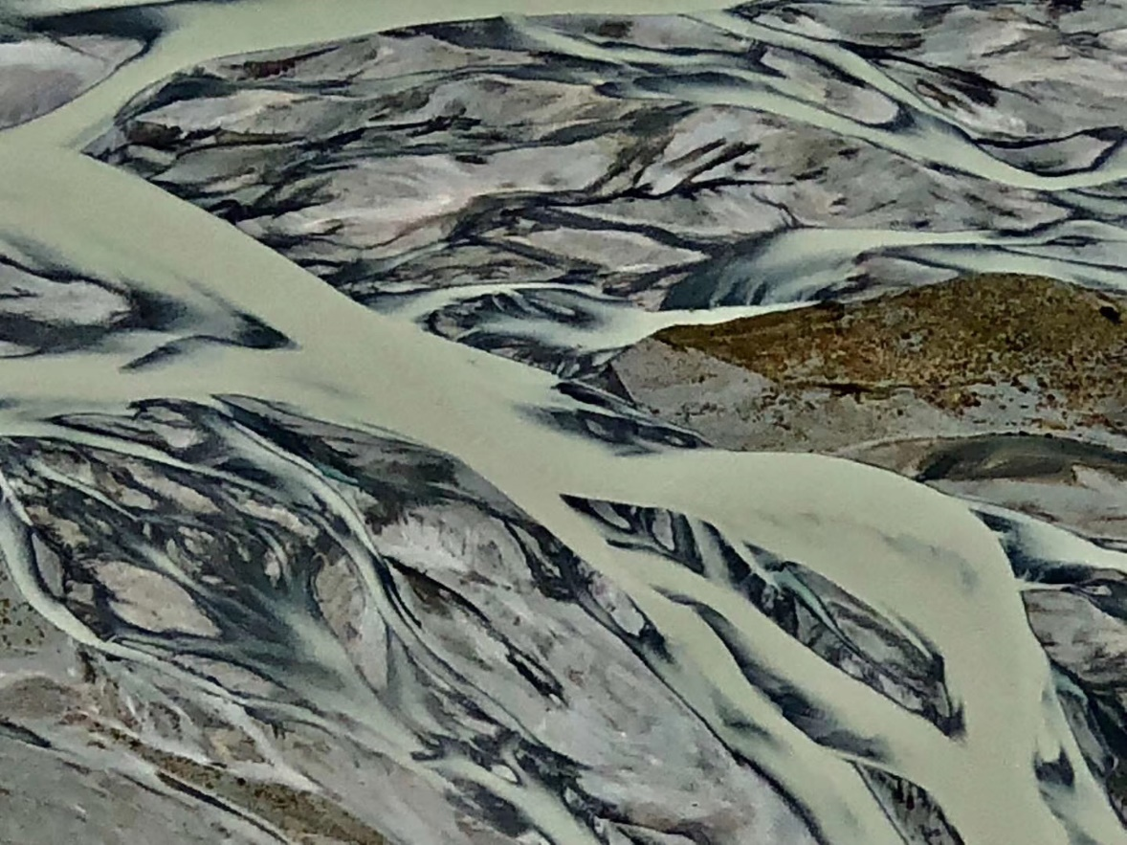Wuhan only received four new cases, a trend for three days now. More and more critical patients are recovering, only 1878 cases remain. We never expected things to turn so quickly, the rising dawn must be around the corner.

We maintained zero death for 1 month and 14 hours.

Let us start over, back to zero.

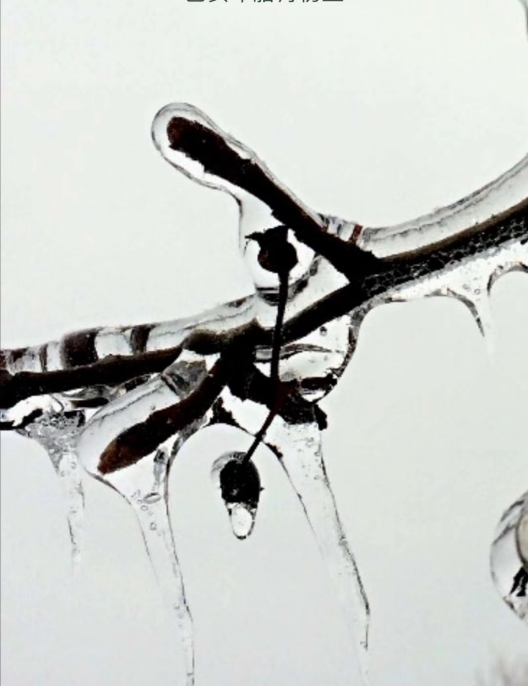

**March 17th, 2020, Tuesday, Wuhan, Clear**

The rainy weather the weather report mentioned never came, although it is the sunny March, no rain would dare to exist. But in a good mood, I still enjoy the light drizzles of rain. If I had nothing to do, I’d love to sit down and enjoy a cup of warm tea with friends. But this is only a dream.

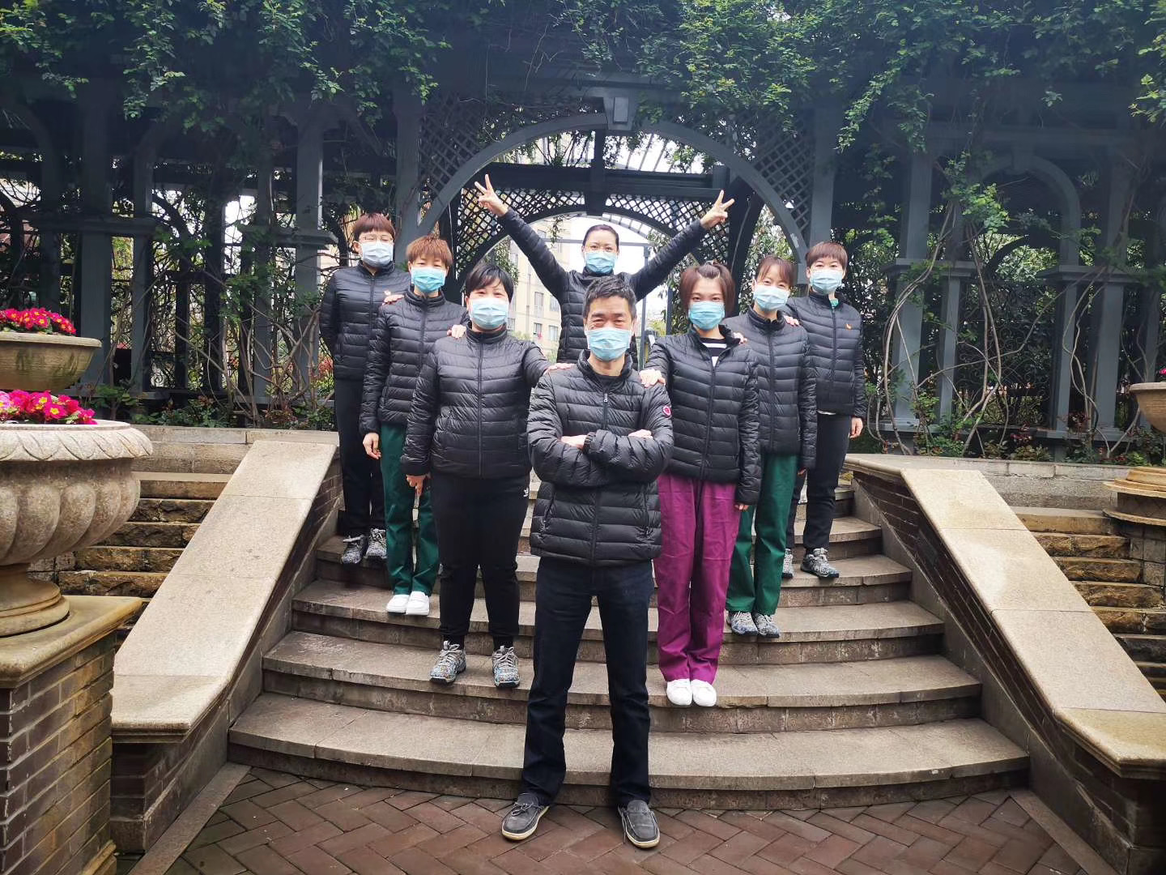

Returning back to the sunny sky, a portion of our team will be leaving Wuhan, I’m very happy for them. The first wave of fighters has already been here for more than 50 days now, Spring festival should’ve been a happy time spent with families. While the virus went on rampage, the casualty is more than you can imagine. Now, we are confident but tired. So when we finally emerge victorious, you can leave with a proud feeling. Know your tears, your unwillingness to leave, and your remorse. Today we received one new case, zero suspected case. 8304 total cases remaining, in those 504 patients are in critical conditions. Although the total cases are low, the fight is still intense. The fight requires endurance, technique, and determination. We cannot lose focus, cannot be clumsy. The Liaoning-Henan Team now have some empty beds now, but since the passing of the old lady from bed 25, everyone is feeling low, feeling regret that we didn’t save her.

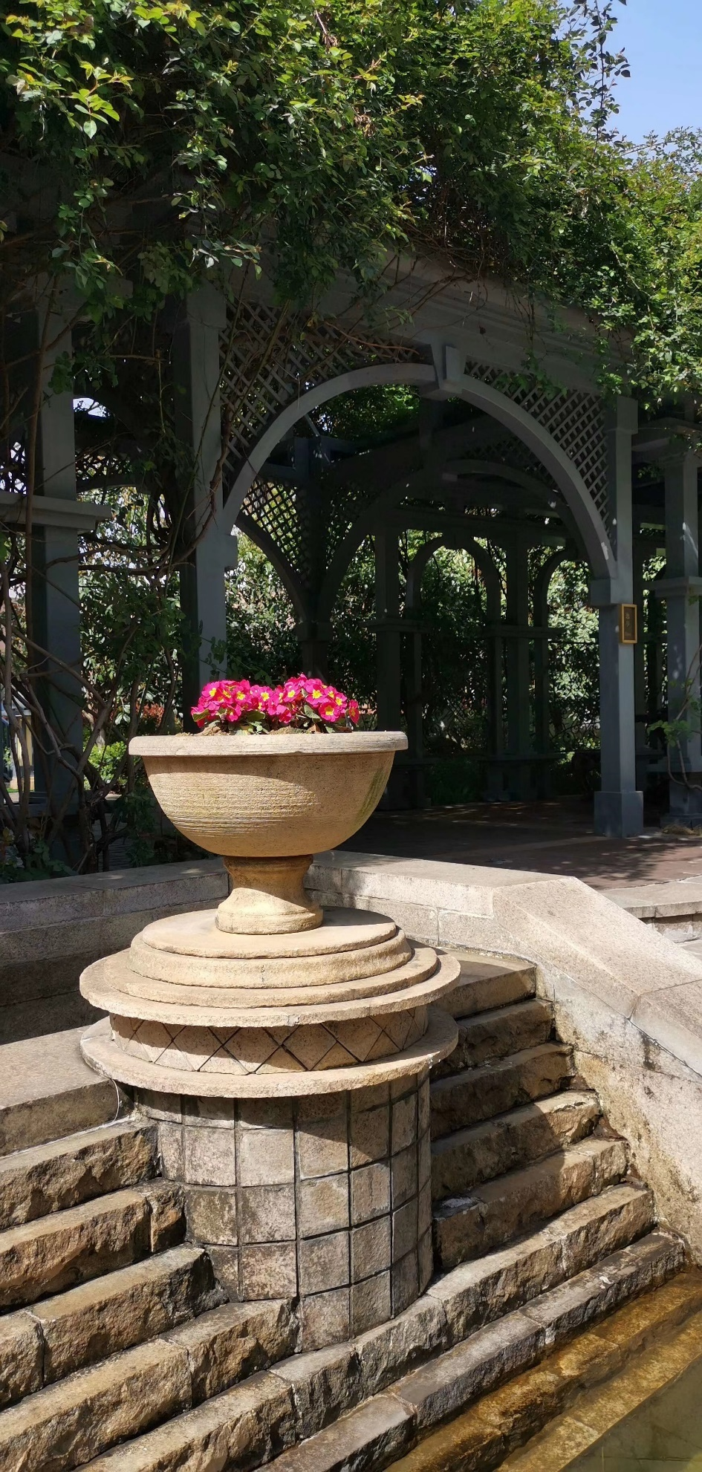

**March 18th, 2020, Wednesday, Wuhan, Clear**

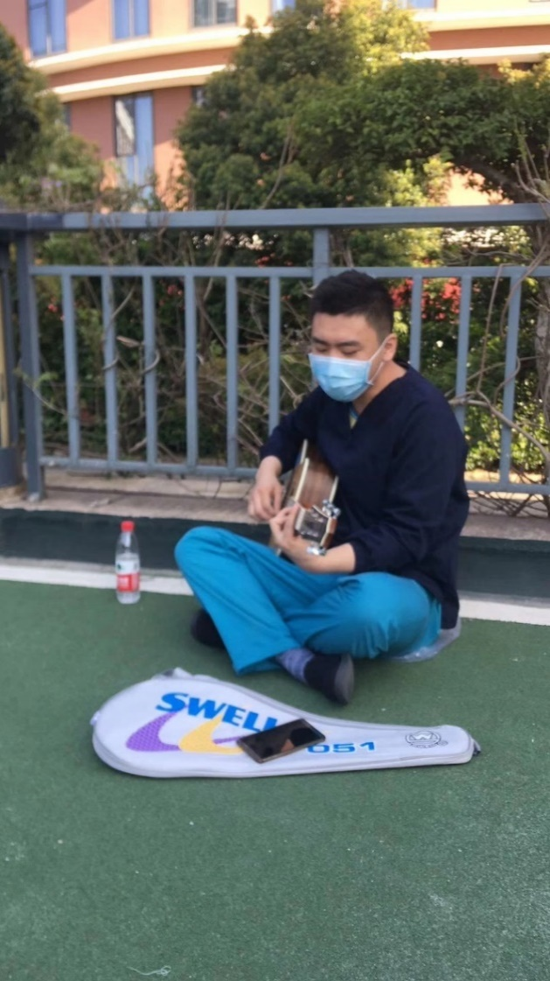The hotel serves warm meals from 5 in the morning all the way till midnight, for me, a person with no set times to eat is perfect. I cherish these worry-free days since we will all be leaving soon. I never realized; we must work to eat. But in reality, there must also be enjoyment, then life becomes interesting. I’ve enjoyed looking at flowers, listening to the rain, and enjoying eating snacks not because we must, but because we can. In the hotel yard, different doctors and nurses took pictures together as a memento, to memorize this forever when they leave. Someone borrowed a guitar from the hotel and started to play and another started to record it on his phone. The crowd is lively, perhaps they are all ready to go back home.

As a critical care team, we all know we will return home later than most. There are still over 2000 patients that need our help, and it will take time for them to recover. We are still receiving more and more critical patients transferred to our hospital. So while we are happy, we still have heavy responsibilities.  The most important goal right now is to save lives. Comparing our statistics to abroad, we are already doing pretty well, but we want perfection. Our health organization said in a press report, that one critical patient will have one group of medical staff. Indeed it is like that here, so the citizens of Wuhan please don’t be scared. The doctors and nurses who were leaving were greeted by the people of Wuhan from their balconies with tears in their eyes.

At night, I was asking my team of their well being. A Nurse called Xinyu Liu told me she is homesick, because her son just became a year old, he growled a lot in those short time. She felt proud coming here. A mother of course will miss her son, so I said “Because you are away, your memories of your son will be much deeper now and much sweeter., so stay strong.”

Friends, Goodnight.



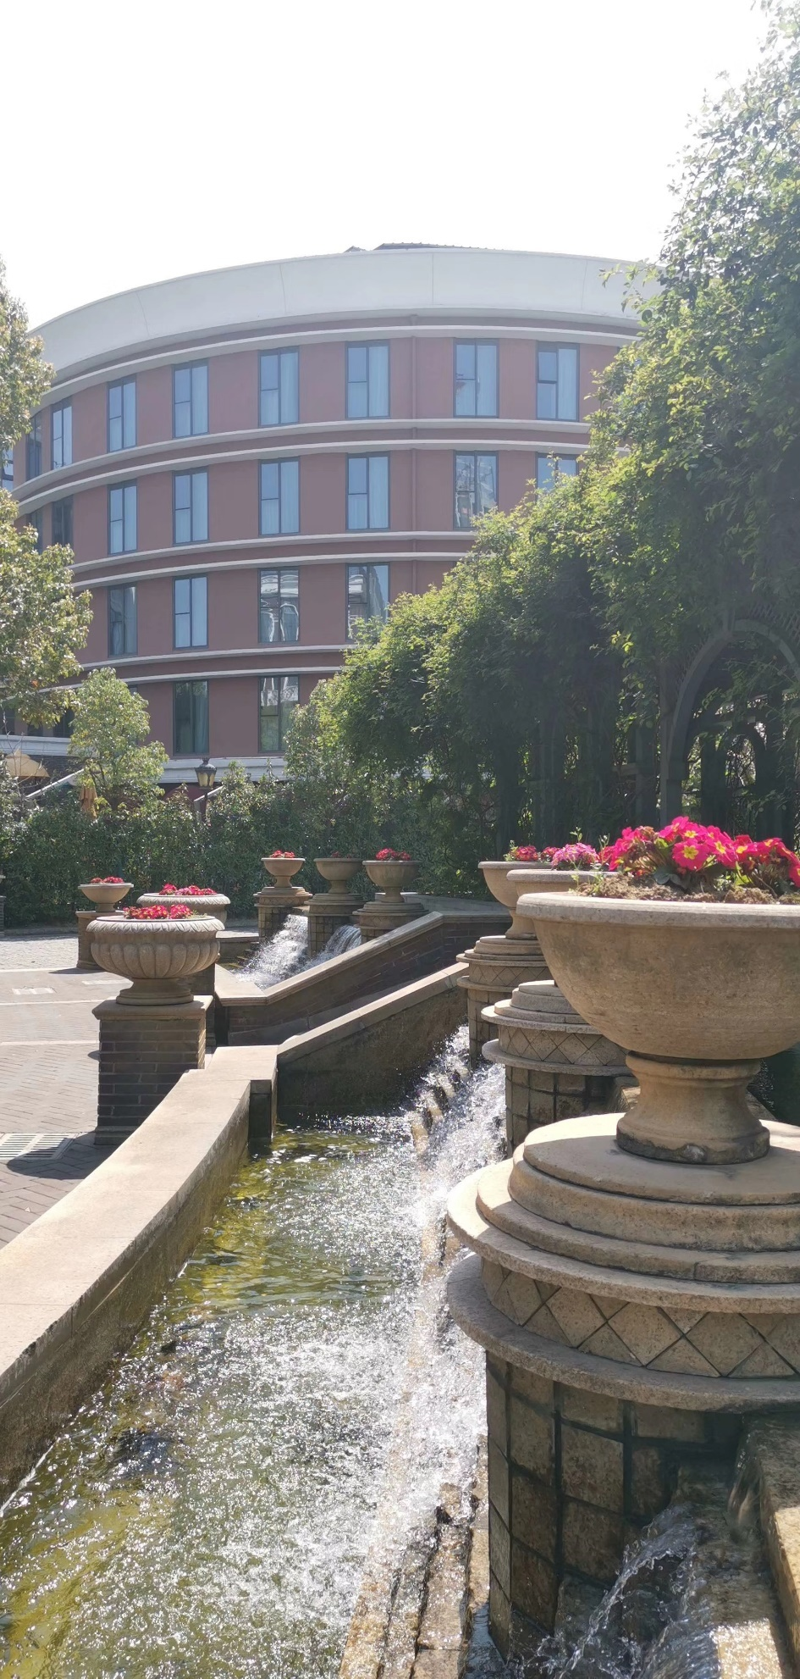

**March 19th, 2020, Thursday, Wuhan, Clear**

Wuhan today, the sun hangs high in the sky, lighting the ground. There is no frost or wind outside of the window, life is all organized. The peaceful time has finally arrived. No new patients or cases today.

After seeing the news, I sat and thought to myself for a long time. Recalling my journey, I felt happy. Wuhan’s been closed for 2 months now, and this zero will finally wash away from sorrow and sadness. And to motivate us.

I remembered a picture of a cherry blossom tree after snow. The combination between the snow and the flower is truly a pretty sight. Just like Wuhan this year, no matter the struggle, the warm spring filled with hope will always arrive, not matter how harsh the winter.

Behind the zero, how much perseverance and effort, how much sacrifice. Success belongs to the aiders and the citizens of Wuhan.

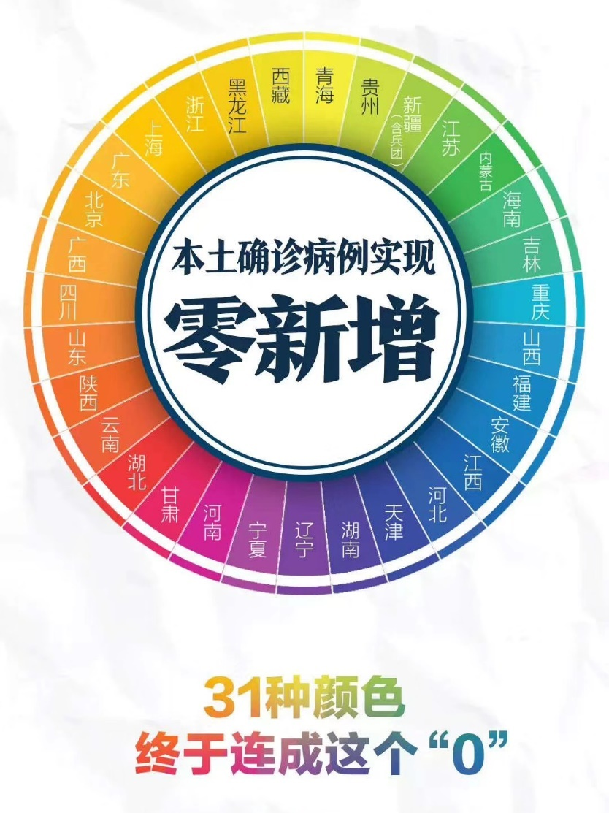

**March 20th, 2020, Friday, Wuhan, Clear**

From today, there will be more daylight than the night. Today we received no new cases, and 624 patients recovered.

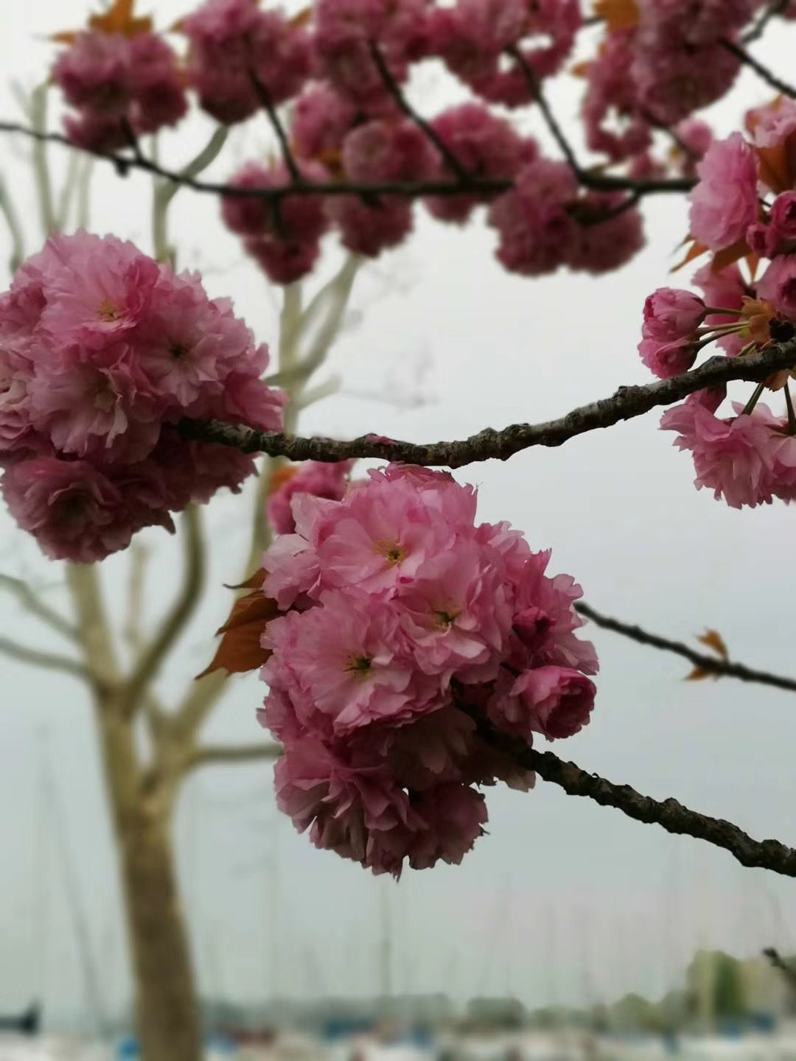

Today the first wave of doctors and nurses from our hospital left for home, they were welcomed wholesomely back home. I felt happy and jealous.

At night, I saw the report from a reporter. It was a video of a fallen doctor’s mother; she took 200 cases of soup to see the doctors that tried to save her daughter. The team and the mother were all hugging. It was a sad scene. Only mothers can understand a person’s soul best, we experienced her love and her suffering. The pain in her heart is light, heat, it is all life.

A great mother who nurtured a great daughter.

The Liaoning medical team built a WeChat group for Xia's mother, named "Liaoning's children".

A friend of mine asked when I would return. I told him it will take some time, there are still 2 thousand patients in hospitals. Those patients are all difficult to treat, but our team is not deterred, we will only leave if everyone recovered. Compared to the beginning, there are only half the amount of patients left.



**March 21st, 2020, Saturday, Wuhan, Rain**

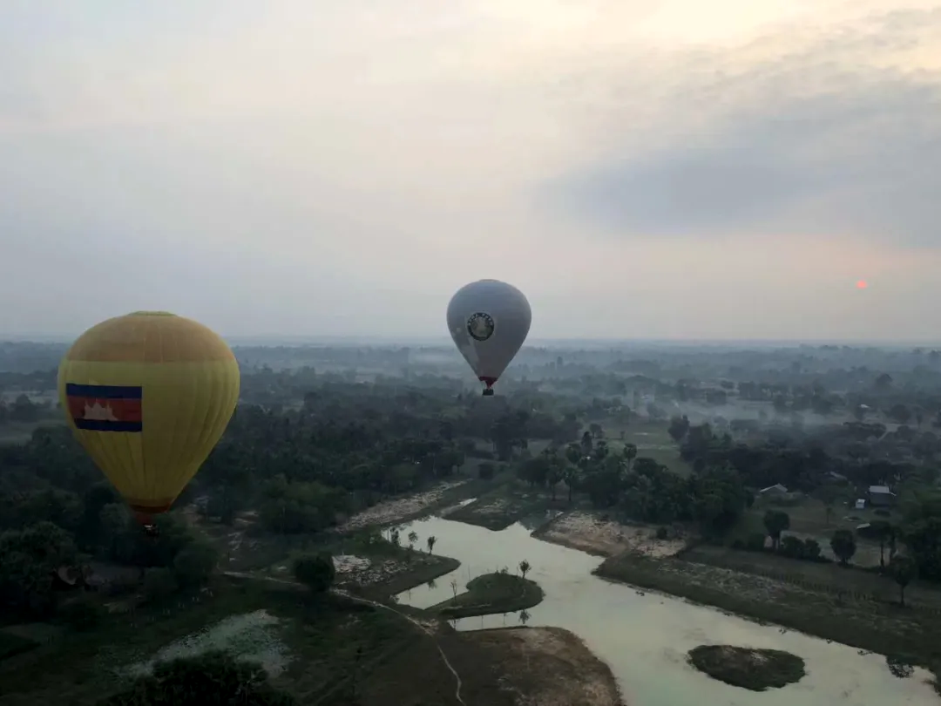Although we were here for only 40 days, those were memorable days. Because in these short times, you brought people hope, you provided people with comfort. Your hard work gives this city warmth, and your sweat brought the spring back to the city. After a night's rain, the star appeared in the dark sky, giving it color and charm.

Wuhan still needs to clean up, we still have 1901 patients. It was decided that we will combine with our other team to make a mega sector. All critical patients will be transferred to us in less than ten days, but there will not be as many transferred cases as before.

The team must miss their home. They dream of their homes.

Today the U.S. The State Department was interviewed by a Chinese news channel and they said that the doctors and nurses in China are the heroes. I thought to myself, the heroes, are people who bravely risked their life for the greater good.

 But of course, the most important quality is commitment.

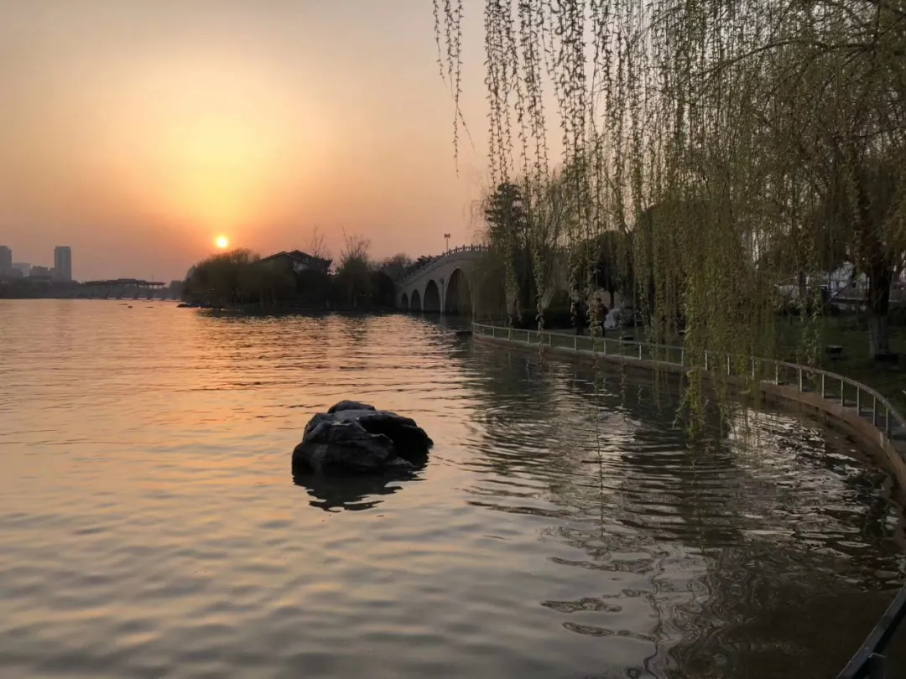

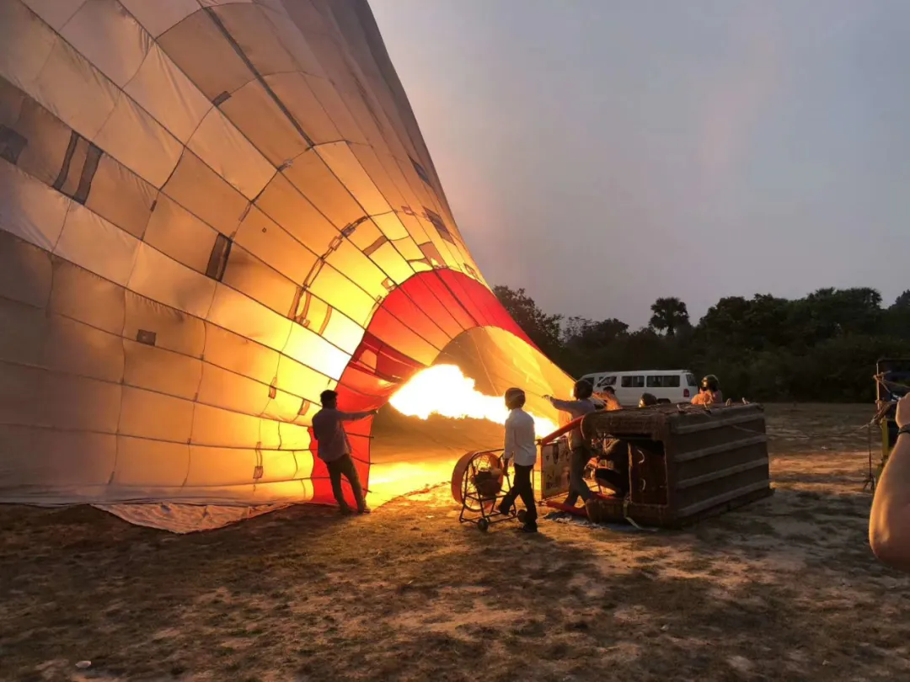

**March 22nd, 2020, Sunday, Wuhan, Rain turn Clear**

Wuhan continued its streak of zero new cases, we now have more patients leaving than people transferred here. I felt proud of the accomplishments we made.

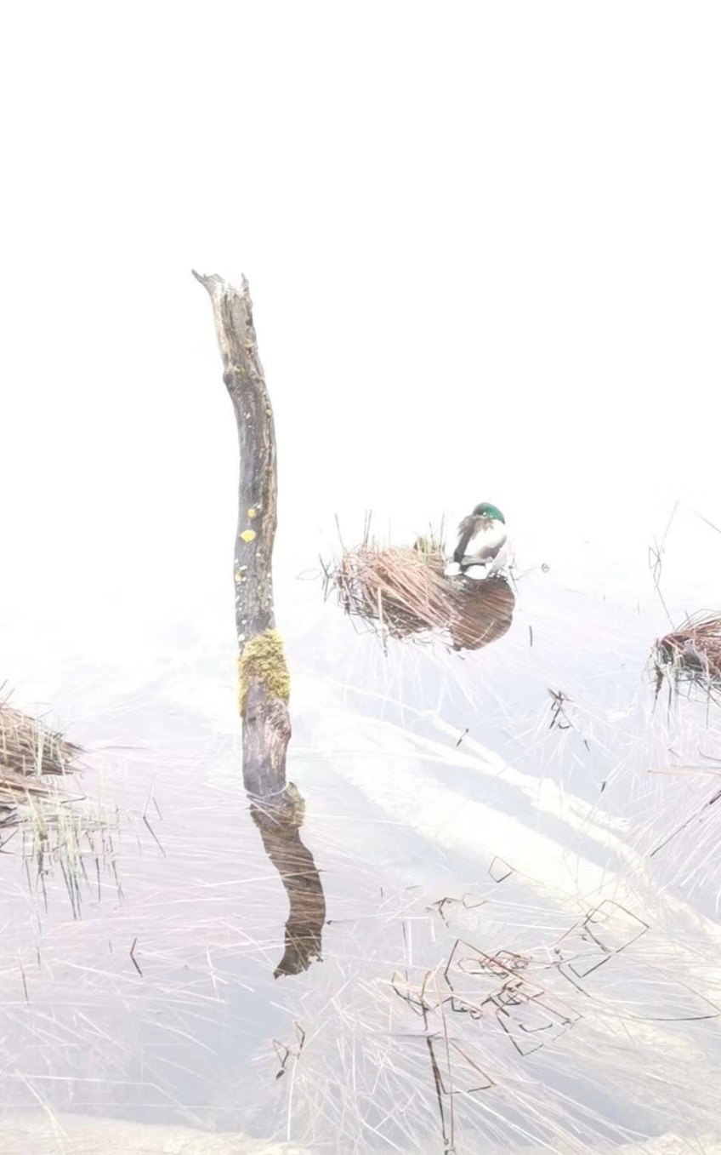

Medical groups from the other provinces will come tomorrow to help us, perhaps to replace the drained doctors from Wuhan who have been working hard for three months.  Those early doctors and nurses faced struggles we have not experienced. Our team in order to reduce stress, always tell jokes before entering to work. But doctors and nurses from Wuhan never show any kinds of positive expression. There is a nurse, who was among the very first wave. She walked for four hours to work at Chinese new year’s evening, and she hasn't returned home, unable to see her parents, husband, and child. She stayed dutiful, keeping the sadness to herself. She is committed to seeing this disaster through, she is one of the nameless heroes.

The weather in Wuhan reached a very comfortable temperature, but because of the protective gear we wear, we are still uncomfortable, but the hotel yard became a place of excitement. Only at night, the hotel becomes quiet, leaving only shadows.

When can Wuhan become crowded again?





**March 23rd, 2020, Monday, Wuhan, Clear**

The weather forecast said it will be clear for two days, and of course the sky is clear. People of Wuhan are going back to work now, the traffic is starting to show. Taking advantage of the warm sun, many doctors and nurses decided to plant trees near the hospital as a memorial. Our team planted an Osmanthus tree. Many teams also took photos with famous old doctors. In the afternoon, we completed our group team photo. But unfortunately, everyone’s smile was covered by our masks.

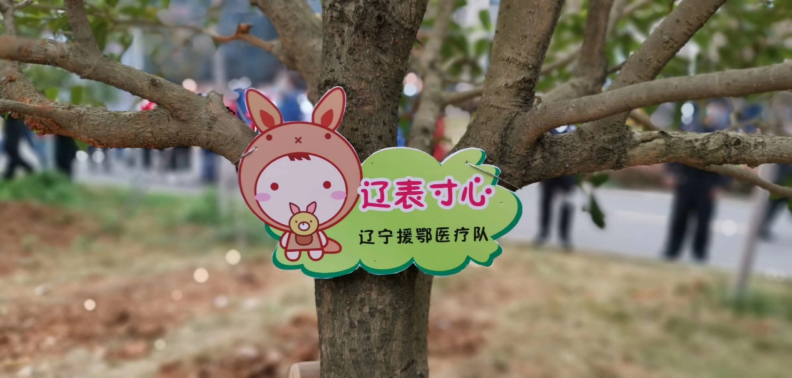

Six new teams arrived here to replace the old teams. We know we will be going home soon, by the rapid decrease of patients. Our section has 22 patients remaining, zero new cases, 463 recovered, still 5143 confirmed cases.

When the virus came, many oversea Chinese people across the country found shipments of masks, donating it to China. Now when the virus hits other nations, we sought masks to send to other countries. It seems the entire world is in this together.

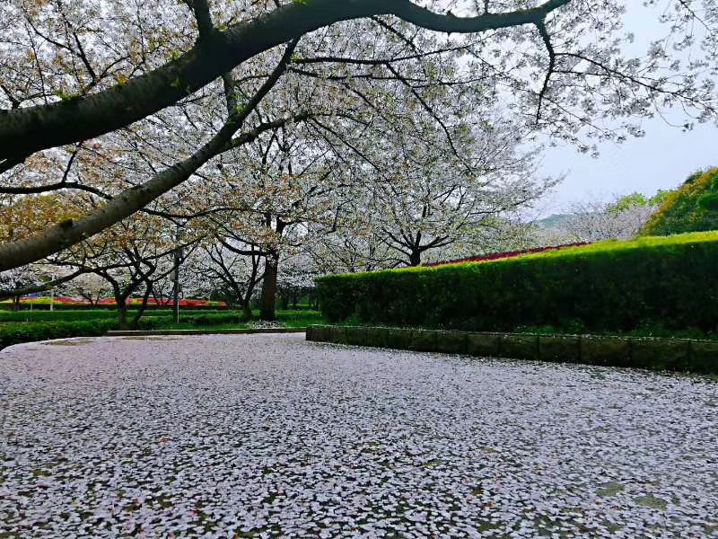All the Cherry Blossoms are blooming now, but no one will be there to enjoy it. But everything is getting better, the blossoms are here to cheer us on.

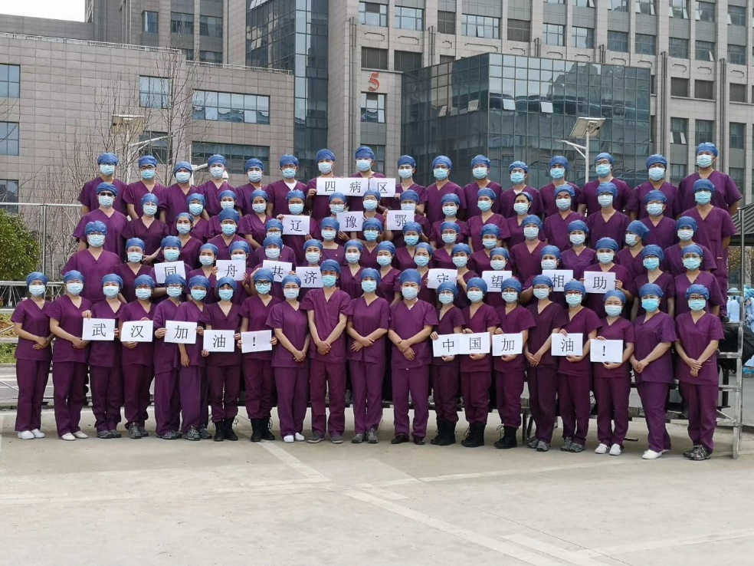

**March 24th, 2020, Tuesday, Wuhan, Clear**

Usually the night is a time for peace and quiet, but tonight is a night of lively laughter. Today we received news that the eight sectors from the People’s Hospital of Wuhan will be transferred to another hospital, and our sector is on the list of transfers. After the news, messages of congratulation flooded people’s phones. Although we know we are cleaning house, we still don’t know when we will be leaving. But it must be soon.

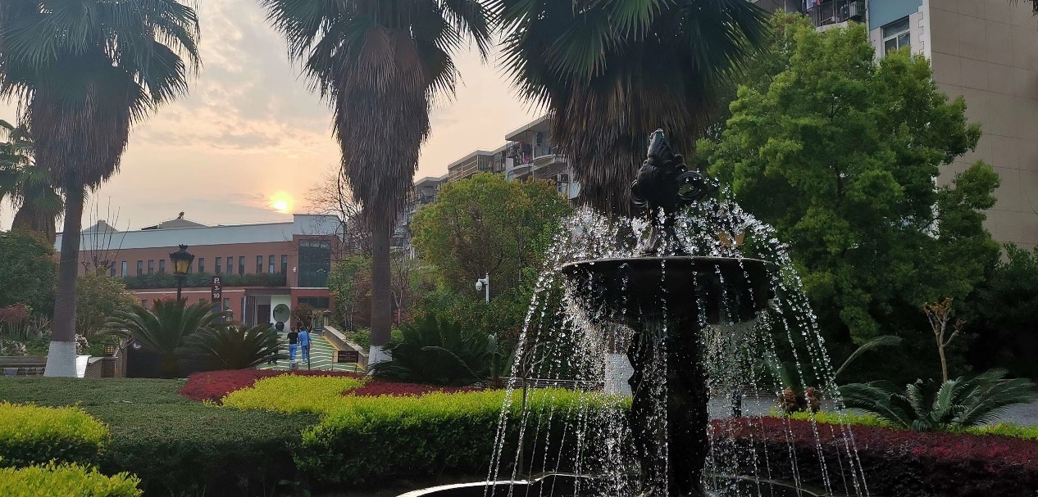

We only have one critical patients left who still need ventilator, all other critical patients have recovered. The medical staff on duty tonight will quickly organize a list of the remaining patients for the next team to take over. We are completing our last job.

From the 25th, Hubei opened its streets, the airports are all open to the public. Wuhan will do so on April 8th.

Although still happy, I couldn't help but to feel a little bit sad. We did not complete our goal of zero death, we tried our hardest, everyone put their best effort. I originally wanted to stay and joined the expert group of medical experts and to give advice for other teams, but now that has to be canceled.

I heard the Cherry Blossom in Wuhan bloomed, the streets filled with blossoms, like tears, I’m not sure if it is tears of joy or tears of sadness.

This event was unprecedented, and it will stay that way forever.

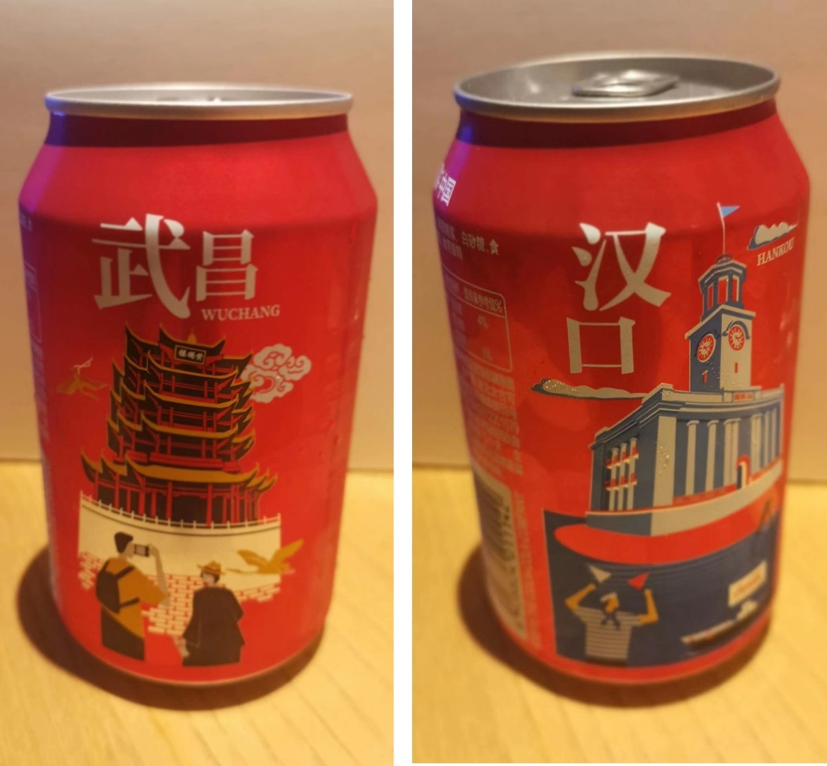

**March 25th 2020, Wednesday, Wuhan, Thunder**

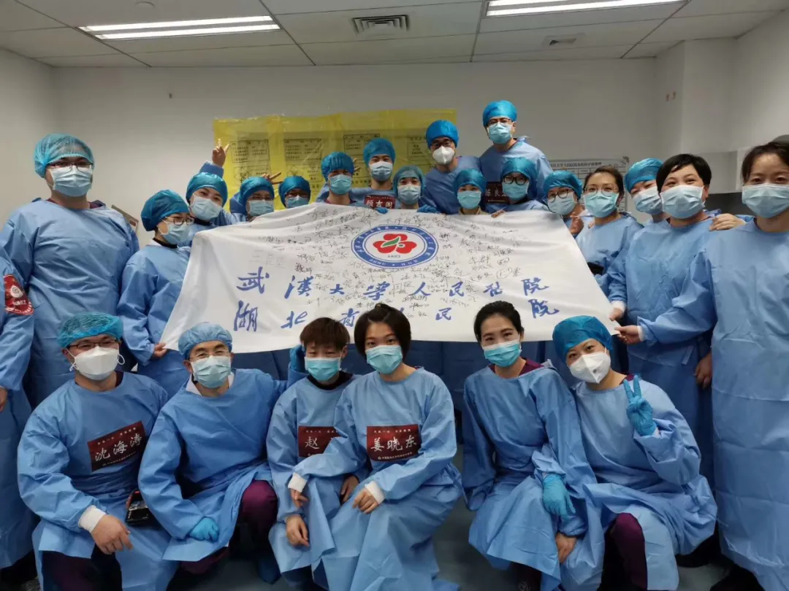The roaring thunder did not stop the entire team from going to work one last time, happily sending three recovered patients, transferred the remaining patients. We cleared the hospital ward, disinfected the ward. Sector four was altered from department of hepatobiliary surgery, the doctors who worked here originally will stay here again, they experience three months of hard work, all with mix experience. Today is the first day I saw them smile in a photo. They signed our protective gear. The feeling was bittersweet for us all. We promised we will meet again next year.

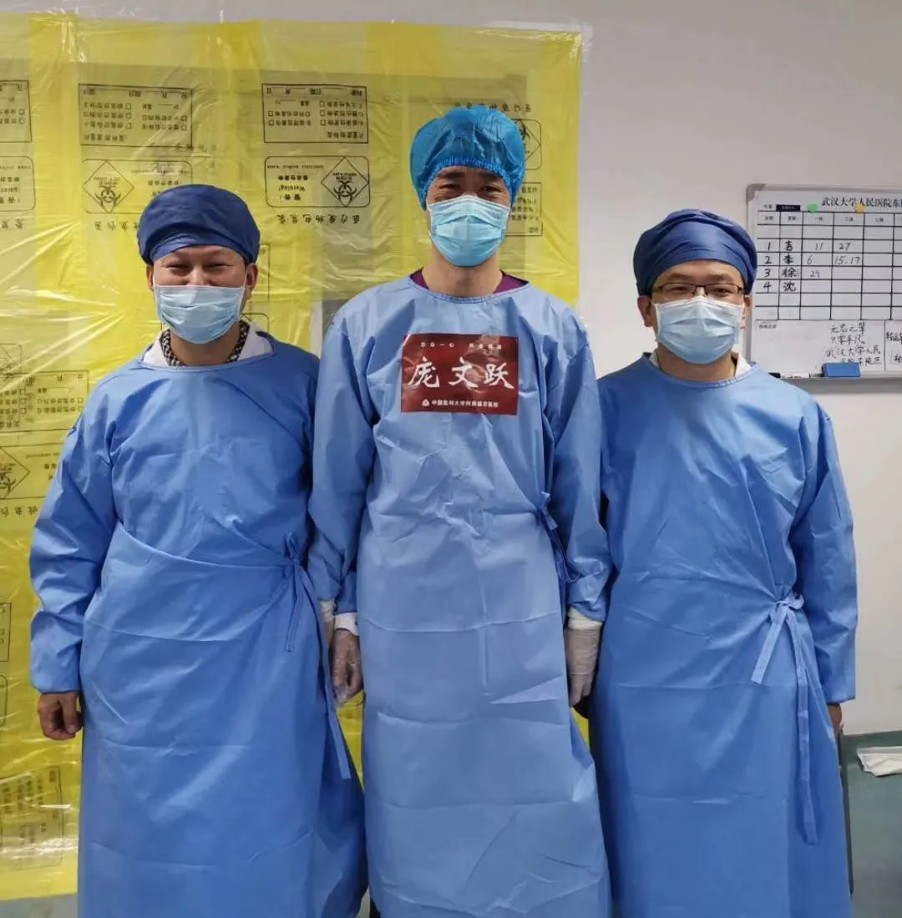

The increase in cases in other countries is very concerning, we must stay strong together. Harvard's headmaster Larry’s message to its students was that “No one knows what we will face in the weeks ahead, but everyone knows enough to understand that COVID-19 will test our capacities to be kind and generous, and to see beyond ourselves and our own interests. Our task now is to bring the best of who we are and what we do to a world that is more complex and more confused than any of us would like it to be. May we all proceed with wisdom and grace”. Unfortunately, he was diagnosed with the virus, I believe he will be able to recover.

The peaceful time will be here soon.

Salute to the doctors of Wuhan, and our team from Liaoning.

Goodnight Wuhan.

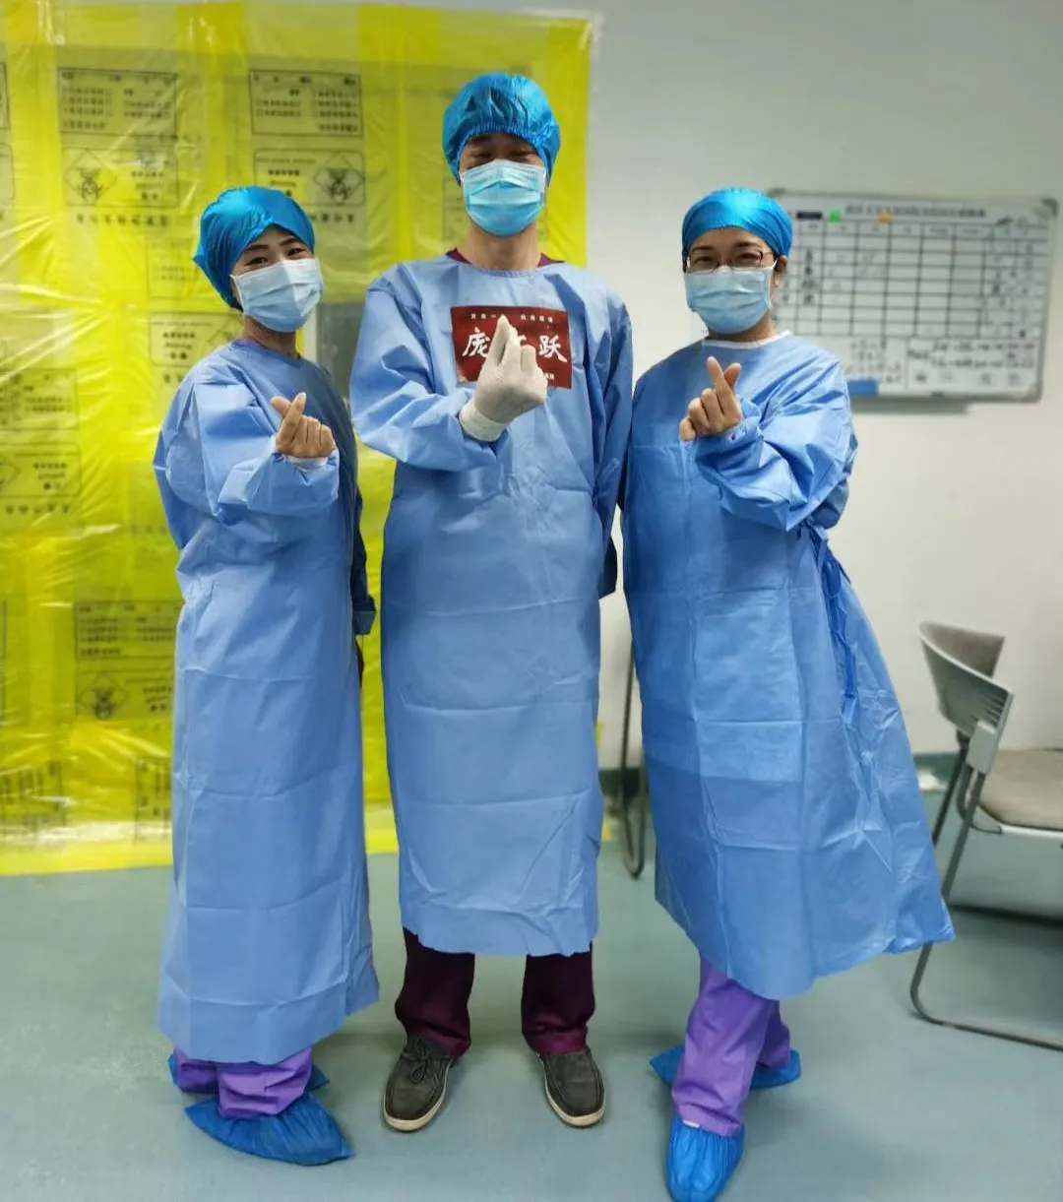

**March 26th, 2020, Thursday, Wuhan, Clear**

There is no more mission, now is the time for relaxation. I planned on sleeping for the entire day, but I was awakened by the chirping birds. The hotel is no longer crowded. The last bus going to the hospital was empty, saying goodbye.

There are many encounters in life, which many come unexpectedly.

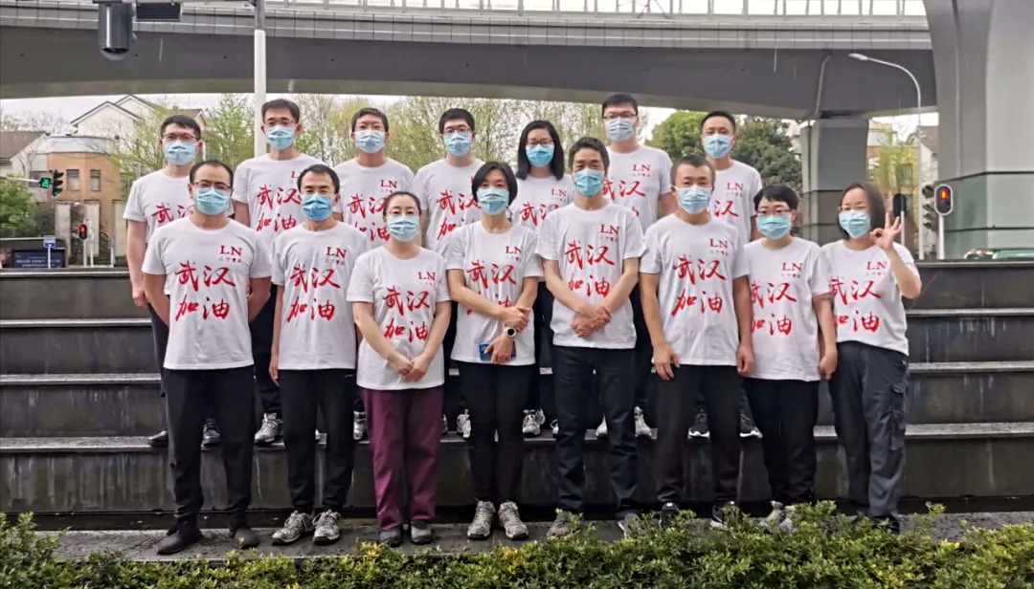The Early Spring of 2020, contains the same chill, the same wind, and the same snow. Only differences are the people flooding in to help fight a virus. When we first arrived, the city looked empty, completely abandoned, no more blooming flowers. We encountered the People’s hospital of Wuhan. In this busy building, countless doctors and nurses work endlessly to fight the battle against death. Fighting every second, every space. Sometimes we feel tired, sometimes happiness, sometimes regret, exchanging tears and blood. Against a never seen before virus, vicious and deadly. We encountered hopeless patients; they were hopeful to see the arrival of doctors. I'm grateful for the doctors and nurses who all came from different regions, I thank the cooperation from the citizens of Wuhan. I thank the hotel for providing us a home outside of our homes. I thank the kindness assistants from familiar or strange individuals and enterprises. I salute to the doctors and nurses who all came here to offer their help.

I only stayed for a few months here, but my memory will keep it for a long time. I will treasure this memory forever. I will look back at the struggles and emotional time.

Say goodbye to the roads which were traveled, the things which were passed, the scenery which have been seen. Everything has to go away with time, but there is no need to be sad.

It's been an experience of a lifetime.

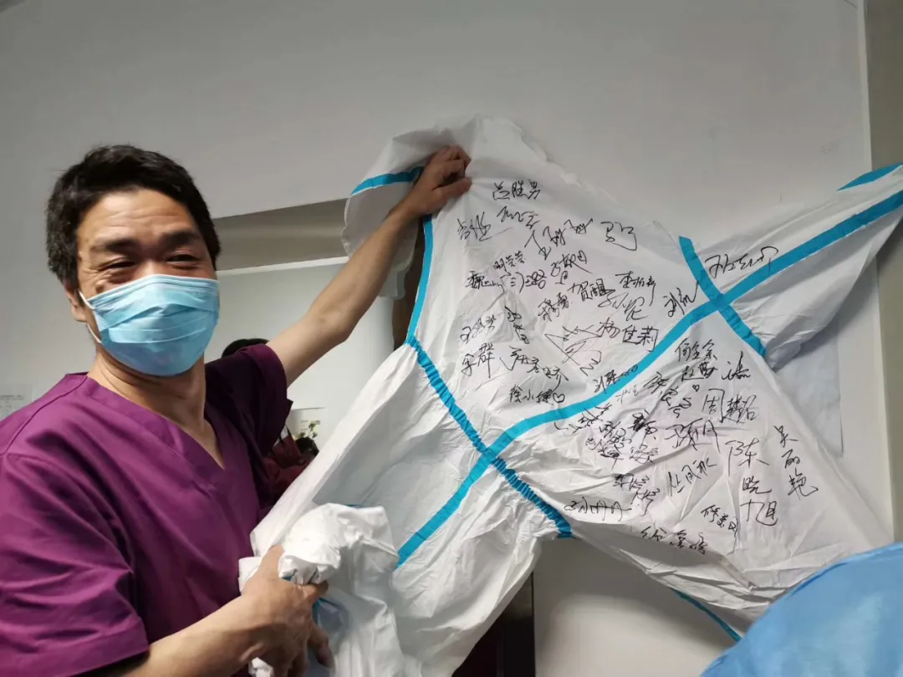

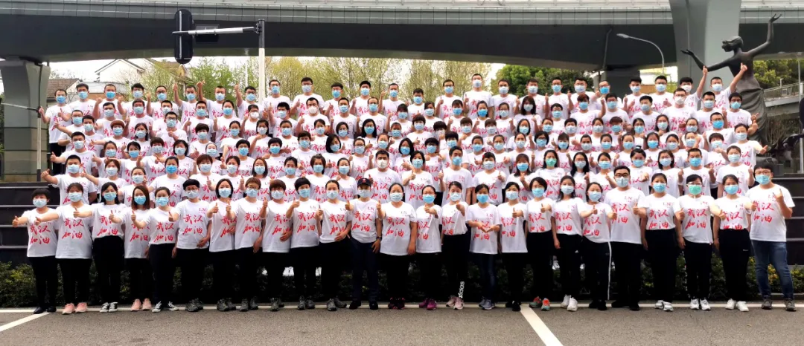

**March 27th, 2020, Friday, Wuhan, Rain**

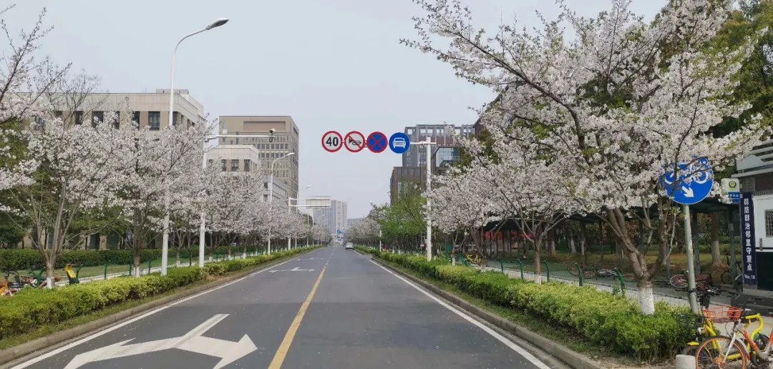The end is here. Wuhan, I lived here for 45 days

It is a bittersweet feeling. But I like the sweet part better, the happiness will chase away the cold air. Life must be like this, happiness with sadness, hopelessness with hope. 45 days ago was at the start line, and today was the finish line. Let us wave goodbye, let us remember these days, remember those familiar and unfamiliar faces. Say good luck to people who we may never meet again. Especially the citizens of Wuhan, even if they are healthy now, their heart has been damaged, it will take time for them to recover. They are the ones that needed our warm welcome and warm goodbye.

In these short times, Wuhan was able to capture our hearts. I hope I can return here again; we everything is better than before. I must remember the things that happened here, from the tiniest detail to the largest.

Although it's the end of the journal, it's the start of a more peaceful time, just like the spring rain taking away the chilliness of Winter. It is forever imprinted onto my memory,   
 I old will can recall these 45 days in the far future with a sense of happiness.

I thank everyone for accompanying me through this journey. Because of you all, I was able to stay determined. Because of you all, I was motivated.

Goodbye Wuhan. I'm only a guest, wishing Wuhan for a quick recovery, I hope you will remember me someday in the future.

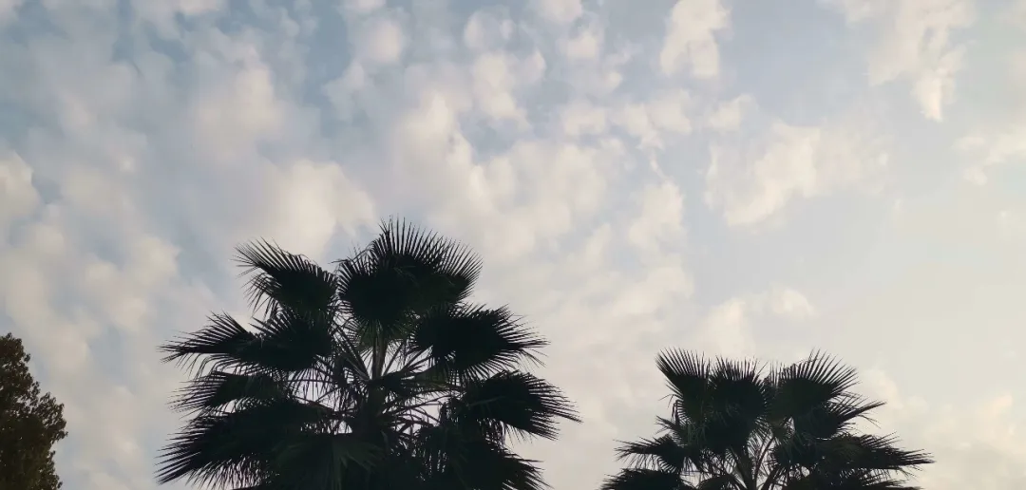Goodbye, my dear friends.

